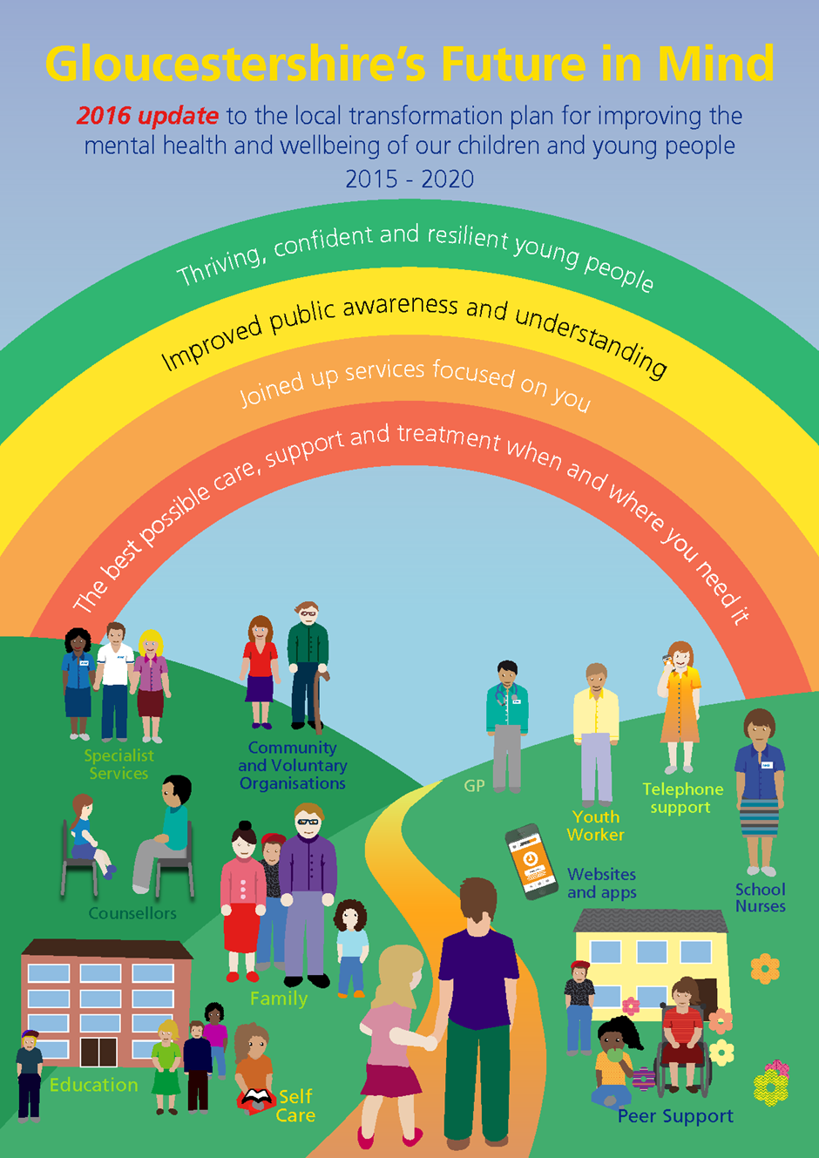

Gloucestershire’s Future in Mind; 2016 update

- Introduction

This update of ‘Gloucestershire’s Future in Mind 5 Year Transformation plan for improving Children and Young People’s Mental Health’ should be read in conjunction with the original ‘Gloucestershire’s Future in Mind’ document which remains the main reference point. The aim of this refresh is to reflect local progress with transforming the system of support for children and young people and further ambitions based on our local developing work in this important area. This update has been developed based on our refreshed needs assessment and with engagement from a wide range of stakeholders including children and young people, parents and carers, schools, social care and the wider partnerships.

We continue with robust governance arrangements and oversight of the implementation as described in the original plan. In addition to this the implementation of Gloucestershire’s Future in Mind sits firmly within the Gloucestershire Sustainability and Transformation Plan (STP) published in November 2016 as a key element for the current and future health and wellbeing of our population. For more information: http://www.gloucestershireccg.nhs.uk/gloucestershire-stp/

- 2016 update to the needs assessment

In August 2015, a children and young people’s mental health and wellbeing needs assessment was produced to inform the development of Gloucestershire’s Future in Mind transformation plan. As part of the 2016 update to the transformation plan, its authors have requested updates to certain sections of the needs assessment. The full update can be found in Appendix 1.

2.1 ‘Higher risk’ groups

The 2015 needs assessment identified a number of groups of children and young people who are at a higher risk of developing poor mental health because of particular characteristics or circumstances.

2.1.1 Accompanied and unaccompanied asylum seeking children

The 2015 needs assessment recommended that the mental health needs arising from a potential increase in numbers of asylum seekers arriving in the UK should be monitored during the lifetime of the transformation plan and action taken where required. Since then, there has been a rise across Europe in the numbers of refugees and asylum seekers, including unaccompanied asylum seeking children (UASC), fleeing countries such as Syria.

At the time of writing, it is expected that a further 70-80 UASC will be arriving in Gloucestershire through one route or another. At the time of writing, some 20+ have arrived already, with the timing for the remainder being unknown. Based on government and other guidance, the expectation is that these CYP will be treated as if they were children in care (CiC) (albeit with a range of complexities) from the point of view of process and assessment of needs.

It is recommended that commissioners of children and young people’s mental health services should continue to work with children’s social care colleagues and other partners to remain up to date with potential increases in UASC arriving in Gloucestershire and to ensure these children, where they need it, can access appropriate mental health support.

2.1.2 Children subject to social care assessments

The 2015 needs assessment identified a number of family factors that placed children and young people at a higher risk of developing poor mental health. These included parental mental illness and substance misuse. Both of these issues continue to regularly appear as factors in children’s social assessments. This is in addition to domestic violence which is a key factor in assessments, which also places children at a higher risk of developing poor mental health. It is recommended that commissioners should continue to work with adult services for mental health, domestic violence and substance misuse and ensure that the impact of these issues on children living in affected families is taken into account in service design and delivery.

The 2015 needs assessment recommended that the provision of evidence-based trauma recovery support be considered for, amongst others, children who have been a victim of CSE or sexual abuse. This remains a relevant recommendation.

2.1.3 Children in care

Although the number of children in care in Gloucestershire remained under 500 until 2013, there has been a steady increase, with 639 children in care registered in August 2016

As identified in the 2015 needs assessment, there is evidence that being in care can place a child at higher risk of developing poor mental health because of the factors leading to them coming into care and, importantly, experiences of trauma such as those outlined above.

The 2015 needs assessment also identified a potentially improving trend in the average Strengths & Difficulties Questionnaire (SDQ) score, which measure the emotional wellbeing of children in care in Gloucestershire. However, the latest available data shows that this trend has begun to worsen again, with the average score in Gloucestershire in 2014/15 being classified as ‘borderline cause for concern’.

Given the increase in the number of children in care in Gloucestershire and the slight increase in SDQ scores, further consideration should be given to meeting the mental health needs of this cohort, and any particular needs that arise from issues such as neglect and sexual exploitation.

2.2 Young people’s mental health needs

There has been no update to national prevalence data since the 2015 needs assessment, which used data from a 2004 Office for National Statistics (ONS) survey. However, the delivery of certain elements of the transformation plan, such as the Schools Pilot, and a more recent Online Pupil Survey (OPS) has added to our understanding of the mental health needs of young people in Gloucestershire. This local intelligence will continue to be used to enhance the implementation of our plan and its refinement as outlined below.

2.2.1 Gloucestershire online pupil survey

Results of the biannual Online Pupil Survey (OPS) took place in 2016, with a sample size of 29,516 children and young people across years 4-12. Whilst the survey shows that there have been some improvements in aspects of emotional wellbeing, based on its findings it is recommended that consideration should be given to the needs of older girls and to pressures created by school work beyond Year 8. Work to build resilience in children and young people should also continue, e.g. through the work of Gloucestershire Healthy Living & Learning (GHLL) and should take account of the findings of the OPS.

2.2.2 Schools pilot

Since January 2016, 15 schools and colleges in the Stroud area have been taking part in a pilot project to provide training and encourage subsequent joint working to improve local knowledge and identification of mental health issues for children and young people and improve referrals to specialist services. The pilot includes primary and secondary schools, a further education college, a special school and alternative provision.

As well as identifying considerable need for support for anxiety, the data also suggest that schools are signposting children and young people for behavioural problems, as well as mental health problems. The data suggests that there is a need to continue efforts to support school staff to identify the most appropriate responses to behavioural or mental health problems.

It is recommended that commissioners should continue to monitor the activity and impact of and learning from the Schools Pilot and, where outcomes are positive or promising, consider ways to sustain and roll out the approach in Stroud and across the county.

- Our continued engagement

Our original Transformation Plan was co-produced with children, young people, their families and carers, commissioning partners, GPs, providers and key stakeholders.
The key message from all of our stakeholders was:
Early access to services is essential – more support and services are needed for children and young people who currently don’t meet the criteria for the Children & Young People Service.

Since its publication, we have continued to actively engage key partners and young people in Gloucestershire to begin to implement our ambitions and develop services.

3.1 Children and young people

Working with young people from Stroud Youth Council, Gloucestershire Young Carers and the Young Ambassadors for Vulnerable Children and Young People, our engagement activities have included:

- Involvement in grant awards for additional one-to-one counselling support in across Gloucestershire.
- Development of a new website for Children & Young People – www.onyourmindglos.nhs.uk
- Production of a promotional video to encourage young people to talk about their mental health and develop ways to support themselves and their peers.
- Promotion of the new website and services to young people through Health & Wellbeing events, carers events, and other school based activities.

3.2 Parents and carers

Although our main focus in recent months has been on working with young people, we are now beginning to re-engage with local parent groups, with a view to increasing access to local information and support for parents and carers.

3.3 Key stakeholders

We have continued to work with key partners from across the county to develop our vision for services. We have held quarterly engagement events with representatives from health, social care, education and the voluntary sector. Key messages continue to focus on:

- reducing stigma and raising awareness;
- improving early support for children and young people;
- providing additional support for parents and carers;
- ensuring consistency across the county;
- developing our local workforce, across all sectors
- Progress with transforming support for children and young people and taking the plan forward

Our transformation plan takes a whole systems approach that is vital to transforming and making significant progress into a growing problem of increasing numbers of children with mental health difficulties. The key focus of our plan aims to:

- Address the gaps identified in our needs analysis
- Provide a balance between the need for more early intervention and prevention
- Meet the needs of those very vulnerable children and young people who achieve poorer outcomes than most of the population.

There are 4 broad themes and layers of support based on our model of coordinated and flexible mental health support.

We have been working hard as a partnership across agencies and with children and young people to implement our plan over the four layers of support identified in the plan. The following sections describe our progress as well as how we intend to take things forward.

4.1 Theme 1: Building resilience, information and advice, & early intervention.

Universal Support

4.1.1 ‘On Your Mind’ Website for children and young people. In direct response to feedback from young people we have progressed coproducing a website with young people that can provide information, advice and guidance about self-help, access to trusted sources of support and available local services. This website was launched in Autumn 2016 and has already had really positive feedback and far reaching effects e.g. highlighted in the national ‘Crisis Concordat ‘e’ bulletin. The website can be found at: www.onyourmindglos.nhs.uk

4.1.2 Working to tackle stigma and normalise mental health. Young people have developed a film about the plan which has three key messages as follows:

  - Gloucestershire is working hard to improve the system of support for mental health
  - It is ok to talk about mental health and get support when you need it.
  - Information and advice is available via the website that has been developed.

The film is available to view at https://www.youtube.com/watch?v=PBhx2JceJJI

4.1.3 Information and advice for parents. Parents and carers have told us that they need easy access to advice and support about their children’s mental health. In response to this webpages are being developed to support information, advice and guidance for parents, including signposting to trusted sources of support. It will include how to help your child and where to get local support. The webpages for parents and young people will be linked to the CCG website. We are also looking at how we can extend information and support for parents and carers in order to empower and enable parents to support children and young people, including trialling joint drop in sessions with school nursing and mental health workers.

4.1.4 Webpages for practitioners. Webpages are being developed for school based staff to be put on the Gloucestershire Healthy Learning and Living website and on the CCG Gcare IT platform for GPs. This will provide:-
- Staff with advice about emotional wellbeing issues.
- Good practice examples that can be implemented in schools to improve emotional wellbeing.
- Links to sources of support including a streamlined training matrix and access to all other training opportunities available in the county and advice about which training may be appropriate to undertake

4.1.5 A Mental Health Champions award has been developed through GHLL which will be awarded to schools that recognise that the way they operate and approach wellbeing has a huge impact on the emotional health of pupils and staff (and on subsequent attainment). During 2017 support to achieve the award will be developed to include:
- Good practice examples about whole school approaches to wellbeing and how they can be implemented.
- An attachment-based approach to support more vulnerable children and young people.

4.2 Theme 2: Joined up support - schools, communities and GPs linked to mental health support.

Early help including workforce planning, development & training

4.2.1 Mandatory mental health training for staff in schools and in other universal or ‘non-mental health-specialist’ services. We believe that mental health is ‘everybody’s business’ and as such the workforce who are not ‘specialists’ in this area should nevertheless have a consistent level of knowledge and competence in mental health. This will make the workforce as a whole better able to identify need, provide support, and in turn be more resilient in the process, thereby reducing the demand for specialist services. We are now progressing this with a stakeholder group representing all agencies.

4.2.2 Online access to counselling support is being piloted through a Voluntary and Community Sector organisation and is a response to young people wanting to access support in different ways and an approach to providing cost effective services. This approach will be evaluated during 2017. Based on the evaluation, a decision will then be taken about next steps.

4.2.3 Schools and Mental Health Pilot funded through DfE/NHSE. This pilot is part of a national project and is operating in the Stroud locality with 15 schools including one college. The project aims to:
- Join up mental health services and schools to promote early identification of need and ensure pupils get the right support.
- Support schools in further developing awareness and knowledge of good mental health and building resilience of staff and pupils

Additional primary mental health workers are available for schools to access support on a routine and regular basis. The pilot is being evaluated by an independent organisation. The interim findings have been really positive with schools valuing the easy access to the specialist advice and support that they are getting from mental health workers. The interim evaluation report demonstrates the value of this model of support. There have been tangible outcomes, for example improvements in children’s mental health and in turn engagement in school and learning. In anticipation of a positive final report we will roll out this model of earlier intervention to the rest of the county using a phased approach.
4.2.4 Earlier Intervention Counselling. As a result of the needs assessment and engagement undertaken in the original plan, the CCG has invested in direct face to face counselling. This is available across the county with the intention that this is in addition to that which the schools, colleges or other organisations currently provide or fund. In the first 6 months, 229 young people received an intervention with an average wait time of 3.6 weeks which is in line with anticipated demand. The majority of the young people were signposted to the service from GPs. Again the impact of this investment is being evaluated.

4.2.5 Mental health support for children with long term health conditions. This has been identified as a gap in local provision, and is vital to prevent long term mental health needs and further physical health conditions developing amongst this group of children and young people, and will now be taken forward as a project in 2017.

4.2.6 Improving Access to Psychological Therapies (IAPT). We are committed to continuing to train members of the specialist and wider mental health workforce, including practitioners in the Voluntary and Community Sector, in evidence based approaches via the Improving Access to Psychological Therapies Programme. Positive engagement with the regional educational collaborative has supported 21 practitioners in Gloucestershire from a range of organisations to be upskilled and trained by completing evidence based nationally recognised CYPS IAPT qualifications. There are currently 4 additional staff in training.
4.2.7 Further workforce development and planning. We know that we need to continue to work hard to attract, develop and retain staff with the right skills to deliver our ambitious plan. Developing the Children’s Mental Health Workforce forms part of Gloucestershire’s Sustainability and Transformation plan as a vehicle to take this forward and maximise success. There are already some innovative approaches to workforce development and planning in the county including the development of the mandatory mental health learning module, the mental health champions awards for schools and the schools pilot described above. In addition ²gether NHS Foundation Trust CYPS service:

- Have developed a modular programme to increase the skills and knowledge of staff working with children and young people with mental health issues. All newly qualified staff and those recruited from other disciplines complete this course. This enables staff to be recruited from a wider pool.
- Identify budding third year student nurses coming up to qualification and initiate recruitment early.
- Operate a clear policy of career progression and development to ensure staff remain within the service and enjoy a varied and rewarding career.
- Have successfully piloted new roles including a Health Care Assistant role working within Children’s mental health services which is now moving to roll out within the service
- Trained staff in evidenced based approaches to supporting children and young people with autism

In order to deliver the overall plan, staffing capacity has increased across the county. Our plan to 2020 requires over 25 whole time equivalent practitioners in order for us to reach our local delivery plan ambitions. The roadmap at the end of this section shows our ballpark trajectory for increasing activity and staffing levels through to 2020. We will utilise the strategies above to continue to recruit and retain staff alongside developments in the Health Education England Mental Health Workforce plan.

4.3 Theme 3: Pathways: access / waiting times / transition.

Getting Help

4.3.1 Access and Waiting times. We had already set challenging local access and waiting times for our children and young people specialist mental health services prior to developing our local Plan in 2015. However, we acknowledged in our original plan that these waiting times had not been consistently met. With additional investment we have now met these waiting times. NHS England have recently provided further investment going forward into 2017 to continue to reduce waiting times for specialist services.

4.3.2 Parenting Programmes. A recent report from the Mental Health Foundation, contributing to the NHS Five Year Forward View for Mental Health, re-emphasised the importance of parenting programmes in protecting mental health in early years. A rapid review of parenting programmes in Gloucestershire has recently taken place looking at what is currently being delivered in county and the current evidence base. Options for taking this forward are currently under discussion.
4.3.3 Eating Disorders. Over the coming year we will work to ensure that there is an effective pathway in place so that all multiagency professionals including Primary Care, the Acute Trust and the eating disorder service work effectively to manage co-morbid physical health issues as well as the eating disorder. The eating disorder service will also be joining a quality network.

4.3.4 Early Intervention in Psychosis (EIP). Gloucestershire operates a fully NICE compliant service for young people who develop psychosis for the first time. This includes a clear pathway and joint working including shared teams roles between the CYPS service and EIP to ensure young people receive joined up care and support

4.3.5 Transition. Work has been ongoing via a CQUIN to improve the experience and journey of young people into adult mental health services or onward care into the community. ²gether NHS Foundation Trust are working with young people and adult services to look at how adult services can be adapted to better meet the needs and expectations of young people. We will be working to implement the National Institute for Clinical Care and Excellence transition quality standard. This work will continue until March 2017 when a final report with improvements and scoping out options for a 0-25 year old service will be produced.

4.4 Theme 4: Vulnerable CYP with complex needs / intensive interventions.

Getting help and Help & support in a crisis.

4.4.1 Young People in crisis. The CCG and county council (GCC) have been working to look at more effective models of joint working including developing collaborative plans with NHS England Specialised commissioning (NHSE SpecComm) to support alternative options to the use of mental health in-patient beds. This is to support young people who are often known to multiple agencies including health and social care and who are experiencing a social and/or psychological crisis. We know that these young people are at greater risk of engaging in offending activity, be subject to forms of exploitation and/or be less likely to be engaged in education and have stable employment prospects and training. These young people often have complex needs and present a challenge in terms of practitioners providing a joined up response, and may often result in them being in placements out of county.

Our proposed response is to provide more local and bespoke support based on the development of a combined health and social care Intensive Intervention Service. This is based on feedback from young people, the needs described and best practice, and aims to support young people based on successful models of practice elsewhere in the country. This is now being taken forward as a business case within the CCG and GCC, and as a potential joint development including NHSE SpecComm.

Integral to this Gloucestershire has also been successful in gaining Capital funding to devlop a place of safety and place of calm. This will be integrated within the Intensive Intervention Service.

Complementary to the above work we have been developing our community Mental Health Acute Response Service (formerly known as the crisis service) and Gloucestershire Hospital based Psychiatric Liaison service to begin to work with younger people. This area of work has not progressed as quickly as we might have liked due to some workforce challenges. However, we are confident that this will progress over the coming year.

4.4.2 Children who suffer from sexual abuse and /or exploitation. We are working collaboratively with our partners including the Sexual Assault Referral Centre Board and NHS England Health and Justice Commissioner to work together to address gaps in the system which include victims of sexual abuse and /or exploitation. During 2017 we will work to ensure effective pathways of support are in place including developing pathways with NHS England for the commissioning of mental health support for children and young people relating to the Sexual Assault Referral Centre, ensuring that current gaps in support are filled.

4.4.3 Children and Young People on the edge of or coming into care. We will continue to work on developing a more comprehensive pathway of support for children on the edge of or coming into care including the younger age group who may have suffered trauma, neglect and abuse. This is to help to ameliorate later mental health crises developing. During 2017 we will bring together all sources of support and look at ensuring a more joined up approach to mental health and wellbeing provision is in place going forward. This includes addressing capacity as the number of children in care rises (as indicated in the updated needs assessment).

We will also look at adapting to changing needs eg the rise in unaccompanied asylum seekers. We are actively working with ²gether NHS Foundation Trust and the voluntary and community sector to address the needs of asylum seekers and refugees through developing expertise and piloting new ways of meeting needs and will seek to ensure that a formal pathway is in place during 2017 with associated investment.

Gloucestershire is an early adopter site for NHS England Integrated Personal Commissioning programme to roll out integrated personal budgets from 2016/17 – 2018/19 to deliver personal budgets for children in care. The aim of this project is to test the use of personal budgets for children in care and young people with mental health and well-being needs with a view to these being scaled up across the sector. The introduction of personal budgets could generate a more flexible, integrated system, in which children and their families and carers are encouraged and supported to be involved in developing and delivering their own care plans. Future in Mind highlighted how children in care faced particular challenges in obtaining support at the right time. Personal budgets for looked-after children may provide an effective way to improve their access to appropriate support and outcomes. Initial feedback from young people and practitioners is that children and young people aged 15-18 thinking about transition from care and children and young people with raised ‘Strengths and Difficulties’ scores could benefit the most from this approach.

4.4.4 Young People at risk of contact with the criminal justice system. We are also working with NHS England Health and Justice commissioning to improve the support for young people at risk of entering the criminal justice system. We are investing to enhance the current arrangements by providing specific and targeted capacity to provide more integrated multi-agency assessment, consultation, formulation and therapeutic interventions. We will also look to provide services at times of the day which are more acceptable and accessible to young people, particularly this group who find it harder to engage with services. This additional investment should ensure improved outcomes for young people in terms of mental wellbeing, family functioning and diversion from statutory youth justice.

4.4.5 Perinatal and Infant Mental Health
Gloucestershire has been working on making improvements to Perinatal and infant mental health services for some time via quality initiatives within ²gether, working across the network including with maternity, health visiting, children centre services and the voluntary and community sector. Gloucestershire has been successful in an NHS England bid to set up and deliver a specialist community perinatal and infant mental health team for women with complex mental health disorders. This includes meeting the needs of infants. We will look closely at the role/function of the infant mental health team and the capacity to support the parent infant relationship for women with mental health needs and women with other risk factors.

The overview of our key activities and increased activity is in our roadmap on the following page.

`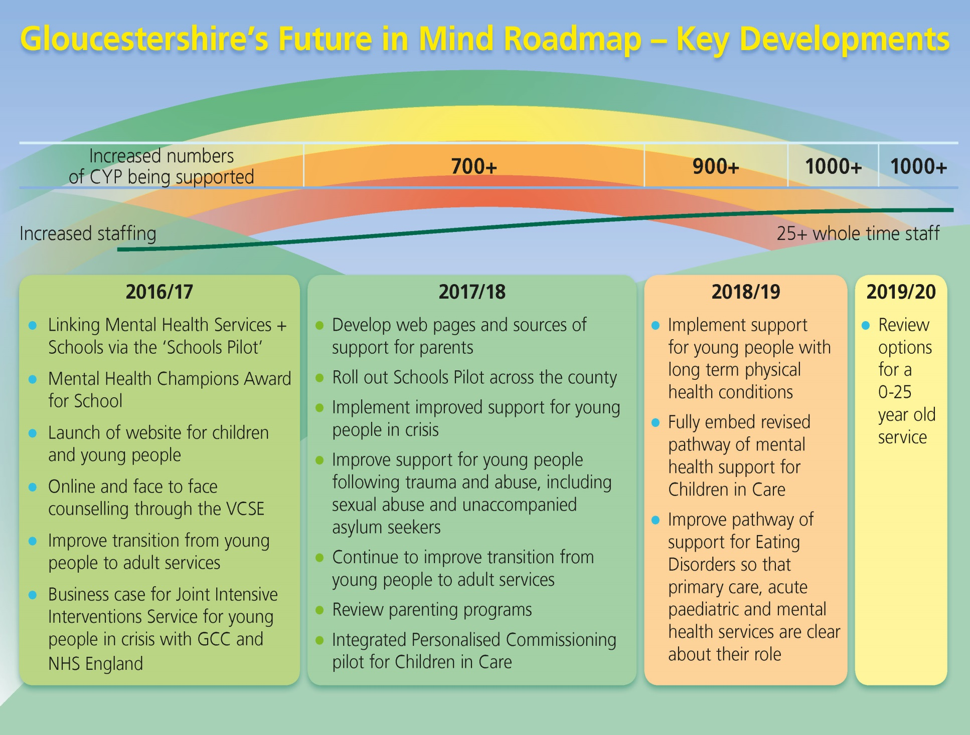

- Next steps

We will continue to track our progress through the outcomes and key performance framework and our action plan, a summary of which can be found in Appendices 2 and 3.
We have a robust governance process in place described in our original plan which will continue to ensure that we deliver transformation for our children, young people and families.
We have a track record of strong engagement and participation with young people from a range of backgrounds about their emotional health and wellbeing. We will continue this into the implementation phase of the plan.

