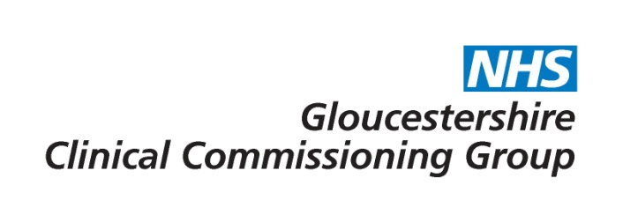
Lycra splinting for paediatric patients with cerebral palsy/movement disorders

Commissioning decision | The CCG will provide funding for Lycra splinting for paediatric patients with cerebral palsy/movement disorders who meet the criteria defined within this policy.

Policy Statement:
Lycra splinting services is commissioned for paediatric patients who meet the following criteria:

- children aged between 3 and 18 years* with a diagnosis of cerebral palsy or other neurological condition
- following multidisciplinary team assessment by the Occupational Therapist and Physiotherapist and support from a Consultant Paediatrician that the child is likely to achieve an improvement in (or maintain) functional abilities regarding balance or movement control
- where the child and family/carers are motivated to support the introduction and maintenance of use of the intervention.

Contraindications for lycra splinting include severe or uncontrolled epilepsy, vascular, or chronic respiratory problems.

Regular monitoring at appropriate intervals by the multidisciplinary team (including Physiotherapist, Occupational Therapist and Consultant Paediatrician) to assess progress or maintenance of functional ability is required. Use of the splint will be discontinued if benefits cease to be achieved or maintained. *Replacement splints will be funded automatically to the age of 16. Requests for replacement splints, for children aged 17-18 or for those previously funded now reaching adulthood, must be supported by a recent NHS physiotherapy or occupational therapy assessment.

Rationale:
Lycra splinting may improve functional abilities in the short term for some children with cerebral palsy, although there is limited evidence available of clinical effectiveness, and no evidence available in relation to cost effectiveness. It is therefore appropriate to consider cases on a case by case basis and fund only where there is a likelihood of achieving benefit.

Plain English Summary:
It is believed that lycra splinting may benefit some children suffering from cerebral palsy and neuromuscular disorders such as muscular dystrophy by improving their balance, muscle control, stability and movement. Lycra splints or suits consist of sections of lycra of varying thicknesses stitched together using specific tensions and directions of pull. Sometimes plastic boning is also added to give extra support. The splints are made to measure and designed to meet the needs of the wearer.

There is limited high quality evidence available to demonstrate the clinical effectiveness of lycra splinting, but some small studies do show there may be potential for certain children to benefit from the treatment. Gloucestershire Clinical Commissioning Group will therefore fund lycra splinting for patients that meet the criteria set out in the policy.
Evidence base:
Dynamic lycra splinting for children with cerebral palsy evidence note 11 -
http://www.healthcareimprovementscotland.org/his/idoc.ashx?docid=cc39b43b-eb68-4a35-9b3e-eb5ac9e766f1&version=-1

Link to application form – Not applicable
For further information please contact GLCCG.IFR@nhs.net

Date of publication | 12th October 2015
Policy review date | October 2017

Consultation
Consultee | Date
Planned Care Programme Board | 21st July 2015
GP Membership (via What’s New This Week) | 10th July – 7th August 2015
Has the consultation included patient representatives? | No

Policy sign off
Reviewing Body | Date of review
Effective Clinical Commissioning Policy Group | 3rd August 2015
Integrated Governance and Quality Committee | 20th August 2015

