Engaging our communities

1. Programme/Project Title: Forest of Dean Community Services Review
1.1 Background to the project
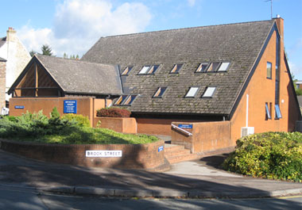
The Forest of Dean Community Services Review aims to develop a plan for high quality and affordable community health and care services with patients, public, staff and key partners, to meet the needs of the local residents now and in the future. In an early media release, NHS Gloucestershire CCG committed to a ‘positive and inclusive’ approach to working with partners and the public during the review.
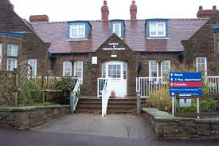
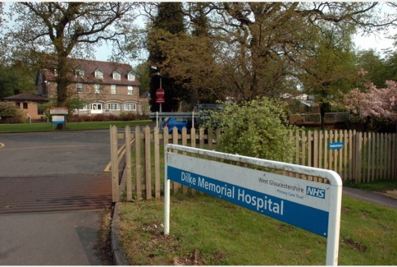
A Communication and Engagement Plan was produced to support the review and ensure comprehensive and planned engagement and communication with interested parties throughout the life time of the project. The plan identified local stakeholders and set out the key messages and milestones for the early engagement work.

1.2 Local Engagement
Local stakeholders were identified during the development of the Communication and Engagement Plan and invited to form a Locality Reference Group with the aim of:
- Maximising local engagement in decisions about healthcare services for the people of the Forest of Dean locality;
- Increasing community awareness and influence; developing local support for initiatives and changes to healthcare delivery.
The Locality Reference Group has met throughout 2016, with good levels of attendance at all meetings. The group is not intended to be representative of the Forest of Dean population, but members are well informed and connected to their local community. The group has helped us to shape our engagement plans and members have been proactive in encouraging their local networks to contribute to the review. This included engagement with young people, parents, patients with long term health conditions, carers and local voluntary sector organisations.
Wider staff, GP and public engagement focussed on providing the opportunity for people to share their views about what currently works well in local health and care services and what was needed to support them in the future.

1.3 What we learned/outcome
Feedback was gathered across 26 stakeholder events, 21 staff events and meetings of both the Locality Reference Group and Locality Executive Group. In addition 73 completed on-line questionnaires were received.
There was significant commonality between the feedback received from staff and the local community. Whilst some of the feedback related to very local services, comments will also be relevant to countywide services and may be helpful in informing wider strategic planning. Key themes noted relate to:
- Access to services
- Community Hospitals
- Urgent care, including Out of Hours GP services
- Outpatient services
- Community Nursing
- Mental Health services
- Education and information
- Integration/Partnership working

A copy of the full engagement report is available here

1.4 The next steps
Whilst our planned engagement activity has come to an end, work is now underway to develop materials to support a formal Consultation on a future model of care. It is anticipated that this will include printed and web-based materials, social media, information drop-ins and promotion of the Consultation via the NHS Information Bus and local media.
A detailed Consultation Plan is being developed and will be presented to the Gloucestershire Health and Care Overview and Scrutiny Committee during the launch of a twelve week Consultation in Summer 2017.

2. Programme/Project Title: Support at The Cavern
2.1 Background to the project
In Gloucestershire, it is estimated that there are around 24,921 with some form of mental health issue, ranging from anxiety and depression through to personality disorder and psychosis. Evidence suggests that for many of these patients, the Emergency Department (ED) at their local hospital may be perceived as their best option for support during a mental health crisis – recent figures show over 1,100 such attendances per annum at our Gloucestershire hospitals.
As an alternative to ED, other areas have successfully trialled a café model to support individuals in crisis. In Aldershot, this model saw an estimated reduction in the number of psychiatric admissions by 33%, with 63 confirmed reports of people using the café as an alternative to ED within its initial 3 month trial.
Consequently, the CCG has commissioned Kingfisher Treasure Seekers Ltd (KFTS), a local voluntary and community sector organisation, to run a pilot of a café for adults in Gloucestershire aged 18+ with mental health needs including those at risk of crisis. The café provides a viable alternative for individuals with mental health issues who require immediate support and advice.
The café provides the following:
- An informal, non-clinical environment offering a range of hot and cold drinks, offering support from trained staff and volunteers as well as social interaction and peer support
- An open, drop in support style where individuals can either seek immediate support or just enjoy the environment seeking help when required
- 365 day, 7 day a week support and advice for those with MH needs between 6pm and 11pm
- Low level interventions and support, either in isolation, in combination with other therapies or as a step down from other services
- Access to additional support groups/activities during the day where appropriate
- Transfer protocols where necessary into more intensive care and close working links with both 2gether NHS Foundation Trust and the ED department at Gloucestershire Hospitals NHS Foundation Trust
Access to The Cavern is either through self-referral, drop in, or through referral from mental health teams, ED, GPs, Social Services and the Police.

2.2 Local Engagement
The café has also offered an opportunity to expand and develop third party voluntary and community sector organisations in Gloucestershire, and to build relationships between different organisations.
KFTS are working closely with health and social care organisations to ensure the café is promoted and well known. A leaflet that has been distributed to promote this service can be found at www.kingfishertreasureseekers.com/cavernsupport
KFTS have been working closely with Gloucester City GPs to ensure the service is meeting the needs of their patients.
Gloucestershire Clinical Commissioning Group will continue to monitor data coming from the service and from the Police and Gloucestershire NHS Foundation Trust.

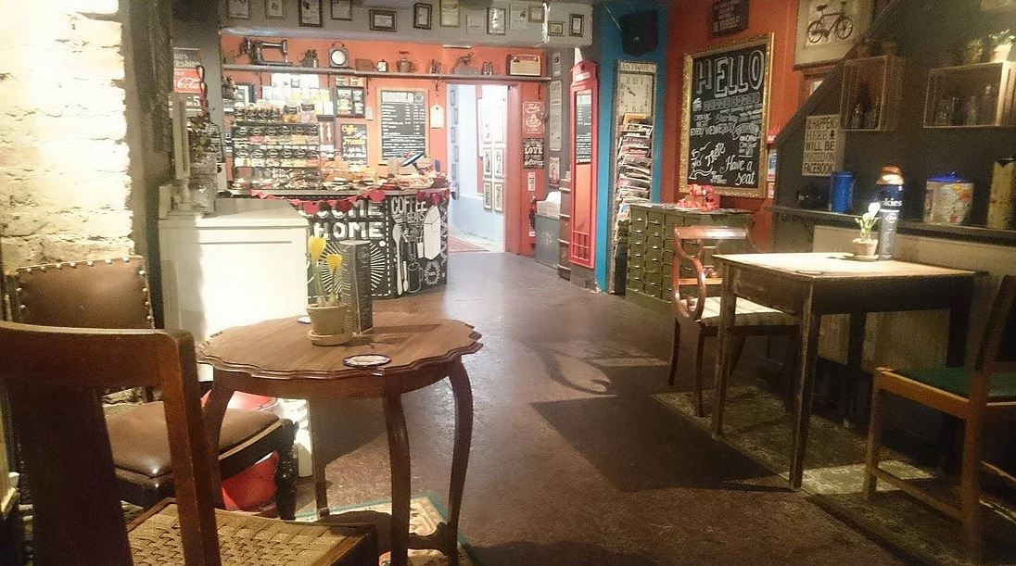

2.3 Lessons learnt/Outcome
The café opened on Monday 11th July 2016 and since opening has received a total of 1248 visits from 354 individuals (as at 30th November 2016).
The majority of people access the service through self-referral currently, however work is being carried out with GPs in the Gloucester City area, the ED and the 2gether Trust Mental Health Acute Response Service (MHARS) to strengthen relationships with these organisations and ensure that individuals are referred/ signposted to the café where appropriate.
Various reasons are reported by individuals for why they visited the café. The most common reason for attendance is “to talk about current circumstance/events/ situations” closely followed by “anxiety”
The average return rate to the café is 5 times per person per month indicating that the service is something that individuals find useful and therefore return to.
Users are asked to rate their mood from 1 (bad) to 10 (good) upon entering and then leaving the café. Since opening in July 2016, the average mood upon entering the café is rated at 5.79, increasing to 8.05 upon leaving.
As well as rating their mood, users are also asked to rate their satisfaction with the café (1=bad, 10=good). The average score since opening in July is 9.55 indicating that service users are very satisfied with the service.
Kingfisher Treasure Seekers also offer people the opportunity to take part in a range of wider activities, such as arts and crafts, singing and dancing. They also help people to achieve their full potential by providing opportunities to gain valuable employment skills and work experience. One individual with a personality disorder who had previously been a frequent attender at ED is now visiting the café on a daily basis and is due to undertake work experience in early 2017. She hopes this will help her in getting back into work when she is ready.
Attendance data from the ED has shown a recent reduction in the number of patients attending with a mental health issue. Whilst it is not possible to directly attribute this reduction to the café, there is evidence from elsewhere that frequent attenders at ED (and other MH services in Gloucestershire) are now starting to visit the café as an alternative. .
We have reports from professionals working with individuals known to multiple services across Gloucestershire that the café has had a positive impact. An example of this involved an individual who has a history of frequent detainment under S136. Since becoming a regular visitor to the café, they have not been detained under S136 for a significant period.
Reports show that the café is also having a positive impact on partnership working across the café, health services and the police
A “real life story” from one of the users of this service can be found at:
https://youtu.be/GcoDfk5TeFw

2.4 Next steps
At the end of the twelve month pilot period, an evaluation will be carried out to establish the efficacy of the service, both in terms of attendance at other services and service user experience.

