Information and Communication
1. Programme/Project Title: On Your Mind Gloucestershire
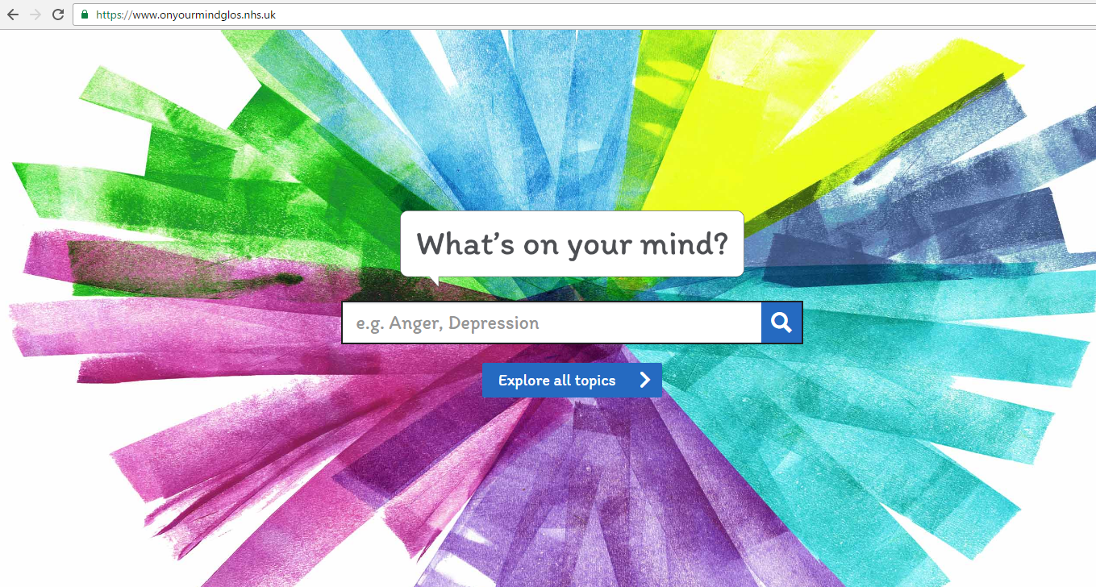

1.1 Background to the project
In March 2015, in response to a report by the national CAMHS (Child and Adolescent Mental Health Services) Taskforce, the Government published Future in Mind.
Future in Mind talked about the need to take local ‘whole systems’ approaches to the issues faced by children and young people, as well as identifying some specific areas that needed improvement nationally. Consequently, it required each local area to develop a 5-year Transformation Plan to improve outcomes. This work was led in Gloucestershire by the CCG, with our local Plan receiving approval in late 2015.
During the development of the Plan, engagement with a range of young people, parents and local stakeholders identified some key themes. Young people told us that they wanted easier access to information about local services, support and self-management. They also wanted to know how they could help friends who were struggling with their emotional health and wellbeing.
Young people wanted us to develop a website, where they could access accurate information which they could trust, with a focus on what support was available locally for them in Gloucestershire.

1.2 Local engagement
Having received approval for the Plan, work on the development of the website began towards the end of 2015.
We had been invited by two local practices to attend Health Awareness Events that they were organising at their neighbouring secondary schools. We used these opportunities to seek ideas from the pupils about the website design. Approximately 500 young people from years 11, 12 and 13 (aged 15-18) attended the event held at Cleeve School and of those, 295 gave us feedback. At Winchcombe School approximately 500 pupils attended the event from years 7 to 11, with 270 giving us feedback.
The pupils were asked to rate “their top three” features they would like on a website supporting children and young people with their emotional health and wellbeing. The results were very similar from both schools, with the following featuring as priorities:
- A list of apps that could help you relax e.g. mindfulness and meditation
- Information on how you can support friends who are suffering with emotional problems.
The third choices were:
- Information on how you can help yourself to feel better; and
- Telephone numbers of helplines to call for support
During the development of the new website www.onyourmindglos.nhs.uk, local engagement during 2016 also included:
- Running a lesson at Newent School around emotional wellbeing, enabling us to ask students their views on website topics.
- A session with children in care and care leavers to clarify the information that they would like to see on a website and capture their views about design.
- An online survey to gather wider views on website requirements
- Engagement with young people from the Prospects Services in Gloucester around what they would like to see on a new website
- Website requirements meeting and art design workshop with Stroud Youth Council, Young Carers and Ambassadors for Vulnerable Children and Young People
- Transformation Plan publicity film scripted and recorded by Ambassadors for Vulnerable Children and Young People
- Feedback gathered from Young Gloucestershire Link visitors once the website was launched.

Examples of the fantastic artwork produced by young people, at the website design workshop.

1.3 What we learned/outcome
The website is now live and being promoted and publicised through schools, partner organisations and youth forums across the county.
Pens, business cards, posters and door stickers are being distributed as part of the Communications Plan.

1.4 The next steps
In November 2016, staff from the Engagement team and Children and Young People’s Commissioning team visited Winchcombe School to feedback to the students about how the views gathered at the school’s 2015 Health and Wellbeing Event have been incorporated into the new website. The website received a very positive response from the students.
In early 2017 the website will be reviewed to take account of comments received to date and consider further updates.

