Developing
Gloucestershire’s
Sustainability and
Transformation Plan (STP)
Outcome of Engagement
November 2016 – February 2017

Foreword: Developing Gloucestershire’s Sustainability and Transformation Plan (STP)
Our STP sets out the very significant challenges that we face and the opportunities we must take to ensure local people can access high quality, sustainable and safe, physical and mental health care into the future. Our approach builds on the foundations of our ‘Joining up your Care’ (JUYC) programme in 2014, which was subject to significant patient and public engagement. The JUYC Outcome of Engagement Report can be found at: http://www.gloucestershireccg.nhs.uk/wp-content/uploads/2012/03/JUYC-Outcome-of-Engagement-Report-Final-v2.pdf
Moving forward, we believe we need to place greater emphasis on prevention of illness, support more self-care, provide more joined up care and support in the community and look at how some of our hospital services are organised to ensure safety and quality.
We know that we cannot make future changes alone and so we have sought the views of the public, patients and carers, community partners and health and care staff about our approach. We undertook a twelve week period of staff and public engagement over our STP priorities. The engagement period ran from the middle of November 2016 through to the end of February 2017.
This Report provides information about the Communications and Engagement activity undertaken and summarises the feedback received. This Report is supported by a series of online Appendices, which provide more detailed engagement feedback. These can be found under Engagement at: http://www.gloucestershireccg.nhs.uk/gloucestershire-stp/
Thank you to all those individuals and groups who shared their views with us.
NHS Gloucestershire Clinical Commissioning Group
Gloucestershire Care Services NHS Trust
2gether NHS Foundation Trust
Gloucestershire Hospitals NHS Foundation Trust
South Western Ambulance Service NHS Foundation Trust
Gloucestershire County Council
Contents
Page 2 Foreword
Page 4 1. STP Checklist for governance and engagement
2. Our approach to STP communications and engagement
Page 5 3. Equality Impact Assessment (EIA)
Page 6 4. Report format
Page 7 Part 1
5. Making the best use the information provided in this Report
You said – we did
Page 9 Part 2
6. Communications and engagement
Communications and Engagement methodologies
Page 10 Engagement activity timeline (November 2016 – February 2017)
Page 13 Developing understanding and supporting STP engagement
Page 14 Part 3
7. Demographics
Page 17 Collecting younger residents’ views
Page 18 Part 4
8. Quantitative and Qualitative feedback
8.1 Quantitative feedback
Page 21 8.2 Qualitative feedback
Page 30 Part 5
9. Learning points for engagement and communication activities
Page 31 References
1. STP Checklist for governance and engagement
The STP Checklist for governance and engagement is a resource we use to support the delivery of change within our Sustainability and Transformation Plan (STP). The Checklist sets out a series of questions that can be asked locally to support effective discussion and decision-making across a place. The questions cover: governance, scrutiny and accountability; system-wide control totals; public engagement; and partnerships and collaborative working. The checklist for engagement asks the following:
- How does the STP communication strategy support meaningful engagement with patients, carers, the public and their representatives? Is the substance of your STP being communicated in a way that is understandable and meaningful to different populations?
- How has your STP engagement plan made the case for ‘public value’? Do plans clearly communicate what changes mean for patient experience and outcomes and help explain how efficiency savings will be made and the impact on patients?
- How are plans being co-produced with patients and the public? What more can be done to involve patients in developing the plans and supporting the delivery of proposals?
- Does your STP engagement plan clearly link to existing plans and demonstrate how STPs are a continuation of plans already being delivered within your footprint? Or does the plan contain new ideas that go beyond existing plans?

2. Our approach to STP communications and engagement
Our approach to communications and engagement seeks to answer the questions above by:
- ensuring the Communication and Engagement work programme is integrated into the Governance and overall STP programme structure
- ensuring that a structured approach is taken to engagement with all interested stakeholders – internal and external - including the seldom heard, paying due regard to ‘Engaging local people’ (NHSE, Sept 2016)
- ensuring that key stakeholders know how they can have their say and influence the work of the STP
- ensuring robust and sustainable communication arrangements are in place so that all identified audiences are kept up to date with progress
- ensuring that the approach to communication and engagement is system wide – emphasising system wide ownership – both constituent organisations and communication and engagement leads
- ensuring that stakeholder groups are communicated with in the right way and in a timely manner e.g. staff and community partners are aware of developments before other external audiences
- ensuring communication and engagement activity, materials and messages are relevant to each target audience
- demonstrating and inform stakeholders of the impact that their feedback has made

3. Equality Impact Assessment (EIA)
Equality, diversity, Human Rights and inclusion are at the heart of delivering personal, fair and diverse health and social care services. All commissioners and providers of health and social care services have legal obligations under equality legislation to ensure that people with one or more protected characteristics are not barred from access to services and decision making processes
An Equality Impact Analysis (EIA) of the planned engagement activities was undertaken prior to the commencement of engagement. The STP Engagement exercise was open to all and engagement activities were designed to facilitate feedback from as wide a cross-section of the local community as possible. The EIA can be found under Engagement at: http://www.gloucestershireccg.nhs.uk/gloucestershire-stp/

4. Report format
The STP Outcome of Engagement Report is presented in five parts:
Part 1 describes how to make the best use the information provided in the Report and online Appendices, and how feedback will be used to inform our thinking going forward
Part 2 describes the communications and engagement activities undertaken
Part 3 provides demographic information about the respondents to the STP survey.
Part 4 describes the quantitative feedback received. Qualitative themes from the feedback received are included in this section, with further detail provided in the online appendices.
Part 5 identifies learning points for future communication, engagement and consultation.
Part 1
5. Making the best use the information provided in this Report
You said – we did
This Report is intended to be used as a practical resource for STP partners to inform the development of STP priorities and programmes. It will be shared widely across the local health and care community and is available to all on the STP website. STP partners are invited to consider the feedback from engagement and indicate how it has influenced their thinking and future planning.

There are elements of feedback which will be relevant and of interest to all readers; these can be easily found in the main body of the report.
More detailed themed feedback, such as comments relating to Enabling Active Communities has also been grouped into key areas in the online Appendices. These Appendices include copies of individual submissions received separately from the STP survey.
The grouping of the qualitative feedback in the online appendices has been undertaken by members of the STP Communications and Engagement Group. Key word searches have been undertaken to assist this selection process. However, we acknowledge that such an exercise includes a subjective element and we recognise that others may have chosen to place items of feedback under alternative headings. To provide assurance, all qualitative written feedback from both survey respondents and individual correspondence received during the engagement period is included within this report and/or the online Appendices.
*Note: Some qualitative feedback received may appear in more than one Appendix, as the feedback relates to more than one theme.
In addition to themed feedback, the online appendices also include variable versions of survey responses for instance survey responses identified by gender, health status.
The report and is produced in both print and on line (searchable PDF) formats. For details of how to obtain copies in other formats please turn to the back cover of this Report.

Part 2
6. Communications and engagement
Communications and Engagement methodologies
A range of communications and engagement methodologies were used during the twelve week STP Engagement period. These are detailed below:
Engagement booklet
A long and short Guide to the STP was produced in both print and online versions. An easy read version of the short guide was also available. These documents set out the details of the STP and the printed version of the short guide included a freepost feedback survey form. The printed short guide was distributed widely across the county to venues such as GP practices, council offices and libraries.
External communications
Advertisements were placed in local newspapers to promote the STP and to advertise Public Drop-Ins. Press releases were issued to raise awareness of the STP and to draw attention to relevant news items. Social media was used to raise awareness of the STP and to encourage feedback. Extensive use of Twitter reached a wide number of local people. STP partners and stakeholders such as Healthwatch Gloucestershire and Carers Gloucestershire promoted the STP through their own networks.
Engaging stakeholders, the public and staff
Local stakeholders were invited to have their say and to attend a range of STP related events. These events were held on different days of the week and at different times of the day. These events provided an opportunity to hear presentations and to discuss the content of the STP during Question and Answer sessions and workshops. Several groups were able to take part in the engagement via targeted events e.g. Young Carers, GP Patient Participation Groups (PPGs). These events provided an opportunity for focussed debate targeted to meet the interests and needs of participants. To reach the wider local population, Public Drop-Ins were held across the county. These took place either on the GCCG Information Bus at venues such as supermarkets and sports venues or as static displays at venues such as shopping centres. Visitors were able to take away information or ask questions about the STP. On several occasions, the Information Bus STP Drop-Ins were enhanced by combining the activity with promotion of ASAP, the smart phone Application designed to help people to find the right advice or care from the right place. Staff and Foundation Trust Members briefings were held. These included question and answer sessions, several of which were recorded and published on staff intranet sites to allow those unable to attend in person to hear the debate.
Engagement activity timeline (November 2016 – February 2017) * / **
Date | Location | Numbers
Mon 21/11/2016 | GHFT Staff Engagement Event | 40
Tue 22/11/2016 | Kings Street, Stroud | 28
Wed 23/11/2016 | Fairford Market Place | 33
Thu 24/11/2016 | Cheltenham (outside M&S) | 53
Tue 29/11/2016 | Gloucester Locality Reference Group | 9
Tue 29/11/2016 | Cross County Engagement Meeting | 6
Tue 29/11/2016 | Tewkesbury Spring Gardens Car park | 20
Thu 01/12/2016 | Lydney Co-op | 7
Fri 02/12/2016 | Urgent Care Workshop | 30
Tue 06/12/2016 | Health and Wellbeing Provider Forum | 32
Thu 08/12/2016 | Winchcombe Back Lane Car Park | 18
Tue 13/12/2016 | Dursley Town Centre | 21
Tue 13/12/2016 | Tewkesbury Newent and Staunton (TNS) Reference Group | 8
Tue 13/12/2016 | Berkley Vale Cluster - Frailty event | 8
Wed 14/12/2016 | Integrated Urgent Care Stakeholder Event | 45
Wed 14/12/2016 | Gloucester Cross | 57
Mon 09/01/2017 | 2Gether NHS Foundation Trust Team Talk | ?
Tues 10/01/2017 | Forest of Dean Locality Reference Group | 22
Tues 10/01/2017 | Gloucestershire Hospitals NHS Foundation Trust Member Event | 100
Wed 11/01/2017 | Newent Co-op | 14
Wed 11/01/2017 | Newent Leisure Centre | 12
Mon16/01/2017 | Kings Street, Stroud | 28
Mon 16/01/2017 | Stroud VCS Forum | 12
Tues 17/01/2017 | Health and Wellbeing Board | 15
Wed 18/01/2017 | Winchcombe, Back Lane Car Park | 5
Thu 19/01/2017 | The Cross. Gloucester | 57
Thu 19/01/2017 | GL1 Leisure Centre | 8
Mon 23/01/2017 | South Cotswold PPG Cluster | 25
Mon 23/01/2017 | Cheltenham (outside M&S) | 48
Mon 23/01/2017 | Leisure @ - Cheltenham | 6
Wed 25/01/2017 | North Cotswold Locality Reference Group | 16
Thu 26/01/2017 | Local Pharmaceutical Committee | 10
Fri 27/01/2017 | PPG Network Event | 44
Sat 28/01/2017 | Regent Arcade, Cheltenham | 52
Wed 01/02/2017 | Oxstalls Tennis Centre | 14
Thu 02/02/2017 | Tewkesbury Borough Council offices | 4
Thu 02/02/2017 | 2Gether NHS Foundation Trust Time to Talk’ event at Gloucestershire College | 55
Thu 02/02/2017 | Tewkesbury Leisure Centre | 13
Fri 03/02/2017 | Local Nature Partnership Board | 9
Mon 06/02/2017 | Stratford Park Leisure Centre | 6
Mon 06/02/2017 | 2Gether NHS Foundation Trust Senior Leadership Forum | ?
Tues 07/02/2017 | Forest Health Forum | 17
Tues 07/02/2017 | Glos Young Carers | 5
Tues 07/02/2017 | Stow Market Place | 23
Wed 08/02/2017 | Tewkesbury Partners Event | 11
Thu 09/02/2017 | Pathology User Group | 10
Thurs09/02/2017 | Cirencester Market Place | 28
Thu 09/02/2017 | Cirencester Leisure Centre | 65
Thu 16/02/2017 | Coleford Clock Tower | 42
Thu 16/02/2017 | Lydney Leisure Centre | 12
Fri 24/02/2017 | Cotswold VCS Forum | 15
Sat 25/02/2017 | Eastgate Shopping Centre, Gloucester (Chatterbox) | 81
Total |  | 1299

*Throughout the engagement period, updates have been provided to the Health and Care Overview and Scrutiny Committee (HCOSC)
** Further dates may be added to this timeline

Developing understanding and supporting STP engagement

Communications activities
During the engagement period there has been a comprehensive/proactive system wide media schedule to increase profile of STP themes and raise profile of STP engagement process.

- Media releases issued 12
- Adverts placed in local titles
- Articles generated in local media titles 20
- Social media reach (supporting engagement process) 44,146
- Social media reach (promoting STP stories/themes) 15,306
- Distribution of STP short guides 6,250
- STP website visits 10,749
All media features promoted the engagement process

Engagement activities
During the engagement period there has been a comprehensive/proactive system-wide engagement approach
- Total recorded events: 53*
- Information Bus: 19 Public Drop Ins
- Leisure/Sport Centres: 8 Public Drop Ins
- Staff engagement
- Targeted engagement e.g. Stroud and Berkley Vale Frailty Event, Health and Wellbeing Provider Forum, Young Carers, Patient Participation Group Network
- Invited engagement e.g. Local Nature Partnership Board, 38 Degrees Cheltenham
- Total number of face to face contacts: 1299*
- Total number of completed surveys: 638
- Total number of local people who want to keep in touch: 198 (via survey feedback)
- Total number of individual written responses: 16 (individual responses can be accessed in the online appendices and print copies on request)

Total activities /events / contacts /reach: 78,694*
Part 3
7. Demographics
Demographic information was collected from respondents to the online and print surveys. Completion of this information was optional. Demographic information about individuals responding to the engagement in other ways e.g. attending an event, or visiting a public drop-in, is not collected.
The demographic results represent a good sample of local residents and localities.

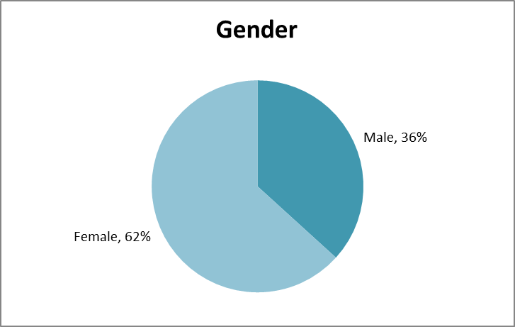
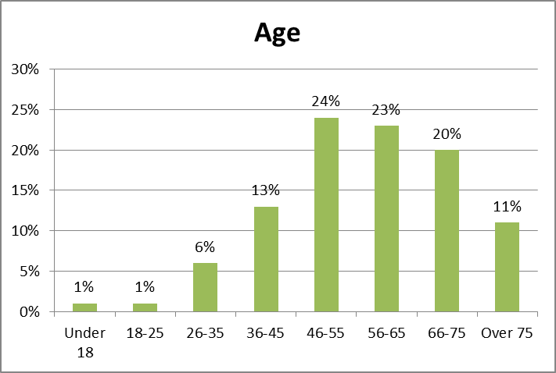
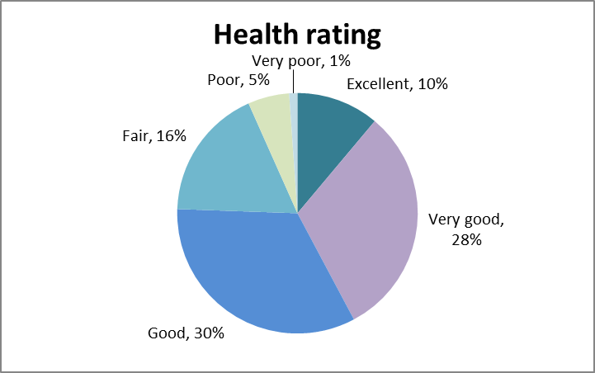
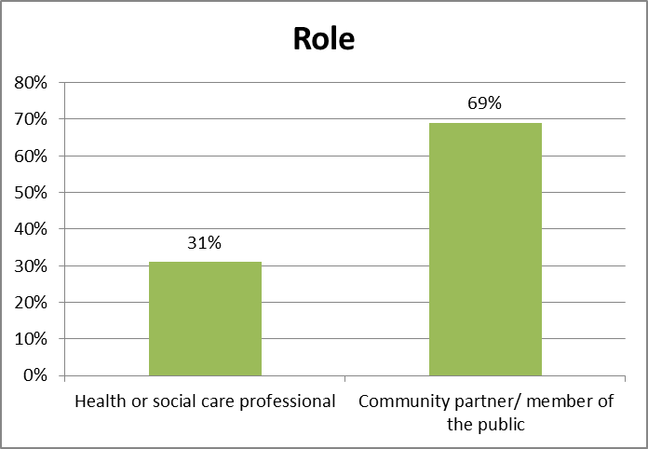
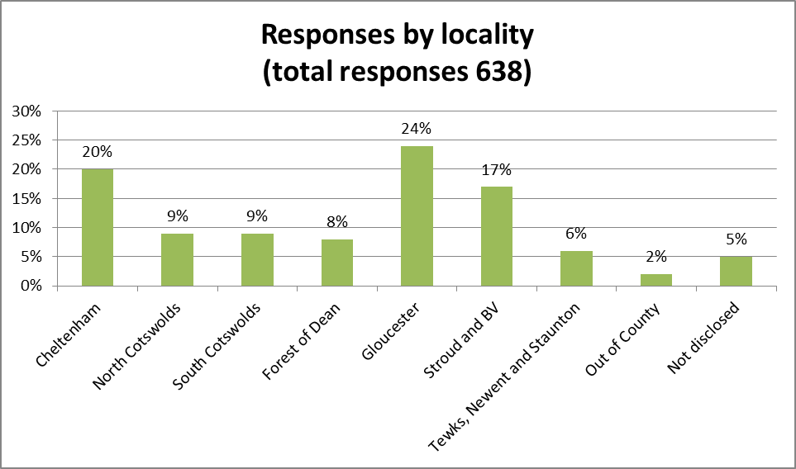
Collecting younger residents’ views
The STP partners wanted to hear the views of younger residents of the county. The STP Communications and Engagement Group commissioned the Chatterbox, an engagement activity provided by Treasure Seekers, a local charity.
The Chatterbox was set up during a busy shopping Saturday in Eastgate Shopping Centre in Gloucester and shoppers were invited to enter the box and record their views on a range of STP topics. The objective of attracting feedback from a younger demographic was achieved as shown below.
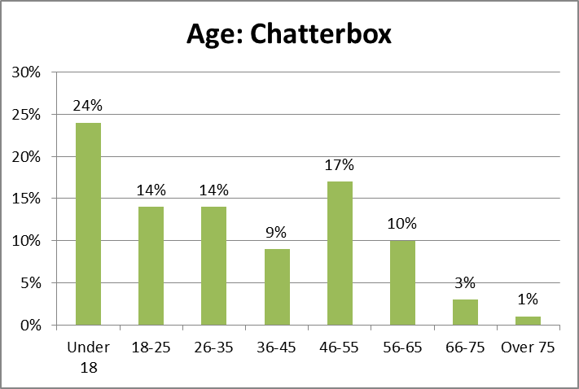

Part 4
8. Quantitative and Qualitative feedback
In this section feedback from the STP engagement is set out. The feedback presented in Part 4 related to all survey feedback received. 638 completed surveys were received during the engagement period.

8.1 Quantitative feedback
The STP engagement survey included a series of five questions together with space for respondents to make further comments about the STP, to state what is important to them and to share ideas for transforming health and care services in Gloucestershire.

Question 1: As part of our Joining up your Care (JUYC) conversations in 2014, people agreed a set of principles. Do you think these still apply today?

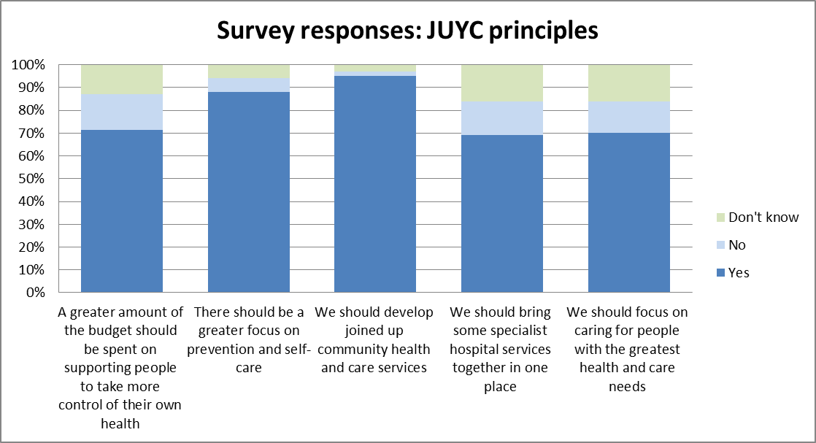
Question 2: When resources are limited, we think the NHS and care services need to prioritise them.
Rank the following in order of importance, where 1 is the most important to you.
Which is the most important?
1st Caring for people in their own homes, or near to where they live
2nd Investing in health promotion – helping people to stay well for longer
3rd Prioritising the funding of drugs and treatments that have the greatest health benefit for the population
4th Treating people with the most complicated health conditions
5th Funding additional community services by reducing the number of hospital beds in the future

Question 3: We think hospital beds should be available for patients requiring medical and nursing care that cannot be provided elsewhere.
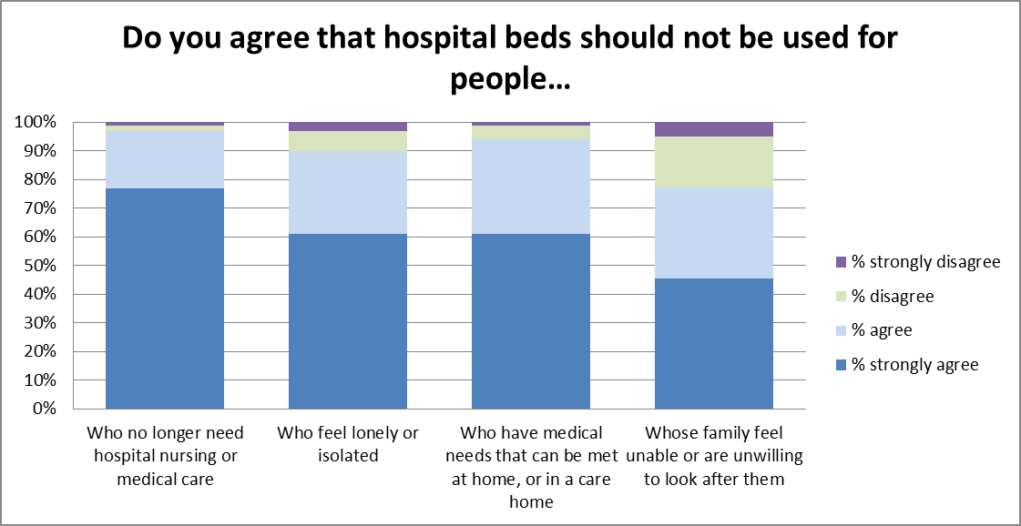
Question 4: If you need to see a specialist (e.g. at an outpatient clinic), the most important thing to you would be: (choose one of the following)
This question was asked both in the STP survey and in the Chatterbox
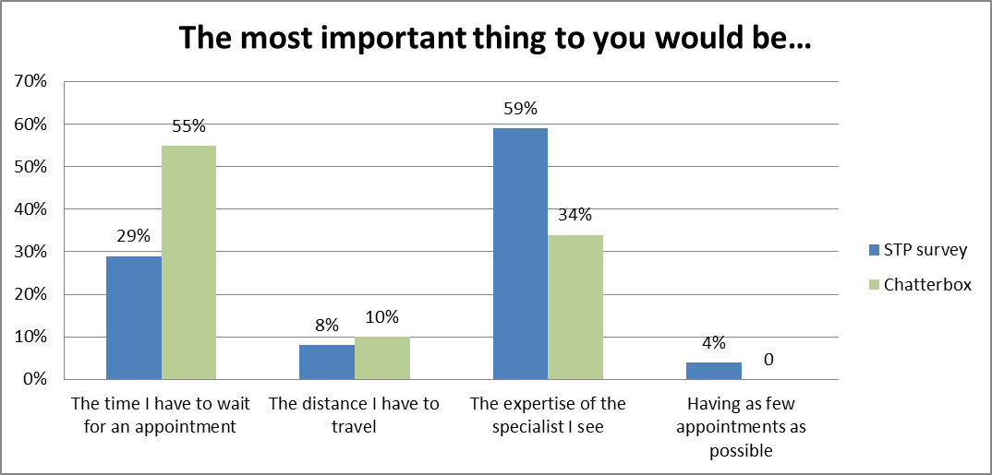

Question 5: If you need urgent or emergency care services, the most important thing to you would be: (choose one of the following)
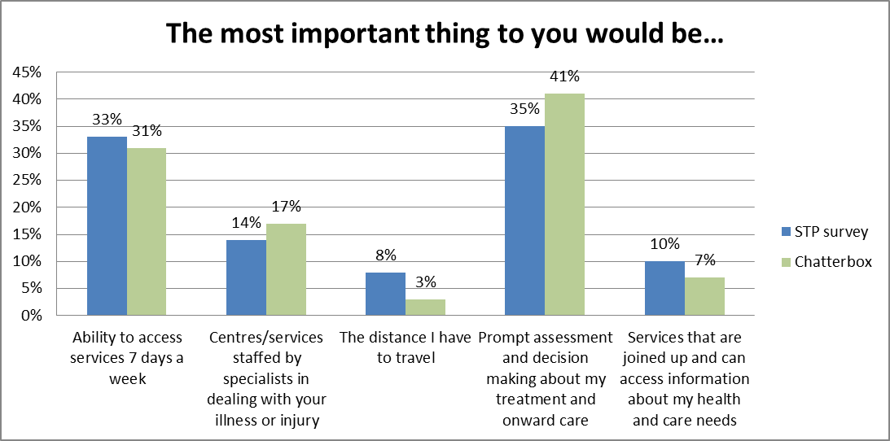
8.2 Qualitative feedback
The qualitative feedback have been grouped into a series of themes, starting with the first STP programme, Enabling Active Communities and progressing to overarching themes relating to topics such as resources and use of technology. This individual feedback is included below in plain text.
In addition to survey feedback, several respondents sent fuller written responses, which have also been grouped under the same themes. The nature of these comments is that they are more specific but less frequently occurring in some cases referred to by a single individual or a group. This individual feedback is included in italics below.
Qualitative feedback was also recorded from public drop ins. This feedback from visitors is included in bold below.
Finally, feedback was collected from participants at events focussing in particular on Urgent Care and the ‘People and Place’ community model. The feedback from these events is included below in underlined text.

Enabling Active Communities
- Health promotion/education are key to enable people to take responsibility for their health
- Support people with long term conditions to self-manage
- Use our local community / environment to encourage healthy lifestyles
- Appreciate the challenges, aim to achieve healthier pop. which is less dependent, with strong community networks
- positive comments about the impact of social prescribing
- Prevention requires longer term investment
- Parish Councils keen to promote local good health
- STPs cannot be successful in isolation from wider determinants of health
- Educate for healthier lifestyles in schools
- Pleased to see a commitment to make it easier for the VCS to work in partnership with us: one of the things sometimes struggle with is knowing where the power lies and where the routes "in" to greater partnership working are
- Use retired staff to promote jobs in health in care to schools
- Build more bungalows / more social housing provision for the elderly
- Concern re distance for rural communities to travel to centres of excellence
- Support for community hospitals
- Isolation of older residents in small rural communities and support for neighbours and smaller home care providers
- Healthy walks good for socialisation
- VCS need longer term financial support to support this agenda
- More self-care /lifestyle information and support needed
- Use the environmental infrastructure more to improve health and wellbeing

One Place, One Budget, One System (including Urgent Care)
- Improved access to GP services
- “Joined up” services across healthcare providers and social care, resulting in improved care in the community
- Use of existing hospital sites (requests for reinstating Cheltenham Emergency Department to pre-2014 arrangements, recognition that specialist services should not be provided at both Cheltenham General and Gloucestershire Royal Hospitals sites, challenge to maximise use of community hospitals
- Positive about the creation of centres of excellence
- Positive about the potential to provide diagnostics, minor surgery, outpatients closer to home
- Direct to specialists more efficiently through ED e.g. eye care specialists
- Anxiety regarding 30,000 model aligning with all natural communities (FoD)
- Community opportunities (e.g. social prescribing) are low cost not no cost, reconsider only funding hubs
- Establish a convalescent/ rehabilitation hospital (consider charging for hotel services)
- Convalescent beds previously provided in community hospitals – bed numbers reduced
- Recognition that Information Technology (IT) can be an enabler, concern regarding potential increased marginalisation of some groups
- Re-introduce GP Out of Hours, but do not extend surgery opening hours
- Rapid Response effective way to provide emergency care
- 111 poor reputation, so go to A&E
- Need a GP in A&E
- Community hospitals good location for urgent care hubs – make better use of nurses, no need to see a doctor.
- Pharmacies don’t understand minor-ailment scheme
- Don’t blame old people for ‘bed blocking’
- Long wait for biopsy result (86 days)
- Long wait for GP appointments
- Difficulty cancelling GP appointment – simpler system needed
- Duplication between GP and Hospital appointments
- Insufficient care packages in place to support discharge from hospital
- Cosmetic procedures should not be NHS funded
- Use community hospitals for rehabilitation and wider range of outpatients
- Too few community hospital beds
- Increase minor ops in GP practices (increased access for older people)
- Support for local primary care service – telephone appointments (+)ive
- OOC inpatient treatment superior (Banbury)
- Year long wait for hernia operation
- Concern re future of Stroud Maternity Hospital

Urgent Care
Key issues
- Where are the senior decision makers in hub and spoke? Experience at weekend, patient flow slows down
- Avoid spreading clinical expertise too thinly
- Be clear about roles and functions Avoid another layer of bureaucracy
- Cluster identity positive development but avoid silo mentality
- Reputation population/media:
- GPs involvement positive experience
- Large hospitals negative experience
- NHS 111 negative experience
- NHS 111 needs to be better promoted and meet the challenge
- GAP: Transition children/adult
- GAP: Mental Health / LD
- Public health priorities must be aligned with urgent care priorities
Key messages
- Clinical hub and spoke model can be a “good offer”
- Emphasize that solution is current services better integrated
- Be clear what is different about streamlining assessment. Be clear on terminology.
- Urgent care is accessible without an appointment!
- Transform and reinvent don’t make do and mend
- Change in culture and simplicity of access
- Urgent care an extension of primary care rather than pre-ED
- Public understand difference between seeing a GP
- ED staff to be prepared to redirect away
- Paid caring as a profession needs higher status

The ‘People and Place’ community model
What works well now:
- lots of community/VCS services
- Telephone helplines: Silverline/Cruse
- Social prescribing
- End of life support
- MIIU
- Community Active Balance Classes
What does not work well now:
- Lack of information sharing
- Low awareness of local services available
- Need to create culture of enabling patients
- Overprescribing without proper consultation with patients
- Emergency services unable to find residences
What could be improved in the future:
- Having a key worker
- Introduce more information-based services
- Improve new staff induction
- Greater use of patient passport
- Ensure regular reviews
- More regular medicine reviews
- Specialist to visit community sites more
- Better NHS / Social care coordination
- Care should be seamless to the patient

Rehabilitation
- Better use of community hospitals/respite/convalescence
- Support for carers

Beds
- Concerns re: delayed transfer of care, often referred to by respondents as bed-blocking and lack of “real” alternatives to a hospital bed
- Reducing the number of hospital beds “is not the answer”
- Insufficient hospital beds across the county currently
Clinical Programme Approach
- Increased focus on mental health services needed
- Consider patient choice – option to contribute to cost of “extras”(extras referred to specifically: additional physiotherapy support and orthotics)
- No mention of muscular dystrophy in respiratory/physio
- Good to see a commitment to better mental illness support
- Involve community pharmacies more
- Greater focus on face to face rather than equipment (MDT)
- Automatic physio referral following joint replacement needed
- Greater investment in primary mental health needed

Clinical Variation (small numbers)
- Support to reduce waste/recycle some products
- Restrict prescriptions for “over the counter” medication
- Medicines Waste – consider options, don’t flush
- Educate people in what constitutes an emergency
- Over-prescribing by GPs – much wasted
- Inconsistent prescribing of incontinence products
- Understand the Gluten Free decision – hope stocks will rise and prices fall
- Create IT link (smart code) between wards and community pharmacies (no need to wait for take home meds)

Use of technology (small numbers)
- Improved IT/access to patient records
- Support use of new technologies/drugs/treatments
- Focus on compatibility of IT

Cross cutting / Resources / Transport
- Increased funding needed across the NHS and social care
- Support workforce – upskill, engage and “educate” staff about new ways of working/services
- Government funding for NHS needs to increase: local lobbying required
- STP appears to be a positive shopping list – but it is required to save money
- Support for STP
- Question: is a five year planning cycle too short? True transformation will require an extended period. Need to avoid a 5 year circle of change.
- Resist organisational restructuring
- Changes make sense, but need a reality check:
- Invest in community before disinvesting in hospitals
- NHS needs to be business efficient
- Survey question (Q3) unfair/judgemental regarding family responsibility to care. Publicly funded services paid for by taxpayers (those in work)
- Listen and learn from complaints
- Develop a workforce strategic plan
- Support for staff to care crucial, current ‘fire-fighting’ unsustainable over a long period.
- More training to recognises specialist conditions e.g. Duchenne’s
- Consider key worker housing for NHS/Care staff
- Foreign staff to demonstrate adequate level of spoken/written English
- Consideration of key worker housing for NHS/Care staff to attract workforce to expensive rural areas
- Explore cross-sectoral working to achieve better outcomes at lower cost on joint solutions
- Shift patterns to reflect 24/7 need
- Fewer managers, more clinicians
- Community care worker training legislated
- Celebrate local assets that do not require travel
- Greater focus on active travel required, pay attention to infrastructure to support this
- Support the principle of Locality working as lack of transport to access services is a huge barrier faced by many people
- Increase tax to support NHS
- How will impact of GHNHSFT deficit be shared across the health and care system
- Anxiety re privatisation of NHS
- Immigration pressure on NHS services / health tourism
- Invest more in NHS/Social Care than city regeneration
- People should pay for food in hospital
- Charge for missed appointments
- Where are the cuts? Not clear in STP
- Focus on better procurement
- Too many managers
- Joint working across NHS and social care is positive
- Split acute hospital site inefficient
- Introduce parking disc system at Tewkesbury Hospital
- Lack of rural transport impacting on health and wellbeing in rural communities

Communications and engagement
- Criticism of the survey questions – leading / restrictive
- Plan is not easy to understand and very high level
- Engagement a tick box exercise – as individuals have different views – someone needs to decide!

Information or ideas that are considered to be ‘missing’ from the current STP
A ‘green’ thread:
- Recognition of natural /physical assets n Gloucestershire – currently STP very service provision oriented
- contribution nature and natural environment can make to health and wellbeing and reduce burden on services
- Normalise tackling health and environmental priorities together
- environment, green policies
- Gap between people and nature
- Social prescribing for mental health, nature based interventions
- sustainability also = avoidance of the depletion of natural resources
- Benefits of woodlands: recreation, amenity, health and wellbeing, water quality and flooding
Other areas identified as ‘missing’:
- Detailed financial, estates, bed number, workforce, projected deficits information
- How the NHS estate will managed sustainably (avoidance of the depletion of natural resources)
- Risk register
- Guarantees about what will not change
- Detail regarding cuts, expectation seems to be public will identify these
- Detail of investment in prevention (£20m)
- Detail of other funding e.g. pharma profits, tax avoidance
- Reducing inequalities, attention to equality - particularly Youth focus
- Sustainability in procurement
- Sustainability training for workforce (avoidance of the depletion of natural resources)

Part 5
9. Learning points for engagement and communication activities
As noted above, some feedback received related specifically to the STP communications and engagement process itself:
- Criticism of the survey questions. Several questions were described as leading or restrictive. The designs of structured surveys are often described in this way. We sought to compensate for this by encouraging respondents to provide qualitative feedback in their own words. This feedback is summarised in Part 4 of this report and published in full in the online appendices on the STP website.
- Plan is not easy to understand and very high level. We sought to provide detailed information in the full document and appendices and summary information in the Short Guide, which provides a more magazine style narrative. We encouraged people to come to public drop ins or events to discuss face to face; and many people took the opportunity to come along to talk with us. These discussions allowed for constructive debate and for questions to be asked and answered.
- Engagement a tick box exercise – as individuals have different views – someone needs to decide! During the engagement period we invited individuals to let us know if they wanted us to keep in touch with them to inform them of ways they have their say. We have recorded contact details for almost 200 local residents and it is our intention to be in touch with these individuals to discuss our plans further, obtain their views and listen to their advice about new ways in which we can communicate, involve, engage and consult local people in the future.

Future communications, engagement and consultation
Any proposals for significant change will be brought back to the public for formal consultation. The public, patients and carers, staff, community partners and elected representatives will have the opportunity to scrutinise new proposals. Ultimately it is the responsibility of STP partners together to pay attention to the feedback received during the STP Engagement period and to any subsequent public consultation and then make decisions about how to transform and maintain the sustainability of Gloucestershire’s health and care system.
References

NHS Clinical Commissioners; NHS Confederation; Centre for Public Scrutiny; National Voices. 2016. STP Checklist for governance and engagement
http://445oon4dhpii7gjvs2jih81q.wpengine.netdna-cdn.com/wp-content/uploads/2016/11/Final-NHSCC-STP-checklist-2016.pdf

NHS England. 2015. Engaging local people: A guide for local areas developing Sustainability and Transformation Plans
https://www.england.nhs.uk/wp-content/uploads/2016/09/engag-local-people-stps.pdf

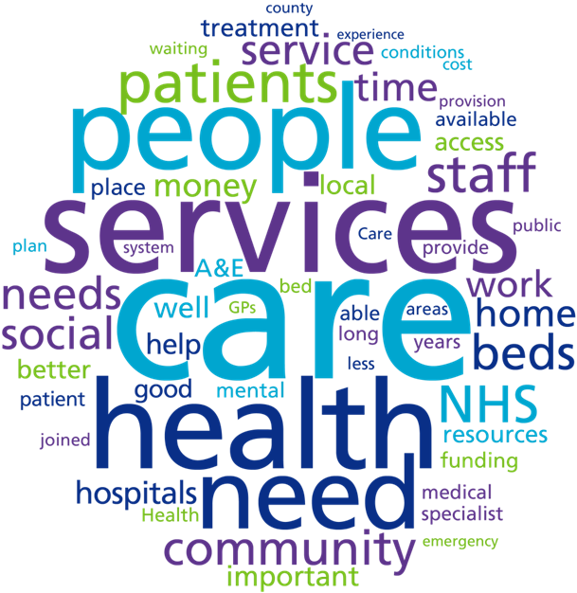
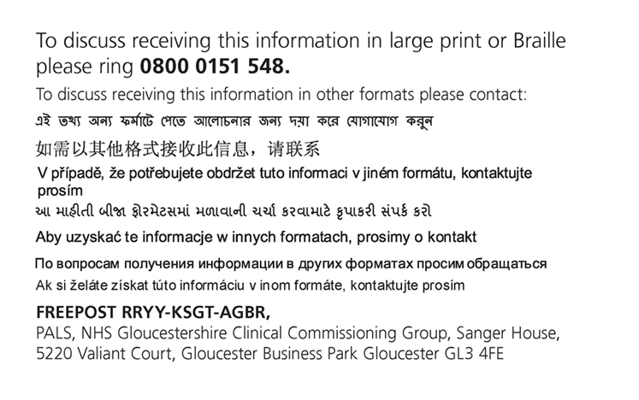
Print date: July 2017

