Gloucestershire Patient Participation Group (PPG) Network

21 April 2017 (10.00 – 12.30) Churchdown Community Centre,
Parton Road, Churchdown, GL3 2JH

AGENDA

10.00/10.05 Welcome and Programme for the Morning: Becky Parish, Gloucestershire Clinical Commissioning Group
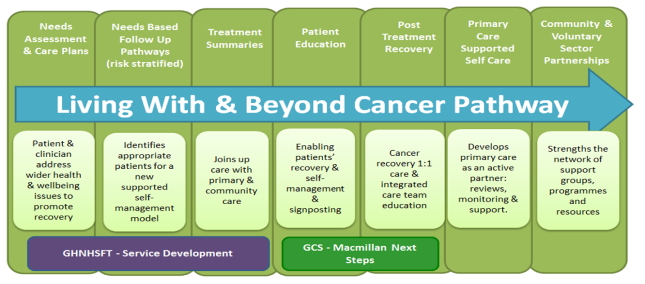

10.05 – 10.30 Introduction - Macmillan Next Steps:
Nikki Hawkins, Macmillan Consultant Cancer Practitioner

10.30 – 10.50 Living With and Beyond Cancer - Diet & Exercise
Jo Pain, Macmillan Specialist Community Dietitian &
Felice Marchetti, Macmillan Next Steps Community Senior Health Trainer

10.50 – 11.00 Question Time 1

11.00 – 11.20 Engaging Patients: Alan Warnock, Macmillan Engagement Coordinator

11.20 – 11.40 Holistic Needs Assessment (HNA) & Treatment Summaries:
Emma Mitchell, Macmillan HNA Project Manager

11.40 – 12.00 Patient Story: Paul Illott

12.00 – 12.10 Question Time 2

12.10 – 12.20 Cancer Patient Reference Group (PRG): Jenny Hepworth, Chair Cancer PRG

12.20/12.30 Sum up and Close: Becky Parish, Gloucestershire Clinical Commissioning Group

12.30/13.00 Informal networking time

Suggested dates for future meetings 2017:28 July and 27 October
Tea, coffee, water, biscuits and fruit provided. A hearing loop is installed at the meeting venue.

