**Patient Experience**

1. **The Producers: Chronic Pain**
   1. **Background**

Clinicians and commissioners identified that there was a significant difference in the uptake of support provision by men and women living with chronic pain. This applied particularly to men of working age who were unable to work due to their pain condition, and who were often socially isolated and experiencing depression

Through the CCG’s cultural commissioning programme, a men’s project was set up with the aim of exploring how taking part in creative activities may provide a means of supporting and managing the symptoms and effects of chronic pain. The project offered men a weekly group based woodcraft activity, in a community building. The project was supported by a male artist and provided an opportunity for participants to:

* re-frame their concept of self -identity
* learn new skills in a supportive activity based environment
* explore an arts based approach with a targeted cohort of participants, in conjunction with clinicians
  1. **Local engagement**

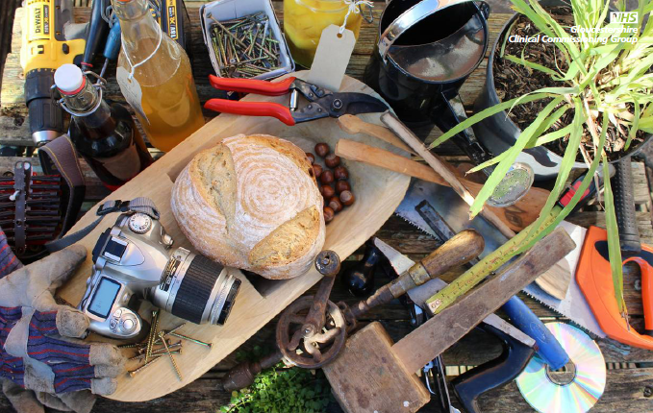Five arts organisations applied to deliver the project, and applications were reviewed by a panel that included two men with lived experience of pain, one of whom had also undertaken the NHS pain management programme offered by Gloucester Royal Hospital pain team. This patient went on to co-design and deliver the successful art organisation’s proposed project with the lead artist, overseen by a co-production team including clinicians, commissioners, the lead patient and lead artist. Together, the lead artist and lead patient offered taster sessions in Gloucester Royal Hospital to people on the pain management programme, in order to encourage other men to join what they called The Producer’s project. Once they had referrals to the project, they worked to co-design and co-produce the creative activities with the participants themselves building on the interests, strengths and requests of the men in the group.

*Illustration used to promote the sessions*

* 1. **What we learned/outcome**

Although the project was challenging in terms of the time required to genuinely co-produce and ensure that the male patients were central to the design & delivery of the project, this was far outweighed by the benefits.

Participants reported:

* an increase in capacity to live alongside their pain;
* less usage of pain medication;
* less reliance on anti-depressants;
* an increased sense of self-worth and purpose;
* better relationships; and
* less sense of hopelessness.

The participants also described a sense of trust, empathy & mutual support that had developed through the co-production process.

Three participants presented at a South West regional arts & health conference in Devon. They shared with delegates the impact of the project not just in terms of the creative activity, but also the impact of having been able to design, develop and sustain the project themselves.

**1.4 Next steps**

Following the end of the pilot project after 16 weeks, the group set themselves up as a self-sustaining community group with a bank account. They continue to meet on a weekly basis in the same location, and are currently advising the CCG regarding the development of a countywide ‘arts on prescription’ offer for people living with chronic pain.

**2.**

1. **Primary Care Patient Advice and Liaison Service**

**2.1 Background**

NHS Gloucestershire CCG (GCCG) was established in 2013. At that time GCCG had a Patient Advice and Liaison Service (PALS) transferred from the Gloucestershire Primary Care Trust, providing advice and support to local people in relation to problems they might be experiencing relating to commissioning decisions or primary care services. However, in 2013 responsibility for commissioning primary care services became the responsibility of NHS England and a decision was taken nationally for a central all-England PALS to be set up to handle all primary care enquiries.

A local decision was required regarding handling of PALS enquiries related to our residents’ experience of local primary care services.

GCCG is a membership organisation made up of 80 GP practices serving diverse populations across Gloucestershire. Member practices, represented by nominated GPs sitting on a Governing Body, considered the NHS England offer but took the decision in 2013 to invest in the continuity of a local PALS service; which also offer a formal commissioning complaints handling service; maintaining a responsive local offer for Gloucestershire residents. This was unusual at that time, when most CCGs ceased to offer local PALS, relying instead upon the national call centre.

Member practices recognised at the earliest stage of the establishment of the CCG the importance of local resolution for patients’ concerns and the potential to learn from the experiences of local people collected through PALS.

**2.2 Local Experience**

Approximately 600 people contacted GCCG PALS in 2017. PALS Case studies have become a routine feature of Quality Reporting to the GCCG Integrated Governance and Quality Committee. The three examples below highlight the range of experiences shared with PALS and action taken:

**Case Study 1:** PALS supported a Patient who for a time was registered on the Potential Violent Patient (PVP) scheme. The Patient was finding it difficult to register with another GP Practice in his area. PALS supported the Patient with completing the forms, ID documents required and ensuring the Practice had received these to complete successful registration.

**Case Study 2:** A Patient contacted PALS to ask if we would help with their concerns about their GP Practice. The Patient had been diagnosed with Cancer stage 4 three years previously. They had a GP at the Practice who had been very supportive, making sure tests/appointments/reviews were followed and always kept them informed of what was happening. When this GP left to go on maternity leave the Patient felt that the support stopped. They did not have a nominated named GP and felt their ongoing care and health were compromised. Before Christmas the Patient had undergone tests and it had been recommended that they receive a course of bone density injections. Five weeks on the Patient was still waiting and the Practice had not actioned any treatment. After regularly contacting the Practice the Patient eventually contacted PALS for advice with the option of possibly registering with a new practice if their experience did not improve.

PALS agreed to speak with the Practice Manager to share the Patient’s concerns. This led to the Practice organising a named GP for the continuation of the patient’s care, until their previous nominated GP returned. Now, when calling the Practice for appointments, the patients’ records are flagged as a priority. The Patient thanked PALS for their support and that the original option to register at another Practice was no longer necessary.

**Case Study 3:** PALS received a formal complaint that crossed-over several services: Personal Health Budgets (PHB CCG), Gloucestershire Care Services (GCS, District Nursing) and Gloucestershire County Council (GCC, Social Services). PALS contacted each of the service departments and coordinated a meeting with both GCS and GCC Complaint Managers to talk through the best way forward and agree which organisation would lead the complaint management. Before this meeting took place, PALS contacted the complainant, listened to their concerns and discussed ways to resolve the matter. PALS worked closely with the PHB team and the complainant to put actions in place within a week to resolve their concerns relating to GCCG responsibilities. The complainant reported that they felt fully supported and satisfied that things had been resolved so quickly by the CCG. Both GCS and GCC continue to address their outstanding items through their formal complaints process. PALS and the PHB team were thanked by the complainant for *“being so supportive and so quick to sort out”.*

**2.3 What we learned/outcome**

As the three examples above demonstrate we have learned that there was benefit in retaining a local PALS service for commissioning and primary care in Gloucestershire. Patients are acknowledging that PALS intervention has helped them and they have felt supported at an earlier stage, negating the need for formal complaints to be made. It is worth noting that the in 2015, GCCG took back delegated responsibility for commissioning of primary medical services from NHS England, vindicating the Governing Body’s earlier decision to retain local PALS.

**2.4 Next steps**

Opportunities in 2018 to be explored include introduction of a more systematic evaluation of the experience of users of the PALS service and collection of more detailed demographic information about those individuals who proactively access the service, based on the NHS England Surveying complainants Toolkit <https://www.england.nhs.uk/surveying-complainants/>. This will enable us to develop targeted communication and promotional materials to reach groups which may currently not be aware of, or are choosing not to access, the service.

1. **Increasing self-management amongst patients with musculoskeletal (MSK) conditions**

**3.1 Background to the project**

This project aims to improve patients’ confidence of self-managing their minor aches and pains and to increase the number of patients self-referring into Core physio, with the objective of reducing the number of GP appointments being requested for MSK conditions.

**3.2 Local Engagement**

****The project manager, working with the CCG Communications Team, designed a range of posters to spread this message across Gloucestershire. Three posters were designed and shared with the clinicians working in the service. However, it was felt that user feedback would be more beneficial.

As aches and pains can affect anyone it occurred to us that we already had a large staff audience who could offer quick feedback within the CCG. With the offer of cake, a drop in session was arranged to encourage anyone to come by and give an opinion on each poster from a user perspective.

**3.3 What we learned/outcome**

A good range of feedback was received from staff about many different aspects that had not even crossed our minds, such as the language used, colour schemes, the imaging and the use of QR codes. Following this we collated all the feedback from the 3 posters. The people who attended the session indicated they were happy to continue to offer feedback on the developments virtually.

**3.4 Next steps**

After the initial feedback from staff, revised versions of the posters were shared with over 50 patient representatives attending the Countywide Patient Participation Network.