Fast Track Pathway Tool for NHS Continuing Healthcare

October 2018 (Revised)
Published March 2018
DH ID box
Title: Fast Track Pathway Tool for NHS Continuing Healthcare
Author:
SCLGCP-SCP 25370
Document Purpose:
Guidance
Publication date:
1 March 2018
Target audience:
Health and social care professionals
Public
Contact details:
NHS Continuing Healthcare and NHS-funded Nursing Care team
Department of Health and Social Care
39 Victoria Street
London SW1H 0EU

You may re-use the text of this document (not including logos) free of charge in any format or medium, under the terms of the Open Government Licence. To view this licence, visit www.nationalarchives.gov.uk/doc/open-government-licence/
© Crown copyright 2016
Published to gov.uk, in PDF format only.
www.gov.uk/dh
- This revised tool accompanies the National Framework for NHS Continuing Healthcare and NHS-funded Nursing Care 2018 (the National Framework) and the NHS Continuing Healthcare Checklist (the Checklist) and the Decision Support Tool for NHS Continuing Healthcare (DST). This is the version that Clinical Commissioning Groups (CCGs) and NHS England should use from 1st October 2018. Please use the tool in conjunction with the National Framework, with particular reference to paragraphs 216-245.
- Standing Rules Regulations have been issued under the National Health Service Act 2006 and directions are issued under the Local Authority Social Services Act 1970 in relation to the National Framework.

What is the Fast Track Pathway Tool?
- Individuals with a rapidly deteriorating condition that may be entering a terminal phase, may require ‘fast tracking’ for immediate provision of NHS Continuing Healthcare.
- The intention of the Fast Track Pathway is that it should identify individuals who need to access NHS Continuing Healthcare quickly, with minimum delay, and with no requirement to complete the Checklist or the Decision Support Tool (DST). Therefore, the completed Fast Track Pathway Tool, which clearly evidences that an individual is both rapidly deteriorating and may be entering terminal phase, is in itself sufficient to establish eligibility.

Who can complete the Fast Track Pathway Tool?
- In Fast Track cases, the Standing Rules state that it is an ‘appropriate clinician’ who determines that the individual has a primary health need. The CCG must therefore determine that the individual is eligible for NHS Continuing Healthcare and should respond promptly and positively to ensure that the appropriate funding and care arrangements are in place without delay.
- An ‘appropriate clinician’ is defined as a person who is:
a) responsible for the diagnosis, treatment or care of the individual under the 2006 Act in respect of whom a Fast Track Pathway Tool is being completed; and

b) a registered nurse or a registered medical practitioner.
- The ‘appropriate clinician’ should be knowledgeable about the individual’s health needs, diagnosis, treatment or care and be able to provide an assessment of why the individual meets the Fast Track Pathway Tool criteria.
- An ‘appropriate clinician’ can include clinicians employed in voluntary and independent sector organisations that have a specialist role in end of life needs (for example, hospices), provided they are offering services pursuant to the 2006 Act.
- Others, who are not approved clinicians as defined above, but are involved in supporting those with end of life needs, (including those in wider voluntary and independent sector organisations) may identify the fact that the individual has needs for which use of the Fast Track Pathway Tool might be appropriate. They should contact the appropriate clinician who is responsible for the diagnosis, care or treatment of the individual and ask for consideration to be given to completion of the Fast Track Pathway Tool.

When should the Fast Track Pathway Tool be used?
- The Fast Track Pathway Tool must only be used when the individual has a rapidly deteriorating condition and may be entering a terminal phase.
- The Fast Track Pathway Tool replaces the need for the Checklist and the Decision Support Tool (DST) to be completed. However, a Fast Track Pathway Tool can also be completed after the Checklist if it becomes apparent at that point that the Fast Track criteria are met.
- The Fast Track Pathway Tool can be used in any setting. This includes where such support is required for individuals who are already in their own home or are in a care home and wish to remain there. It could also be used in other settings, such as hospices.
- If an individual meets the criteria for the use of the Fast Track Pathway Tool then the Tool should be completed even if an individual is already receiving a care package (other than one already fully funded by the NHS) which could still meet their needs. This is important because the individual may at present be funding their own care or the local authority may be funding (and/or charging) when the NHS should now be funding the care in full.
- The completed Fast Track Pathway Tool should be supported by a prognosis, where available. However, strict time limits that base eligibility on a specified expected length of life remaining should not be imposed:
a) ‘rapidly deteriorating' should not be interpreted narrowly as only meaning an anticipated specific or short time frame of life remaining; and

b) ‘may be entering a terminal phase’ is not intended to be restrictive to only those situations where death is imminent.
It is the responsibility of the appropriate clinician to make a decision based on whether the individual’s needs meet the Fast Track criteria.
- An individual may at the time of consideration be demonstrating few symptoms yet the nature of the condition is such that it is clear that rapid deterioration is to be expected in the near future. In these cases it may be appropriate to use the Fast Track Pathway Tool in anticipation of those needs arising and agreeing the responsibilities and actions to be taken once they arise, or to plan an early review date to reconsider the situation. It is the responsibility of the appropriate clinician to base their decision on the facts of the individual’s case and healthcare needs at the time.

How should the Fast Track Pathway Tool be used?
- Appropriate clinicians should complete the attached fast-track documentation and set out how their knowledge, and evidence about the patient’s needs, leads them to conclude that the patient has a rapidly deteriorating condition and that the condition may be entering a terminal phase.
- It is helpful if an indication of how the individual presents in the current setting is included with the Fast Track Pathway Tool, along with the likely progression of the individual’s condition, including anticipated deterioration and how and when this may occur. However, CCGs should not require this information to be provided as a prerequisite for establishing entitlement to NHS Continuing Healthcare.
- Whilst the completed Fast Track Pathway Tool itself is sufficient to demonstrate eligibility, a care plan will be required which describes the immediate needs to be met and the patient’s preferences. This care plan should be provided with the Fast Track documentation, or as soon as practicable thereafter, in order for a CCG to commission appropriate care.
- The setting where an individual wishes to be supported as they approach the end of their life may be different to their current arrangements (e.g. even though they are currently in a care home setting they may wish to be supported in their family environment).The important issue is that (wherever possible) the individual concerned receives the support they need in their preferred place as soon as reasonably practicable, without having to go through the full process for consideration of NHS Continuing Healthcare eligibility.

How should the individual/representative be involved?
- The overall Fast Track process should be carefully and sensitively explained to the individual and (where appropriate) their representative.
- It is also important for the CCG to know what the individual or their representative have been advised about their condition and prognosis and how they have been involved in agreeing the end of life care pathway.
- Clinicians completing the Fast Track Pathway Tool should make the individual aware that their needs may be subject to a review, and accordingly that the funding stream may change subject to the outcome of the review.

Careful decision-making is essential in order to avoid the undue distress that might result from changes in NHS Continuing Healthcare eligibility within a very short period of time

Fast Track Pathway Tool for NHS Continuing Healthcare
To enable immediate provision of a package of NHS Continuing Healthcare

Date of completion of the Fast Track Pathway Tool _____________________________

Name D.O.B.

NHS number:

Permanent address and Current location (i.e. name of
telephone number hospital ward etc.)

Gender _____________________________

Please ensure that the equality monitoring form at the end of the Fast Track Pathway Tool is completed
Contact details of referring clinician (name, role, organisation, telephone number, email address)

(please turn over)

Fast Track Pathway Tool for NHS Continuing Healthcare
To enable immediate provision of a package of NHS Continuing Healthcare
The individual fulfils the following criterion:
He or she has a rapidly deteriorating condition and the condition may be entering a terminal phase. For the purposes of Fast Track eligibility this constitutes a primary health need. No other test is required.
Brief outline of reasons for the fast-tracking recommendation:
Please set out below the details of how your knowledge and evidence of the patient’s needs mean that you consider that they fulfil the above criterion. This may include evidence from assessments, diagnosis, prognosis where these are available, together with details of both immediate and anticipated future needs and any deterioration that is present or expected.
(continue overleaf)
Please continue on separate sheet where needed. This should include the patient’s name and NHS number, and also be signed and dated by the referring clinician.

I, an appropriate clinician, confirm that I have explained to the individual/their representative (tick as appropriate):

the reasons why a Fast Track application for NHS Continuing Healthcare has been made to the CCG.

that the purpose of this is to enable the individual’s needs to be urgently met as they have a rapidly deteriorating condition which may be entering a terminal phase.

that their needs may be subject to a review, and accordingly that the funding stream may change subject to the outcome of the review
Please ensure this form is sent directly to the CCG without delay
Name and signature of referring clinician Date

Name and signature confirming approval by CCG Date

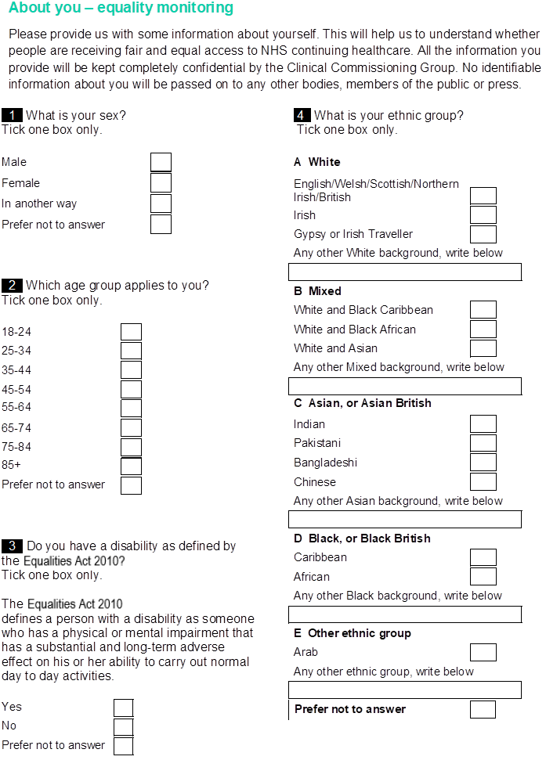

For the purposes of this document references to CCGs after this point also include NHS England where it is responsible for commissioning services for an individual for whom a Fast Track Pathway Tool has been completed.
The National Health Service Commissioning Board and Clinical Commissioning Groups (Responsibilities and Standing Rules) Regulations 2012 (“the Standing Rules”)
National Health Service Act 2006 (c.41), (“the 2006 Act”).

