Frailty Information Bus and Frailty Wheel
Background to the project
The CCG is using its Information Bus to host a frailty roadshow around the county, providing resources to increase knowledge and confidence in manage frailty.
The specific areas were chosen to reflect SWAST data regarding the highest admission rates for people with frailty: Cirencester, Stroud, Bishops Cleeve, Coleford, Cinderford and Lydney. Further venues will be booked for 2019.
Key messages for the bus include:
- Frailty is often a combination of long-term conditions that can reduce your ability to manage well, and increase the likelihood of you going into hospital unexpectedly;
- There are different degrees of frailty - it is possible to recognise how frail you are;
- Frailty can be prevented, delayed and reversed through proactive action.
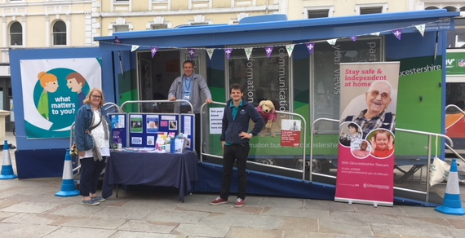
Local Engagement
The bus is specifically targeting people with disabilities and long-term conditions, and their families and friends.
Over the six sessions, the bus has representation from a large number of organisations/providers: Carers Glos, Age UK, Telecare, Community Wellbeing Services (GRCC & Independence Trust), Self-Management, 2gether, Shared Lives and the Fire Service in addition to CCG and Council staff.
Leaflets from the above organisations are available in addition to P3 Community Based Support (Cirencester) and Shared Lives as well as postcards for Your Circle. Healthwatch End of Life and Care Homes surveys are also being distributed.
A survey of 7 questions and a ‘myth buster’ leaflet to complement the survey will be used to help educate people about frailty as a condition. The leaflet is available on request in different languages.
In addition, a “frailty wheel” (see below) is being used as an educational tool to help people understand their level of frailty and ways of preventing it getting worse.
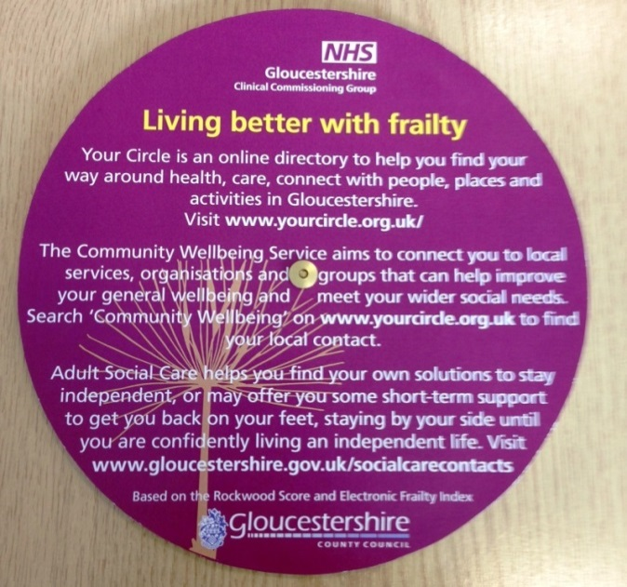
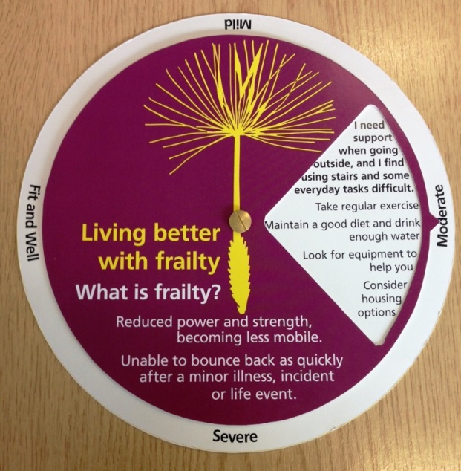

What we learned/outcome
Having a clinician on board has been beneficial as we have been able to offer blood pressure checks which has been popular and gives the opportunity to talk about improving wellbeing although, it is just a guide and where there are any concerns the individual will be referred to their own GP.
The bus has helped the CCG and partners to engage with those who have concerns about family members or would like to start thinking about themselves or family members own health and wellbeing and what they can do to prepare for the future.
Next Steps
We will now be reviewing the feedback received during these sessions and considering how we broaden our reach and share information across the county.

