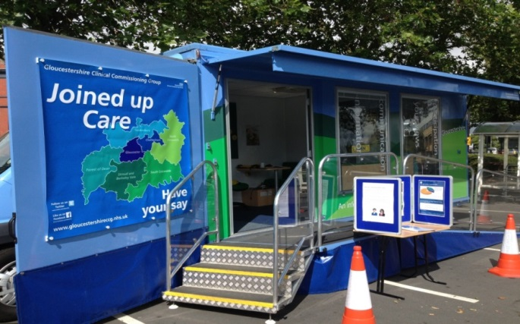

NHS GCCG Information Bus Schedule

The Information Bus provides the opportunity for people to come and talk to us about their queries or concerns on any health, social care or disability.

The schedule below lists dates the Information Bus will be out during March 2019. The focus of the Bus visit varies but we are always happy to receive your feedback on the NHS.

Date | Time | Venue | Topic
Thursday 7th March | 10am – 3pm | Pullman Place, Gloucester | No Smoking
Wednesday 13th March | 10am – 3pm | The Cross, Gloucester City Centre | Healthy Lifestyles Service – No Smoking
Monday 18th March | 10am – 3pm | Market Square, Stow on the Wold | NHS Long Term Plan
Tuesday 19th March | 10am – 3pm | Newent Town Centre | Building Your Circle
Wednesday 20th March | 10am – 3pm | Morton In Marsh Town Centre | Building Your Circle
Thursday 21st March | 10am – 3pm | Outside M&S, Cheltenham Town Centre | NHS Long Term Plan
Friday 22nd March | 10am – 2pm | Outside Winchcombe Library | Building Your Circle
Saturday 23rd March | 10am – 3pm | Tesco, Cirencester | Building Your Circle & NHS Long Term Plan
Monday 25th March | 10am – 3pm | Tesco, Tetbury | Building Your Circle
Tuesday 26th March | 10am – 3pm | Tesco, Stroud | NHS Long Term Plan
Wednesday 27th March | 10am – 2pm | Co-op, Cinderford | Building Your Circle
Thursday 28th March | 10am – 3pm | Morrisons, Tewkesbury | NHS Long Term Plan

