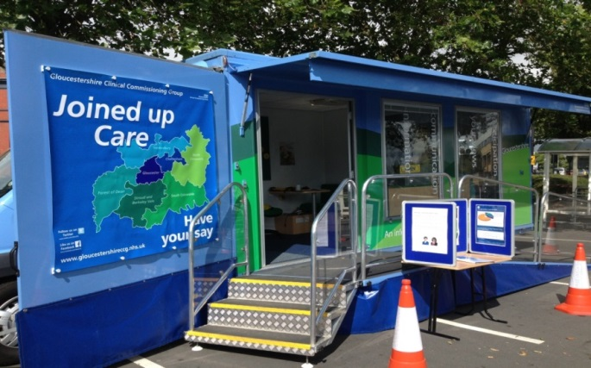

NHS GCCG Information Bus Schedule
The Information Bus provides the opportunity for people to come and talk to us about their queries or concerns on any health, social care or disability.

The schedule below lists dates the Information Bus will be out during April 2019. The focus of the Bus visit varies but we are always happy to receive your feedback on the NHS.

Date | Time | Venue | Topic
Monday 1st April | 10am – 3pm | Co-op, Cinderford | NHS Long Term Plan
Tuesday 2nd April | 10am – 3pm | The Cross, Gloucester City Centre | NHS Long Term Plan
Wednesday 3rd April | 10am – 3pm | The Cross, Gloucester City Centre | Family Safety Week
Thursday 4th April | 10am – 3pm | Outside M&S, Cheltenham Town Centre | Family Safety Week
Friday 5th April | 10am – 3pm | Morrisons, Tewkesbury | Fostering / Family Link
Monday 15th April | 10am – 3pm | Morrisons, Tewkesbury | NHS Long Term Plan
Tuesday 23rd April | 10am – 3pm | Budgens, Moreton in Marsh | NHS Long Term Plan
Wednesday 24th April | 10am – 3pm | Gloucester Cross | ICON – Shaken baby syndrome
Thursday 25th April | 10am – 3pm | Tesco, Cirencester | NHS Long Term Plan
Friday 26th April | 10am – 3pm | Coleford Clock Tower roundabout | ICON – Shaken baby syndrome
Saturday 27th April | 10am – 3pm | The Cross, Gloucester City Centre | NHS Long Term Plan
Monday 29th April | 10am – 3pm | Tewkesbury Morrisons | ICON – Shaken baby syndrome
Tuesday 30th April | 10am – 3pm | Coleford Clock Tower roundabout | Building Your Circle

