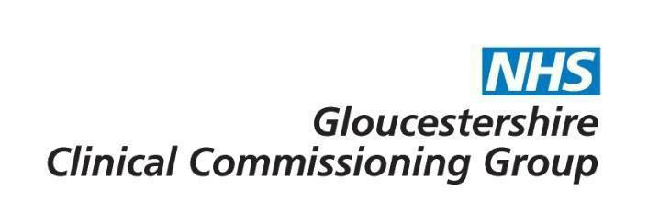

Breast reconstruction (cancer related indications and treatments)

Commissioning decision | The CCG will provide funding for cosmetic/reconstructive breast surgery following initial cancer surgery for patients who meet the criteria defined within this policy.

Policy Statement:
Cosmetic/reconstructive surgery to reduce discomfort and improve appearance following initial cancer surgery will be funded if it involves a maximum of four procedures . This includes any surgery to the contralateral side.

Scar revision will be funded where the patient is unable to wear a prosthesis, or has other significant problems related to previous cancer surgery.

Procedures requested beyond the fifth or subsequent procedures will require funding approval from Gloucestershire Clinical Commissioning Group. All cases prior to August 2015 are exempt.
Rationale:
Four procedures are considered to be the usual maximum required to achieve acceptable results.

Plain English Summary:
In cancer patients, reconstructive surgery, including breast implants, is often necessary following initial cancer surgery, particularly in order to reconstruct the breast mound after a mastectomy (the surgical removal of the breast, often used to treat breast cancer). In some cases further surgical procedures may be required to achieve an acceptable result, and some patients may choose to delay this surgery for a number of years after the initial cancer surgery.

Local doctors have agreed that generally 4 surgical procedures should be sufficient to achieve a good result (to include contralateral surgery if required), and that further procedures beyond this generally will not deliver sufficient benefit to justify the cost and risk of surgery. However, if your doctor believes that you would benefit from additional surgeries beyond this, the CCG will consider applications for funding on a case by case basis.
Evidence base:
Information for commissioners of Plastic Surgery - referrals and guidelines in Plastic Surgery
Modernisation Agency (Action on Plastic Surgery) (2005)

Link to application form – Prior Approval Application Form (for additional procedures outside of criteria)
For further information please contact GLCCG.IFR@nhs.net

Date of publication | 1st August 2015
Policy review date | June 2022

Consultation
Consultee | Date
Planned Care Programme Board | 31st March 2015 (virtual)
CCG Governing Body Development Session | 4th June 2015
GHNHSFT (via General Manager/Head of Contracts) | 18/05/2015 – 29/05/2015
GP Membership (via CCG Live/What’s New This Week) | 06/05/2015 – 05/06/2015
Has the consultation included patient representatives? | No

Policy sign off
Reviewing Body | Date of review
Effective Clinical Commissioning Policy Group | 8th November 2016
Integrated Governance and Quality Committee | 18th June 2015

Version Control

Version No | Type of Change | Date | Description of Change
V2 | Minor amendment | 14.5.19 | Removal of 5 year time limit as endorsed by the Cancer CPG Jan 2019. Minor change agreed by M Andrews-Evans & M Walkingshaw 14.5.19
V3 | Minor amendment | 11.6.19 | Policy review date changed to June 2022

