Patient Experience
1 Real-life/patient stories
Real-life stories provide powerful evidence to help us develop services that are responsive to the needs of our local communities. A range of patient stories are available on the CCG website at: http://www.gloucestershireccg.nhs.uk/feedback/

2. Programme/Project Title: Wheelchair Services
2.1 Background to the project
The assessment element of the Gloucestershire Specialist Wheelchair Service (GSWS) is provided by Gloucestershire Care Services NHS Trust (GCS). Provision and maintenance of equipment prescribed by GSWS is delivered by NHS North Bristol Trust (NBT).
GCCG and GCS have jointly reviewed the current service and developed a Service Improvement Plan. As part of this work, a small pilot was established to provide seat risers to service users who had been assessed by GSWS.
‘Out and about Wheelchairs as part of a whole-systems approach to independence’ produced jointly by The Department of Health and Care Services Improvement Partnership 2006 establishes the importance of good wheelchair provision:
‘Investment in an appropriate wheelchair can improve quality of life and well-being through increased independence and opportunities to work and participate in society. This can result in reduced need for care services and less dependence on benefits.’
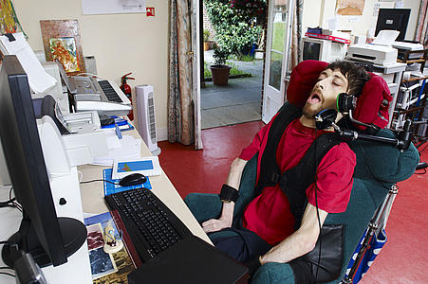

The Better Care Fund exemplifies the Wheelchair Assessment Service as a system enabler and an area where integrated working and person centred assessment of service user’s needs promotes independence and produces better outcomes.
The pilot aimed to:
- Promote provision of equipment to maximise independence, which is currently out of the scope of Wheelchair Service to provide.
- Gain qualitative evidence to support wider benefits of extension of equipment provision to individuals and demonstrate benefits and outcomes.
- Promote holistic assessment and advice on the provision of equipment for work, education or leisure when people fall into categories outside of the current criteria.
- Ensure the Service Improvement Plan was informed by Service User experience and direct involvement and decision making.
- Monitor costings to help inform commissioning decisions re: extended provision.
- Enable collaborative working between the commissioner, provider, supplier, third sector and service user to improve outcomes for service users and achieve best value.

2.2 Local Engagement
Local patients, carers and stakeholders were invited to a share their views at a listening event held at the Independent Living Centre in Cheltenham. Views already collected from service users were posted around the walls of the main room and attendees were invited to comment on these. The engagement team supported the event and documented the feedback received.
As part of the seat riser pilot, the engagement team also carried out a number of structured telephone interviews with service user. The information collected has informed the Service Improvement Plan.

2.3 What we learned/outcome
Feedback from the listening event and telephone interviews was taken into account in the Service Improvement Plan. Key themes included:
- Staff are really helpful and knowledgeable – good continuity of care;
- Service needs more capacity – reflected in wait times for appointments;
- Important to assess the environment that the wheelchair will be used in;
- Not always clear how to access the service.

2.4 The next steps
The pilot has now concluded. Patient feedback and views will inform further development of future services.

