Primary care
1. Programme/Project Title: The Family: South Cotswold Locality Frailty Project
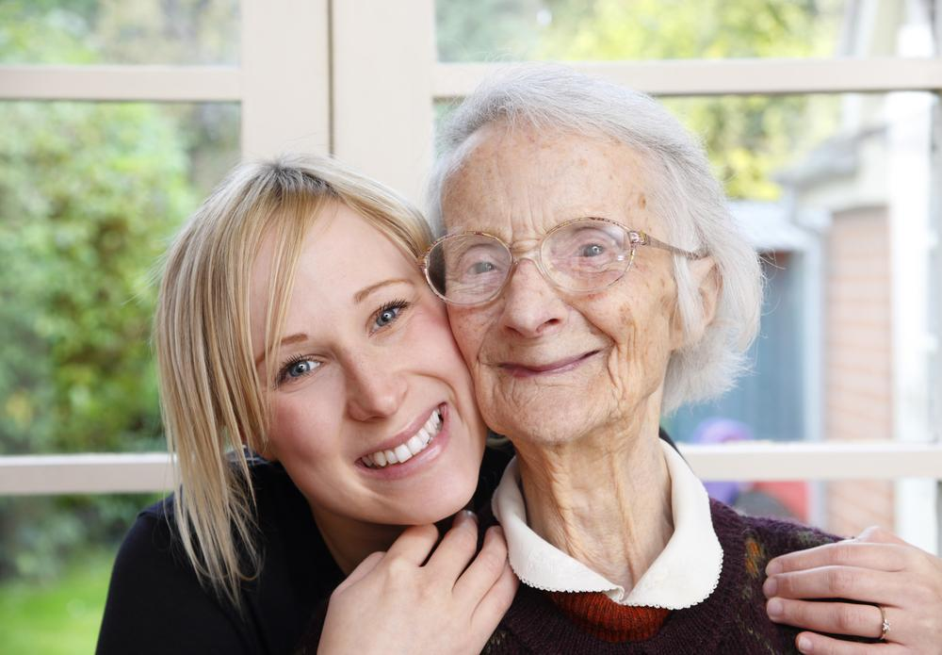
1.1 Background to the project
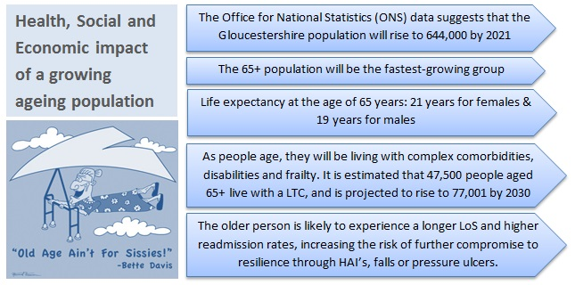
The South Cotswold Locality Executive, chose to think about the patients in the area as a ‘Family’. The Locality, having chosen to focus on Frailty, agreed they needed to consider how to commission services and support for their ‘family’, local people with frailty, to create more joined up working. They wanted to engage with local stakeholders and patient representatives about their idea to commission a new locality based Multi-disciplinary Frailty Team.
Why focus on Frailty?
- Frailty has an impact on individuals’ Quality of Life
- Frailty can affect people at any age
- Holistic support is required – Physical, Mental and Social
- Frailty is a major contributor to Unplanned Hospital Admissions
- If identified early, support can reduce negative impact

1.2 Local Engagement - Listening to views on Frailty
The following engagement and learning activities were undertaken:
- Best Practice – Members of the Frailty Project Group attended the Kings Fund Conference on Frailty 15 March 2016
- Lessons learning from Locality GP Best Practice – Phoenix Practice, Cirencester
- Healthwatch Gloucestershire published its reports following Enter and View visits at both Acute and Community Hospitals in the county, focussing on Dementia Care. http://www.healthwatchgloucestershire.co.uk/News/HW_publishes_2_phase_report_dementia_care_hospital.aspx
- Locality based Frailty workshop held for key Voluntary and Community Sector (VCS) stakeholders in March 2016
- Locality based stakeholder group Frailty Event held for providers held in March 2016
- South Cotswold Locality Community Frailty Project: Feedback event July 2016

1.3 What we learned/outcome
The Project Team asked stakeholders a few simple questions:
- What is particularly good about your local health & care services?
- What could we do better?
- Thinking about yourself, your family and your local community, what do you need:
  - To keep you well at home?
  - From specialist hospital services?
- What opportunities exist for health and care services to work more closely with the voluntary sector/community organisations?
The following were key themes from feedback:
- Join up information across different services.
- Community Matron' Excellent and helpful role and understandable title!
- Identify what people would like - staying at home if they can as changing routines can impact negatively.
- Planning and preparing, care plans at an earlier age and knowing what people’s preferences are
- Looking at adaptations to home

1.4 The next steps
The Project Team successfully engaged on the proposed service model with patients, public and provider stakeholders on numerous occasions. There was a significant Locality based appeal and commitment to support the development of additional resources based in South Cotswolds Locality GP practices for frail patients.
The proposed new service, shared across all eight South Cotswold GP practices, aims to include four Complex Case Management roles from ‘Community Matrons’, and four Wellbeing Coordinators who will specialise in supporting frail patients on their social and well-being needs. The South Cotswolds Locality Frailty Project began implementation in Autumn 2016.

