Engagement and Consultation
- Developing Gloucestershire’s Sustainability and Transformation Plan (STP)
1.1 Background
Gloucestershire’s STP sets out the very significant challenges that we face and the opportunities we must take to ensure local people can access high quality, sustainable and safe, physical and mental health care into the future. Our approach builds on the foundations of our ‘Joining up your Care’ (JUYC) programme in 2014, which was subject to significant patient and public engagement.
Moving forward, we believe we need to place greater emphasis on prevention of illness, support more self-care, provide more joined up care and support in the community and look at how some of our hospital services are organised to ensure safety and quality.
We know that we cannot make future changes alone and so sought the views of the public, patients and carers, community partners and health and care staff about our approach. We undertook a twelve week period of staff and public engagement over our STP priorities. The engagement period ran from the middle of November 2016 through to the end of February 2017.

1.2 Local Engagement
Our approach to STP engagement

A range of communications and engagement methodologies were used during the twelve week STP Engagement period. These are detailed below:
Engagement booklet
A long and short Guide to the STP was produced in both print and online versions. An easy read version of the short guide was also available. These documents set out the details of the STP and the printed version of the short guide included a freepost feedback survey form. The printed short guide was distributed widely across the county to venues such as GP practices, council offices and libraries.
External communications
Advertisements were placed in local newspapers to promote the STP and to advertise Public Drop-Ins. Press releases were issued to raise awareness of the STP and to draw attention to relevant news items. Social media was used to raise awareness of the STP and to encourage feedback. Extensive use of Twitter reached a wide number of local people. STP partners and stakeholders such as Healthwatch Gloucestershire and Carers Gloucestershire promoted the STP through their own networks.
Engaging stakeholders, the public and staff
Local stakeholders were invited to have their say and to attend a range of STP related events. These events were held on different days of the week and at different times of the day, providing an opportunity to hear presentations and to discuss the content of the STP during Question and Answer sessions and workshops.
Several groups were able to take part in the engagement via targeted events e.g. Young Carers, GP Patient Participation Groups (PPGs). These events provided an opportunity for focussed debate targeted to meet the interests and needs of participants.
To reach the wider local population, Public Drop-Ins were held across the county. These took place either on the GCCG Information Bus at venues such as supermarkets and sports venues or as static displays at venues such as shopping centres. Visitors were able to take away information or ask questions about the STP.
Staff and Foundation Trust Members briefings were held. These included question and answer sessions, several of which were recorded and published on staff intranet sites to allow those unable to attend in person to hear the debate.

1.3 What we learned/outcomes
Communications activities
During the engagement period there has been a comprehensive/proactive system wide media schedule to increase profile of STP themes and raise profile of STP engagement process.

- Media releases issued 12
- Adverts placed in local titles
- Articles generated in local media titles 20
- Social media reach (supporting engagement process) 44,146
- Social media reach (promoting STP stories/themes) 15,306
- Distribution of STP short guides 6,250
- STP website visits 10,749
All media features promoted the engagement process

Engagement activities

During the engagement period there has been a comprehensive/proactive system-wide engagement approach
- Total recorded events: 53*
- Information Bus: 19 Public Drop Ins
- Leisure/Sport Centres: 8 Public Drop Ins
- Staff engagement
- Targeted engagement e.g. Stroud and Berkley Vale Frailty Event, Health and Wellbeing Provider Forum, Young Carers, Patient Participation Group Network
- Invited engagement e.g. Local Nature Partnership Board, 38 Degrees Cheltenham
- Total number of face to face contacts: 1299*
- Total number of completed surveys: 638
- Total number of local people who want to keep in touch: 198 (via survey feedback)
- Total number of individual written responses: 16 (individual responses can be accessed in the online appendices and print copies on request)

Total activities /events / contacts /reach: 78,694*

Learning points for engagement and communication activities
As part of the qualitative feedback received, there were comments which related specifically to the STP communications and engagement process:
- Criticism of the survey questions. Several questions were described as leading or restrictive. The designs of structured surveys are often described in this way. We sought to compensate for this by encouraging respondents to provide qualitative feedback in their own words.

- Plan is not easy to understand and very high level. We sought to provide detailed information in the full document and appendices and summary information in the Short Guide, which provides a more magazine style narrative. We encouraged people to come to public drop-ins or events, to discuss face to face; and many people took the opportunity to come along to talk with us. These discussions allowed for constructive debate and for questions to be asked and answered.
- Engagement a tick box exercise – as individuals have different views – someone needs to decide! During the engagement period we invited individuals to let us know if they wanted us to keep in touch with them to inform them of ways they have their say. We have recorded contact details for almost 200 local residents and it is our intention to be in touch with these individuals to discuss our plans further, obtain their views and listen to their advice about new ways in which we can communicate, involve, engage and consult local people in the future.

1.4 Next steps
Future communications, engagement and consultation
Any proposals for significant change will be brought back to the public for formal consultation. The public, patients and carers, staff, community partners and elected representatives will have the opportunity to scrutinise new proposals. Targeted events and engagement will also be undertaken, including further work with the almost 200 local residents noted above.

2. Community Hospitals in the Forest of Dean
2.1 Background
Between September 2015 and June 2016, a range of engagement activity was undertaken to gather feedback from Forest of Dean residents regarding their health and care needs now and into the future. Health care professionals working in the Forest were also asked to give their insights and ideas for further improvement in delivering local services.
This feedback has informed the development of options for community hospital services in the Forest of Dean, leading to a period of consultation on a preferred model for the future. The preferred model is to build one new community hospital in the Forest of Dean which will ultimately replace the Dilke Memorial Hospital and Lydney and District Community Hospital.

2.2 Local Engagement
To support the early engagement work on this project, a Forest of Dean Locality Reference Group was established. This group included public representatives and community partners with a wide range of interests in healthcare in the Forest of Dean. The group worked with us to develop our engagement with the local community and contributed to the public consultation regarding the future of the two community hospitals. The review was also supported by the Forest of Dean Primary Care Group, which is made up of representatives from the local GP surgeries
The consultation was launched at the Gloucestershire County Council Health and Care Overview and Scrutiny Committee (HCOSC) on 12 September 2017. This launch was extensively promoted through the local media and social media, including a Facebook advertising campaign (details below). Information cards, signposting people to the dedicated consultation website and on-line feedback form, were also available and posters advertising consultation events were sent to all host sites.
Over 9,000 consultation booklets were distributed to GP surgeries, pharmacies, hospitals, libraries, leisure centres and district council buildings across the Forest of Dean and were available at all the venues used for consultation events. We responded to specific requests from community groups and organisations for copies of the consultation booklets, for example Forest Routes (Community Transport provider), dentists, local political representatives. Around 1,000 copies of an ‘easy read’ guide were also distributed. Consultation materials, including the survey, were made available on-line at www.fodhealth.nhs.uk
A total of 52 consultation events – presentations with question and answer sessions, information bus visits and public drop-in events (see below) - were held across the district and these were publicised in advance through social media, through regular half and full page advertisements in the Forest and Wye Valley Review, The Forester and the Citizen. Flyers with the original set of extensive dates were also included in every consultation booklet.
Invitations to attend other meetings/groups were also sought and received, providing an opportunity for targeted engagement with specific groups such as young people and family carers. As a result we attended numerous meetings of local clubs, support groups and organisations such as town council meetings, schools, Crossroads Care, Forest Sensory Services and Gloucestershire Young Carers.

Consultation activity throughout the Forest of Dean
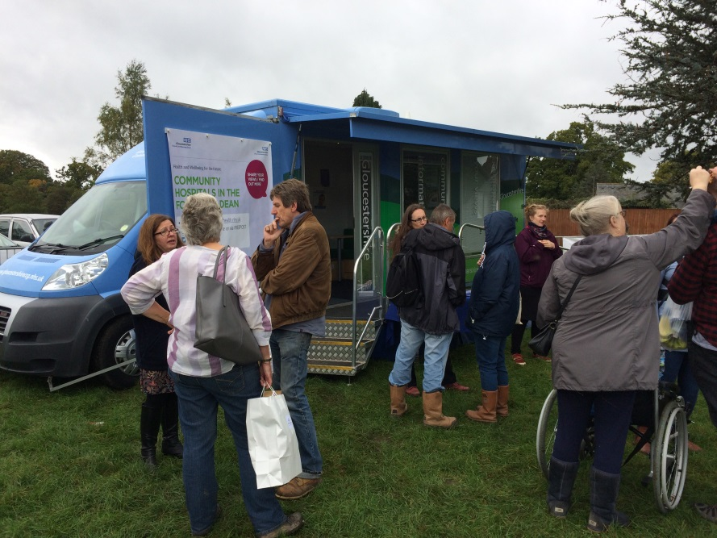
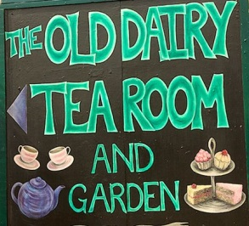
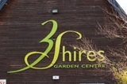
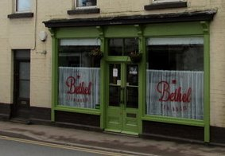
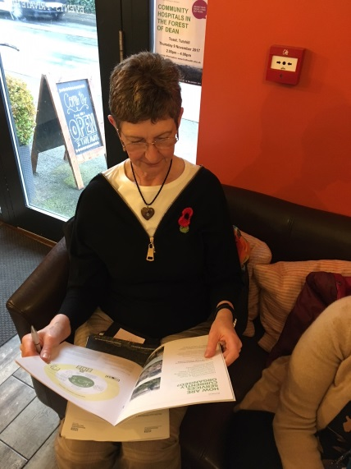

2.3 What we learned/outcome
In total, members of the consultation team supported 52 events, accounting for 1318 face-to-face contacts at consultation events with local residents
During the consultation there were:
- 3,456 individual visitors to the consultation website
- 27,498 Twitter impressions
- 3,779 Facebook impressions
- Facebook consultation advertisement, total number of people reached:
- 15,420, of which 11,918 was a result of paid-for advertising, and 3,502 as a result of organic sharing.
- 38,720 Facebook consultation advertisement impressions – the number of times our advert was displayed, whether the post was clicked on or not. The advertisement can be attributed to generating an additional 834 clicks to the consultation website home / landing page. Once the campaign finished online, Facebook gave us a relevance score of 8 out of 10. The high score shows how relevant our advert was to our target audience, compared to other adverts which may have targeted the same audience.
In response to the consultation activity we received:
- 3344 surveys (including 354 Easy Read surveys) submitted between 12 September and 10 December (receipt of postal surveys extended by 2 extra days to account for inclement weather conditions at the end of the consultation period).
- 28 items of Correspondence received (emails and letters)

Healthwatch Gloucestershire, the county’s independent health and care champion, took a keen interest in the consultation. This took the form of attending a number of the presentations and ‘drop-ins’ as well as reviewing the information available to the public.
Healthwatch Gloucestershire’s made three specific comments regarding the consultation process. These are highlighted below:
- Healthwatch Gloucestershire was impressed by the high level of preparation that had gone into the consultation which provided a good opportunity for residents of the Forest of Dean to participate and share their views. The consultation included a range of ways for people to have their say including attending public meetings, visiting an information bus, and drop-ins – all delivered in local venues. There was also on online option to share views via a survey. We were impressed by the number of face-to-face opportunities for engagement with nearly 100 people present at the Lydney meeting and a high number of drop-ins. Every presentation we attended was handled professionally including when there was robust challenge and questioning by local people.
- The consultation was supported with good quality information which explained the ‘case for change’, background, FAQs, and the options. We were impressed by the dedicated website which provided clear and very comprehensive information. The audio-visual content was useful for those who like to access information in this way as was the easy-read documentation.
- The information available clearly set out the preferred option of the commissioners and the provider and invited local people to say whether or not they agreed with this option. We believe that taking such a clear position is helpful.
2.4 Next steps
Following the consultation, the decision was taken to proceed with the preferred option of a new community hospital in the Forest of Dean. The next steps in the programme include identifying a location for the new hospital; this process will be supported by a Citizen’s Jury.
Citizens Juries Community Interest Company (CIC) has been appointed to run an independent citizens’ jury, to consider the location of a new hospital. The appointment of Citizen’s Juries CIC reflects feedback from the public consultation where people who responded were clear that they wanted local residents to be involved in making a recommendation to Gloucestershire Care Services NHS Trust and NHS Gloucestershire Clinical Commissioning Group regarding the preferred location of a new community hospital for the Forest of Dean.
The “jury” will be made up of 18 local residents and four health care professionals. In April, Citizens Juries CIC will invite applications from local residents to be involved in the jury, ensuring a balance in terms of age, gender and geography. It is expected that the jury will sit for three and a half days and be presented with information and hear from expert witnesses to take a view on whether they think the new hospital should be located in, or near, Cinderford, Coleford or Lydney.

3. Workplace Health and Wellbeing Charter (Staff engagement)
3.1 Background
The Workplace Wellbeing Charter is an opportunity for employers to demonstrate their commitment to the health and well-being of their workforce, whilst providing employers with an easy and clear guide on how to make workplaces a supportive and productive environment in which employees can flourish. These standards reflect best practice and are endorsed nationally by Public Health England.
The Charter takes a holistic approach that includes leadership, culture and communication, as well as health & wellbeing topics such as physical activity, alcohol and mental health. The framework promotes rounded discussions between employer and employees about health, safety and wellbeing.
The CCG completed the accreditation process and was awarded the Workplace Wellbeing Charter in April 2017.

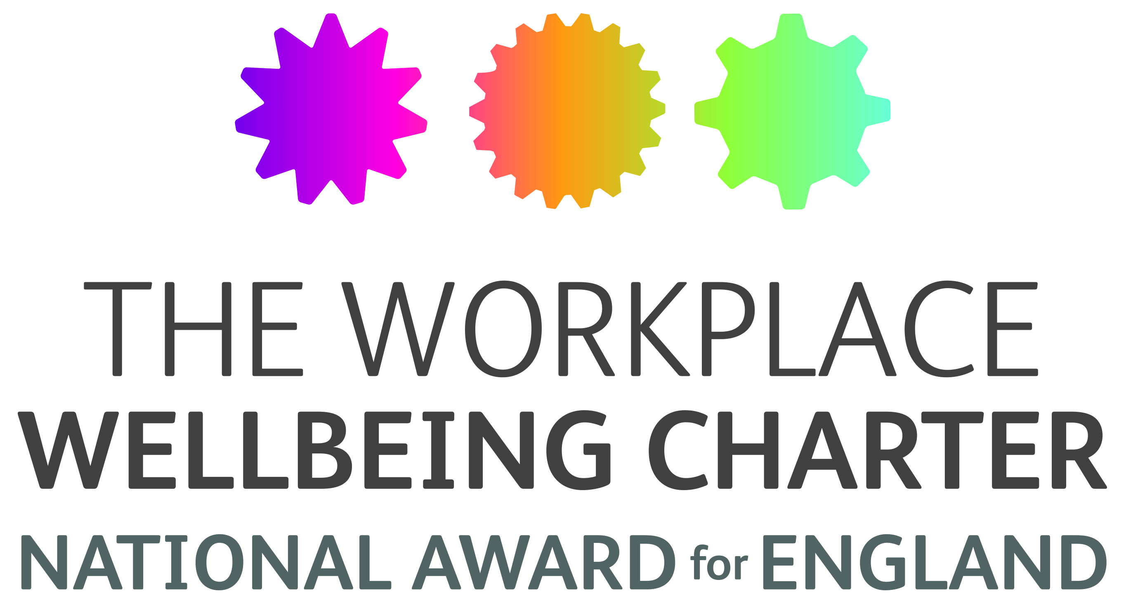

3.2 Local engagement
The assessor conducted around 20 interviews with individuals based in Sanger House and facilitated two sessions with small focus groups.
Feedback from staff is that they found the process extremely useful and beneficial. In particular, they reported increased awareness of the long term benefits of healthy eating, mental health issues and physical activity. There has been good uptake on the use of Fitbits, standing desks, people taking proper lunch breaks and the introduction of walking 1:1 meetings.
The assessment is against 8 standards, which have 3 elements to each of them; commitment, achievement and excellence. Accreditation took place at commitment level with achievement and excellence merits awarded during the process.
- Leadership Excellence
- Absence Management Excellence
- Health and safety Achievement
- Alcohol and substance misuse Achievement
- Smoking Excellence
- Mental Health Achievement
- Healthy eating Commitment
- Physical Activity Achievement

3.3 What we learned/outcomes
Many strengths and areas of good practice were identified during the accreditation process. It was clear that the organisation had fully integrated policies and procedures and that these had been cascaded to all employees. Evidence showed that employees are engaged at the start of employment about the ethos of the organisation and the support that is available.
All those interviewed expressed how much they appreciate their job and role. Most spoke highly of their line management and how well supported they are; but more importantly, how appreciated they felt. This indicates that the GCCG values their employees and understands that the employees are the biggest asset of the organisation.
Absence management procedures are in place and from the interviews it was indicated that employee experiences with absence management has been a supportive one. The appropriate procedures are used and all employees are aware of what is expected of them. The attitude of all employees needs to be commended. Their appreciation of the support given to them by the organisation is evident and the support shown by managers to encourage this shows their commitment to ensure the GCCG continues to commission successful health care services.
Gaining the Workplace Wellbeing Charter demonstrated the CCG’s commitment and support to staff. The evidence presented and the interviews that were held all provided assurance that the GCCG is an “employer of choice” and committed to investing in employees to ensure that it remains a successful and happy place of work.
3.4 Next steps
Through the accreditation process, the following opportunities for continual improvement were recommended:
- Ensure Employee Health, Work and Wellbeing Surveys include questions on Lifestyle topics
- A two-year Health, Work and Wellbeing action plan reflecting the Charter Standards to be implemented. This should detail a strategy as to how to improve the wellbeing of your employees and be based on key finding in a lifestyle survey.
- Tailored programmes to improve understanding and motivate behaviour change in relation to healthier diets and physical activity are offered.
- Managers have access to training on identifying the signs of substance misuse. All staff have access to alcohol and substance use awareness and behaviour change training
- Managers to be given specific Health and safety management training to enhance their skills
- A mental health and wellbeing strategy to be implemented. Staff consultations or surveys introduced that provide information on the mental wellbeing of staff that include working conditions, communication, work life balance, cost of living wage, staff support, and work related or other causes of stress, with action plans drawn up to address major issues.
This work will be taken forward by the Organisational Development Group and reviewed in light of the outcomes of 2017 staff survey.

