Future in Mind - Refresh
Background
Gloucestershire’s Future in Mind 5 Year Transformation Plan for Children and Young People’s Mental Health’ continues to involve a range of local stakeholders, including children and young people, in its work. The plan takes a whole systems approach to prevention, provision of information and advice; and early intervention through to crisis support.
This ambitious Transformation Plan outlines how, over the next 5 years, we will achieve our shared ‘Vision’ for the emotional and mental health and wellbeing of children and young people.
Our Vision: ‘Children and young people of Gloucestershire thrive and grow up to be confident and resilient individuals’
Supporting statement to the Vision:
‘They will do this within families, schools and communities that understand and talk about the importance of emotional and mental health and wellbeing, and will be supported, when needed, by:
- a skilled workforce that provides services that are joined up, intervene early, are easily accessible, and are of high quality,
- providing the best possible care, support and intervention when and where it is needed, within a sustainable system that focuses on achieving good outcomes
The plan needed to be refreshed, and following approval by NHS England and the Health and Wellbeing Board, an update was published in October 2018. The aim of the refresh was to reflect local progress with transforming the system of support for children and young people, and identify further ambitions based on our local developing work in this important area.
Local engagement
A workshop was held in August 2018 with young people to:
- Test the work undertaken against priorities identified through previous engagement ensure
- Help identify emerging priorities for inclusion in the 2018 refresh.
14 young people attended: they were asked to provide their views, feedback and opinions throughout the duration of an informal workshop. Feedback was also sought through the Children's Emotional Health and Wellbeing Partnership: a group of local key stakeholders from across children’s services, including health, education, schools and third sector organisations.
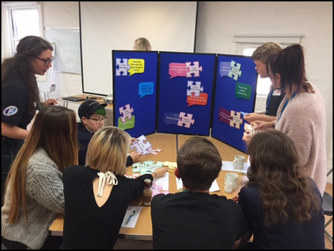
What we learned/outcome “You said – We Did”
The session was designed to enable us to revisit the key elements and priorities for future services identified by children and young people during engagement in 2015 for the original plan.
Young people were separated into two groups of roughly 6-8 and were asked to connect speech bubbles with the aforementioned statements on to puzzle pieces which detailed work being done or completed within health and social care.

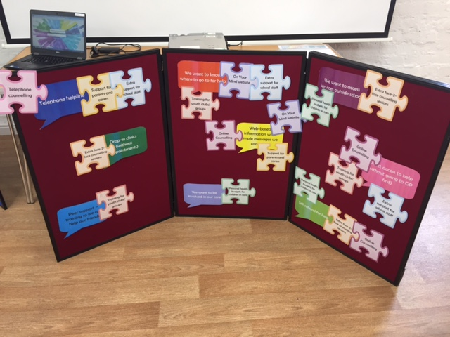
We wanted to test whether the local priorities of children and young people, identified in 2015, have been met through existing/planned programmes of work. It was apparent from the exercise that young people were able to clearly identify links between priorities and new services or facilities commissioned in response to the issues raised.

It was however noted that many of the young people present were not familiar with the ‘On Your Mind’ website and welcomed watching the online video to understand more about the resource: https://www.youtube.com/watch?v=PBhx2JceJJI.

“Support in Schools”
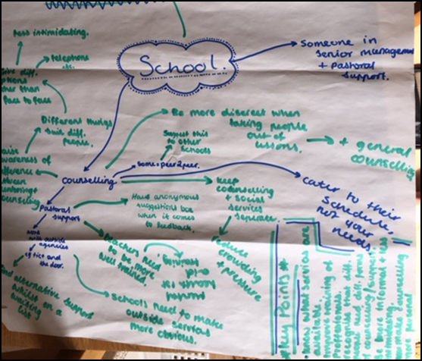
We wanted to know whether young people are aware of what work is being done in schools, any changes they may have noticed or experienced recently and what could be done better or developed further.
Remaining in their groups of 6-8, the young people discussed their experiences and agree the following key themes:
- School Nurses need to be upskilled in Mental Health First-Aid
- More discretion is needed to help most vulnerable.
- There needs to be multiple access methods – not one size fits all eg. Face to face, telephone, text, website information
Practical or informative sessions to inform all children, not just those with a medically diagnosed condition - normalise mental health!
Next steps
The events and feedback received identified the need to:
- Re-launch the ‘On your Mind’ website – https://www.onyourmindglos.nhs.uk/ and promote through schools and youth groups.
Undertake further work in schools - (Editor note: this will now being addressed through the Mental Health Trailblazer Programme - In December 2018, the Government announced Trailblazer sites, of which Gloucestershire was successful in securing £5m funding up until 2021).

