Our open culture

Strategy for engagement and experience

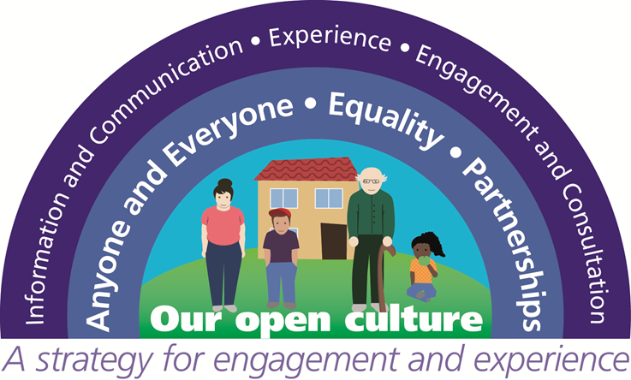
Our open culture: Strategy for engagement and experience
Background
The CCG has responsibility for commissioning (buying) local NHS services to meet the needs of local people. These services include emergency care services, operations or treatments that can be planned in advance, community services and mental health services. From 1 April 2015, the CCG took on ‘delegated’ responsibility from NHS England for commissioning primary care (GP services) for the resident population of Gloucestershire.
Our open culture: Strategy for engagement and experience informs the day-to-day work on NHS Gloucestershire Clinical Commissioning Group (CCG). It builds on the five year Strategy developed by the CCG when it was established in 2013/14. This Strategy is reviewed annually and modifications are made as required.
The CCG’s Vision and Values
Our Vision: Improved health and wellbeing through joined up care and communities
Our Values:
- Caring – Meeting your needs with compassion and respect
- Integrity – Acting with professionalism, fairness, honesty and openness
- Quality – Working positively with you for the best quality of life and safe, effective care
- Collaborative– Supporting healthy, active communities and joined up care through strong partnerships
- Innovative – Being forward thinking and creative to transform care and to make best use of limited resources

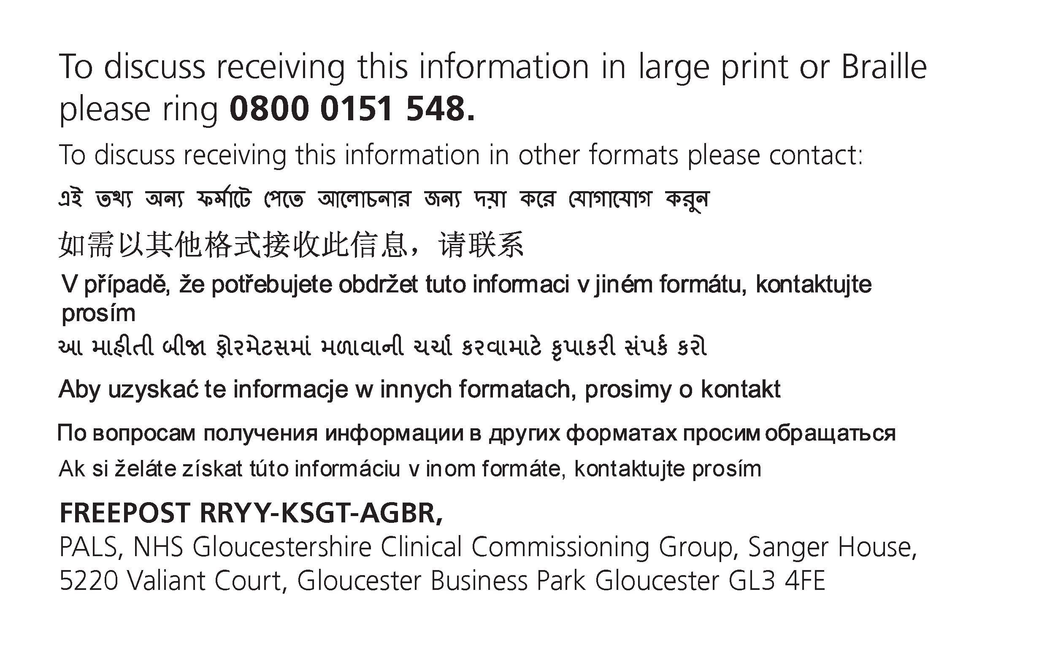

Last review: February 2019 (April 2019: GCCG Quality and Governance Committee)
Next scheduled review: February 2020
It is the intention during 2019/20 to combine this Strategy together with the CCG’s Equality and Diversity Strategy and to consider these strategies in the context of the wider One Gloucestershire Integrated Care System (ICS), the NHS’s 10 year Long Term Plan (LTP) commitments and Gloucestershire’s response to the Long Term Plan.
Our commitment to you
The target audience for this strategy is you – the people who live and work in Gloucestershire. This includes the majority of the CCG’s GP Members (across 70+ GP Practices), NHS staff, volunteers and community partners promoting healthier lives and providing health and care services in the county.
We are ambitious in relation to our work to deliver good quality engagement with local people, building on their experiences of living in Gloucestershire’s diverse communities. Our former Clinical Chair, Dr Helen Miller and our Accountable Officer, Mary Hutton said in 2013, when NHS Gloucestershire CCG was formed, that we wanted to ensure that the ‘quiet voices’ are heard and that we are recognised as ‘commissioners on the ground’. Our current Clinical Chair, Dr Andy Seymour, has built on these ambitions, saying that the CCG ‘values and seeks to learn from the experiences of everyone involved in promoting, delivering and receiving health, wellbeing and care in Gloucestershire’.
Maintaining and building upon these ambitions and the approach set out in this Strategy will facilitate an informed, ongoing dialogue with you, which is both reactive and proactive.
Not everyone will notice the impact of our engagement, experience and inclusion work but our aim is that your will benefit positively from good quality, responsive, inclusive services that have been influenced and improved because we have taken into account the views of local people.
We have learned that investing the time and effort in building strong and sustainable relationships and engaging in open conversations can avoid surprises, builds trust, confidence and credibility and engenders mutual respect. This provides firm foundations for the development of better future services. Ensuring that we hear from as many people and communities in Gloucestershire as possible, requires us to understand that the way we seek your feedback and views influences who gets involved. The design of our experience and engagement processes addresses this.

Engagement and Experience Governance and Accountability
The CCG Constitution reflects the accountability between the CCG and member practices and is supported by appropriate strategies to maintain quality, safety and effectiveness. In turn the Constitution upholds the principles of patient and public engagement which are adhered to by this Engagement and Experience Strategy. The CCG constitution is published on the CCG’s website at https://www.gloucestershireccg.nhs.uk/wp-content/uploads/2014/07/Constitution-January-2016.pdf
The CCG Constitution describes how that the CCG demonstrates its accountability to its members (GP practices), local people, stakeholders and NHS England in a number of ways. Of particular relevance to Engagement and Experience are the following:
- appointing independent lay members and other healthcare professionals to its Governing Body;
- holding meetings of its Governing Body and Primary Care Commissioning Committee in public (except where the Group considers that it would not be in the public interest in relation to all or part of a meeting);
- meaningful engagement, communication and consultation with the population of Gloucestershire;
- complying with local authority health overview and scrutiny requirements;
- meeting annually in public to present its annual report (which must be published);
- having a published and clear complaints process; and
- complying with the Freedom of Information Act 2000.

Working in partnership
The CCG is a key partner in the local Integrated Care System (ICS): One Gloucestershire. We work closely with local providers of NHS funded services, strategic partners in statutory agencies, such as county and district councillors and the emergency services, as well as the voluntary and community sector.
Local people’s (lay) voices are heard at all levels of the organisation from the Governing Body to focused working groups. Your voices are heard alongside those of clinicians and managers, when we are planning, developing, procuring, evaluating and monitoring services. We aim to be clear about what you can and cannot influence, explain where there is scope for local decision making, or where we must follow actions mandated by others.
We bring our knowledge of your care to look at how services are planned and how your journey through care can be improved. Combining this clinical knowledge with your first-hand insights, and those of communities in Gloucestershire, provides a unique collaboration. We believe that the combination of this local clinical knowledge, together with the knowledge you have regarding your own experiences, and communities have about their particular circumstances, will lead to evidence and experience based commissioning and design of services.
The following diagram shows the structures we have in place to enable local people’s voices to be heard within the CCG in order to inform CCG planning, commissioning intentions and decision making.

Governing Body Lay Members
Our Governing body is accountable for the decision making of Gloucestershire CCG. It makes sure that the organisation is making best use of the money available and buying and developing health services that meet the needs of local people. Two Lay Members have a special interest in Patient and Public Engagement and bring specific expertise and experience, as well as their knowledge as a member of the local community, to the work of the governing body. Their focus is strategic and impartial, providing an independent view of the work of the CCG that is external to the day-to-day running of the organisation. They help to ensure that, in all aspects of the CCG’s business, the public voice of the local population is heard and that opportunities are created and protected for patient and public engagement in the work of the CCG. In particular, they will ensure that:
• public and patients’ views are heard and their expectations understood and met as appropriate;
• the CCG builds and maintains an effective relationship with Local Healthwatch and draws on existing patient and public engagement and involvement expertise; and
• the CCG has appropriate arrangements in place to secure public and patient engagement and responds in an effective and timely way to feedback and recommendations from patients, carers and the public.
The CCG’s two Lay Members for Patient and public Engagement are:
- Alan Elkin https://www.gloucestershireccg.nhs.uk/about-us/the-governing-body/member-profiles/alan-elkin-lay-member-public-and-patient-engagementinvolvement/

- Joanna Davies https://www.gloucestershireccg.nhs.uk/about-us/the-governing-body/member-profiles/joanna-davies-lay-member-public-and-patient-engagement/
Lay Workers
The CCG has a group of paid Lay Workers (bank staff) who provide additional support to the Governing Body Lay Members. Lay Workers have a breadth of knowledge and experience, extending the organisational lay voice into even more commissioner led meetings, such as Clinical Programme Groups, where they are referred to as Lay Champions, and Clinical Effectiveness, Individual Funding Request (IFR) and Continuing Healthcare (CHC) Panels.
Healthwatch Gloucestershire and Evolving Communities
https://www.healthwatchgloucestershire.co.uk/
Healthwatch Gloucestershire is the county’s independent health and social care champion. It exists to ensure that people are at the heart of care. The Healthwatch Gloucestershire service is commissioned from Evolving Communities by Gloucestershire County Council, with a contribution from the CCG to enhance the provision of information to local residents.
The Health and Social Care Act of 2012 established the requirement for there to be a Healthwatch organisation in every local authority area across England. Each one is a key part of its local community, and works in partnership with other organisations in its area.
Dedicated teams of staff and Healthwatch Gloucestershire volunteers listen to what people like about local health and care services, and what could be improved. These views are then shared with decision-making organisation e.g. the CCH, so together a real difference can be made.
We work closely with Healthwatch Gloucestershire, with Healthwatch Gloucestershire volunteers taking part in CCG led programmes and activities and the CCG and other ICS Partners commission Healthwatch to gather feedback from local people. For example Healthwatch Gloucestershire:
- is represented on many of our programme and project groups and undertake activities to support service review and redesign e.g. The End of Life Care Clinical Programme Group is a group of partners that work collaboratively to ensure all people at end of life, their carers and family, receive high quality end of life and palliative care in their preferred place of care and death. Healthwatch Gloucestershire has a seat on this Group to ensure the voice of local people is heard and considered at a high level. There has been recognition in this Group, that a holistic approach to care was needed to support the person to ‘live well’ with their condition and to understand ‘what is important to them’. Healthwatch undertook research and produced the following report: https://www.healthwatchgloucestershire.co.uk/wp-content/uploads/End-of-Life-HWG-Final-Nov18r.pdf
- co-produced an engagement facilitation tool with the CCG in 2018/19 called: Facilitating Feedback
- supports the production of accessible written patient information through their Readers’ Panel
- observes and comments on the quality and effectiveness of engagement undertaken by the CCG
Patient Participation Groups (PPG)
https://www.gloucestershireccg.nhs.uk/about-you/patient-participation-groups/
From April 2016, it has been a contractual requirement for all English GP practices to form a Patient Participation Group (PPG). In Gloucestershire the CCG facilitates a Network of active PPGs who meet together on a quarterly basis. The CCG offers proactive and reactive support and advice to PPGs to support their engagement with their practice and registered patient population.
Insight Gloucestershire
In 2016/17, the One Gloucestershire Sustainability and Transformation Partnership (STP), now an Integrated Care System, invited local people to get involved in shaping local services. Over 100 people from a wide range of interests and experience completed an Insight Survey to share with us some information about themselves and areas they are interested in. The data collected through the survey enabled the CCG and Integrated Care System partners to align individuals’ stated interests to relevant projects and programme e.g. urgent care model redesign.
Experts by Experience
Where the CCG is undertaking a focussed piece of work e.g. establishing a community stroke rehabilitation service, it is important to hear from local patients and carers about their recent experiences of existing services to inform the development of new services. Such patients and carers are referred to as ‘Experts by Experience’ and the CCG usually identifies them and invites them to get involved through their clinical teams rather than general population recruitment.
Community Partners (Community and Voluntary Sector)
As well as inviting individuals with particular experience, the CCG regularly contacts community and voluntary sector partners to ask their views on service delivery, development and change. In particular the CCG works with Gloucestershire Voluntary and Community Sector Alliance (GVCSA) http://www.glosvcsalliance.org.uk/
The Alliance has been established to act as the independent voice for the voluntary and community sector in Gloucestershire and to ensure the independent voice of the voluntary and community sector is heard by commissioners, policy holders and service planners
The CCG Engagement and Experience Team
The CCG has a small, dedicated Engagement and Experience Team, who advise the CCG on ways to engage our local community; seek feedback on services, plans and proposals; and ensure that the CCG complies with current legislation relating to engagement and equality. The Team members’ skills include:
- the planning, design and delivery of engagement and consultation activities
- developing and undertaking survey work and reporting
- providing support to patients who want to share their experiences of using NHS services, raise a concern/complaint, ask questions or need help to access healthcare
- providing advice on equality good practice
- Graphic Facilitation
- training (10 Steps to Even Better Engagement)

Legal requirements
We have a legal duty to make arrangements to ensure you are involved in the commissioning decisions we make. There are several ‘must dos’ in the field of engagement, experience and inclusion. These are set out in national legislation and guidance. The key requirements and mechanisms we must work with are described within three key pieces of legislation: Health and Social Care Act 2012, The Equality Act 2010 and The NHS Constitution 2010. Delivering this Strategy ensures GCCG meets these legal responsibilities. This Strategy is supported by resources on the CCG website https://www.gloucestershireccg.nhs.uk/about-you/
The Gunning Principles
Before 1985 there was little consideration given to consultations until a landmark case in that year (R v London Borough of Brent ex parte Gunning). This case sparked the need for change in the process of consultations when Stephen Sedley QC proposed a set of principles that were then adopted by the presiding judge. These principles, known as Gunning or Sedley, were later confirmed by the Court of Appeal in 2001 (Coughlan case) and are now applicable to all public consultations that take place in the UK. We pay due regard to the Gunning Principles.
1. When proposals are still at a formative stage
Public bodies need to have an open mind during a consultation and not already made the decision, but have some ideas about the proposals.
2. Sufficient reasons for proposals to permit ‘intelligent consideration'
People involved in the consultation need to have enough information to make an intelligent choice and input in the process. Equality Assessments should take place at the beginning of the consultation and published alongside the document.
3. Adequate time for consideration and response
Timing is crucial – is it an appropriate time and environment, was enough time given for people to make an informed decision and then provide that feedback, and is there enough time to analyse those results and make the final decision?
4. Must be conscientiously taken into account
Think about how to prove decision-makers have taken consultation responses into account. The risk of not following these principles could result in a Judicial Review. A number of public bodies across the UK have been taken to Judicial Review and deemed to have acted unlawfully in their Public Sector Equality Duty – usually linked to the four Gunning Principles.
The Consultation Institute (tCI)
The CCG is an Organisational Member of The Consultation Institute (tCI), a not-for-profit best practice Institute, promoting high-quality public and stakeholder consultation, which complies with relevant legal duties, in the public, private and voluntary sectors. tCI is a membership body offering a variety of support services and training for any person or body with an interest in public dialogue, engagement and participation. https://www.consultationinstitute.org/

Our Open Culture Framework for delivering this Strategy
‘Our Open Culture’ Framework promotes ‘Equality’ and working in ‘Partnership’ and the desire to enable ‘Anyone and Everyone’ to have a voice. To achieve this we provide ‘Information and good Communication’, focus on ‘Experience’ feedback and undertake good ‘Engagement and Consultation’.
Enabling principles
We have three enabling principles to support the delivery of this Strategy (a, b, c)
a) Equality
We want to ensure that we hear from all people and communities living and working in Gloucestershire. We understand that the way we seek people’s feedback and views influences who gets involved; so our experience and engagement processes are designed with this in mind – it’s a cliché, but one size does not fit all.
We use an Equality and Engagement Impact Assessment, which is used to consider any potential or existing impact on protected groups, as defined by the Equality Act 2010, of proposed service development. https://www.gloucestershireccg.nhs.uk/about-us/equality-diversity/practical-resources/
https://www.gloucestershireccg.nhs.uk/wp-content/uploads/2016/01/EIA-form.pdf
As well as paying due regard to the nine protected characteristics, the Impact Assessment also pays attention to wider inequalities that people of Gloucestershire may experience because of social, domestic, environmental and economic circumstances, e.g. unpaid carers, rural isolation, areas of deprivation.
Where there are gaps we adapt and make new plans to address them. We acknowledge the crucial benefit of working with partners in other agencies and across the voluntary and community sector to achieve this.
Our legal duty is to be compliant with the Equality Act 2010. However, our commitment is not only to our legal duties. We are committed to having open and honest conversations, which we believe will help to build strong relationships with communities, with ‘protected’ groups and within ‘communities of interest and place’.
The surveys we develop routinely include ‘About You’ questions. Completing the "About You" section is optional, but the information you give us helps us to ensure that we hear from people with a wide range of experiences and circumstances. Your support with this is really appreciated.
When we produce public facing engagement or consultation materials we always include information about how to obtain these in different languages. This is included at the front of this document.
We have a Strategy for Promoting Equality and Valuing Diversity (2015 – 2018). In recognition of the clear linkages between that Strategy and this Engagement and Experience Strategy, during 2019/20 we will be combining these into one overarching Strategy for Engagement, Experience and Promoting Equality and Valuing Diversity.
(b) Partnership
We want to maintain and further develop our partnerships across the county, from encouraging people to become partners in their own care, to working with communities and with strategic partners such as district councils, to promote healthy lifestyles. The CCG has good working relationships within the third sector locally, in particular with Healthwatch Gloucestershire and the Gloucestershire Voluntary and Community Sector (VCS) Alliance. We will continue to build upon these in future.
To work in partnership is more challenging for some that others. This may be as a consequence of skills, resources, capacity, inclination or confidence. We seek to establish mutual trust with partners, established and new. We believe this can be done through a common commitment to the future of the health and care in this area. We are realistic, we know that mutual trust takes time to build and can be damaged quickly without practicing openness and transparency.
c) Anyone and Everyone - you
You are ‘Anyone and Everyone’. Anyone and everyone is any individual who lives or works in Gloucestershire. Sometimes you might also be someone who lives or works close to Gloucestershire, or who comes into the county to access services.
To support wider engagement, we want to ensure that you, if you wish to participate, it is your choice, can be individually or collectively involved in the decisions that are made by us.
We continue to build upon existing mechanisms for engagement and establish new ones, which allow everyone who has a stake in healthcare services to have the opportunity to have a voice. This can range from the information we publish, to the activities we invite you to take part in.
We can’t force you to participate, but we can make getting involved more valued as a meaningful option for greater numbers of people locally. We can do this by the manner in which we make it possible for you to participate and the recognition involvement provides to you. For effective involvement, people need to feel supported, and for their contribution to be valued. There are many ways to do this including: being thanked; receiving acknowledgement; or seeing the improvements made as a result of people’s involvement. In valuing the contribution of stakeholders, the CCG recognises that it needs to remove the financial barriers that can prevent participation. Patients and public should not be out of pocket as a result of their involvement with the CCG so reasonable expenses will be reimbursed. We always include a FREEPOST address when we design ‘pull out and return’ surveys in printed engagement and consultation materials.
To support patients, carers and the wider public who are involved in helping it shape the development of health services the CCG has developed a more formal Reward and Recognition Policy based on NHS England good practice guidance and policies in neighbouring CCG areas https://www.gloucestershireccg.nhs.uk/your-views/
Our Policy (currently draft with Healthwatch Gloucestershire, and on the CCG website, for comment) will be shared for approval by the CCG Policies and Procedures Committee during 2019.
Methods of delivery
We have three methods of delivery which support the delivery of this Strategy (d,e,f).
d) Information and Communication
How we inform and communicate with people are the first two building blocks for good engagement. You should feel that you get the right information, in the right way, at the right place and the right time for you. We communicate clearly developments in local services using a range of media, often using case studies to illustrate how new services will be delivered.
We are fortunate to have access to a mobile resource, our Information Bus, which is used to bring information to all areas of the county and is a valuable mobile venue for engagement and a visible presence in the community https://www.gloucestershireccg.nhs.uk/about-you/nhs-information-bus/
We are increasingly using films and animations and social media; regularly tweeting and updating our Facebook and website pages. We have increasing numbers of ‘followers’. Our website is a valuable communications tool, which we use to provide information and as a platform for online surveys.
We aim to improve ‘health literacy’ amongst the population of Gloucestershire. Health Literacy is the level of knowledge and understanding you have about how to prevent ill health or to be involved in decisions and actions affecting your health. Actions which increase healthy literacy, such as providing information and training, enable you to make informed choices about your lifestyle and, when you need to, to know which support or services to access. Increased health literacy supports people with local term conditions to participate more in decisions about their treatment and care, sharing control with their clinicians.
e) Experience (of care)
Patient experience is a core component of quality in the NHS, identified as one of three quality areas or ‘domains’ (Safety, Experience, Clinical Effectiveness). Our role is to ensure care is safe; ensure care is effective and ensure individuals have the most positive experience possible. We do this through contract setting and monitoring, by considering information in Care Quality Commission reports, audits, incidents and serious incidents notifications, NICE standards, professional body standards, complaints, national and local surveys (staff and patient and public), service reviews, Healthwatch feedback, NHS England Area Team, NHS Choices website, and the Friends and Family Test.
The CCG uses digital survey software to develop bespoke patient, public and staff surveys. Examples of recent surveys and their impact on developing services locally can be found on the CCG website https://www.gloucestershireccg.nhs.uk/your-views/
In the context of this Strategy, ‘experience’ is what the process of care feels like for you.
Experience can be defined as feedback from individuals about: ‘what actually happened in the course of receiving care or treatment, both objective facts and their subjective views of it’ (Dr Foster, The Intelligent Board 2010). Routinely we bring Patient Stories to the CCG Governing Body and use them in engagement and communications campaigns. The impact of stories is that they bring experiences and service developments to life. Examples of recent Patient Stories can be found on the CCG website https://www.gloucestershireccg.nhs.uk/multimedia/patient-stories/
We receive experience feedback in many ways, for instance through our Experience Team (PALS and Complaints) or via the service providers we commission services from. https://www.gloucestershireccg.nhs.uk/about-you/complaints-compliments-concerns/
The experience feedback we collect helps us to understand how you feel about the services we commission, what we may need to consider changing and signals areas for improvement. Often suggestions are put forward by carers and family members or friends, who sometimes have a different view of what an experience has been like than the individual receiving care. We also hear from those who deliver services, the staff and, often volunteers, within communities.
Experience in an Integrated Care System
The CCG sits within an Integrated Care System (ICS) called One Gloucestershire. For more information about the ICS visit the One Gloucestershire website https://www.onegloucestershire.net/
The feedback all ICS partners receive and proactively collect from local people is used to build an evidence base to inform future commissioning intentions, service changes, open procurements (when required) and the monitoring of existing services. We analyse the qualitative and quantitative feedback gathered, providing relevant data to support the work of the ICS as required.
f) Engagement and Consultation
Engagement can be defined as the active participation of the public, patients, including children and young people, carers and community representatives, in the development of health services. Engagement gives you a say in how services are planned, commissioned (purchased/procured), delivered and reviewed. It is important to recognise who we involve through our engagement activity and we are keen to ensure that we provide opportunities for individual, group and collective engagement.
More formal engagement, for instance with the a Local Authority Health and Care Overview and Scrutiny Committee (HCOSC) and the wider general public, relating to proposals for a ‘substantial change’ to the health service in the area, or a ‘substantial variation’ in the provision of services, such as a changing where a service is provided from, is referred to as ‘consultation’.
We facilitate engagement and consultation in many ways including: hosting public events, drop-ins, stakeholder workshops and presentations and targeted focus groups. We commission community volunteer activities, undertake telephone structured interviews and social media conversations, we also frequently attend partner events, produce on-line and freepost surveys.
The CCG has a dedicated consultation email account, which is regularly monitored so you can contact us easily: glccg.consultation@nhs.net
There are accompanying online engagement resources to support the delivery of this Strategy provides links to a range of tried and tested techniques. This is a dynamic resource, frequently refreshed to take account of new ways of thinking in relation to engagement, experience and inclusion activities. One example highlighted in the online resources is the Engagement Cycle:
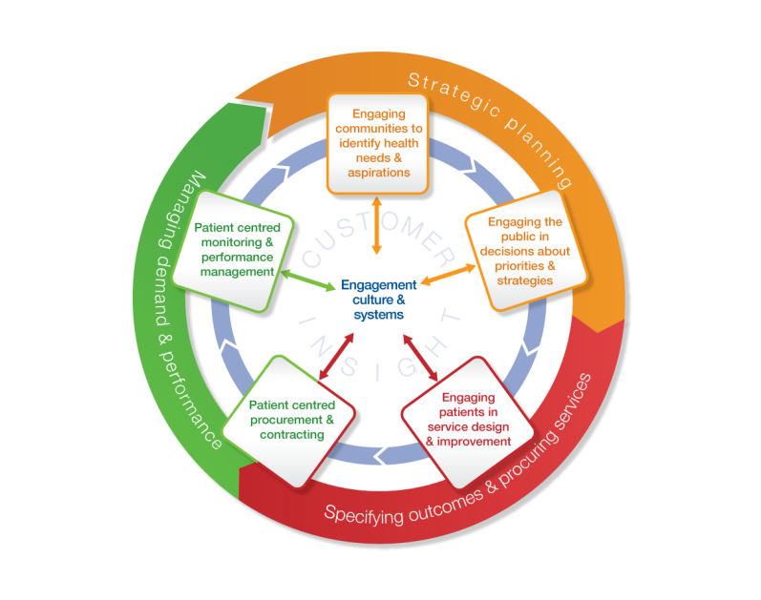
The Engagement and Commissioning Cycles and three levels of engagement
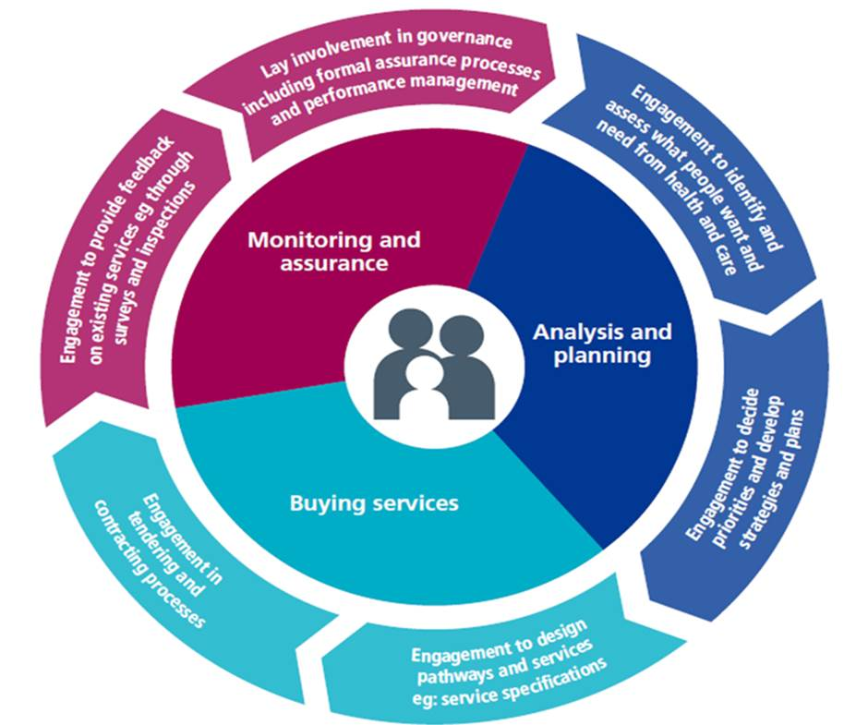

The Engagement Cycle is a tried and tested, practical resource, used by dozens of Clinical Commissioning Groups to plan, design and deliver services for, and with, local people, supporting public participation in the commissioning cycle. Our approach locally is to take the commissioning cycle and overlay it with the Engagement Cycle to support public engagement to drive our decision making process.
The Engagement Cycle:
- Serves as the foundation for an engagement culture – where working with patients, carers and the public becomes part of everyday behaviours, and effective relationships between professionals and patients is the norm
- Provides the basis for developing sustainable systems and processes in order to turn engagement into everyday practice
- Sets out what is required when engaging patients, carers and the public at each stage of the commissioning process
- Supports the development of effective engagement strategies and plans that embed engagement in decision-making – ensuring that ‘nothing about us without us’ is more than rhetoric
- Outlines, who needs to do what at each stage of the commissioning cycle, to ensure meaningful engagement for maximum impact
For us engagement consists of three levels of engagement, which describe a continuum from activities associated with responding to an individual’s experience of care through to formal public consultation:
- Level 1 – one to one engagement or personalisation
- Level 2 – targeted specific service change
- Level 3 – policy and strategic service development with the wider public.
Our approach recognises that some individual’s engagement with us will not extend beyond the receipt of treatment and care, but for others it will be an important element of their lives. We respect the fact that each individual’s wish to be involved will depend on their own circumstances, which may change at any time.
We have a range of opportunities for involvement in place, which are responsive to individuals’ changing circumstances. These recognise the differences in circumstances between particular individuals and groups and we tailor our approach accordingly, where possible supporting groups and communities with the tools to undertake engagement themselves.
Facilitating Feedback
With funding support from NHS England, the CCG has coproduced an engagement resource called Facilitating Feedback resource with Healthwatch Gloucestershire and Evolving Communities. In order to reach the maximum number of people, we want local groups and organisations to be able to engage effectively with their members/clients to gather feedback about local health and care services. Facilitating Feedback sets out more traditional methods like discussion groups and interviews. However, these methods do not suit everyone. Therefore, in Facilitating Feedback we suggest some more creative methods that have been successfully used elsewhere. We have commissioned Healthwatch Gloucestershire to put together a companion website that gives more details about each method and links to videos and ‘how to’ guides.
Feedback loop
Being responsive to the feedback we receive is important, not just in terms of reporting the outcome of engagement, but also in being clear how any changes we wish to take forward are evaluated and how outcomes will be shared and monitored.

‘Our open culture’ – Evaluating our engagement and experience activities
Evaluation enables us to learn from experiences and to assess the impact of our work together.
Benefits of evaluation can include:
- Assistance with planning - Evaluation helps us to focus on what we want to achieve, how we will achieve it and how we will know if we have been successful
- Evidence of impact - It can help measure the value and benefits of our activity and provide a record of our achievements
- Critical reflection - Evaluation provides a tool for critical reflection for us and the people we engage with.
- Accountability - Evaluation can help to demonstrate whether our activity is adding value and can stand up to independent scrutiny
- Learning - Evaluation generates learning that can be shared with others and inform future activities
Simply put, our approach to evaluating the effectiveness of our engagement, experience and inclusion activities is to apply a well-known quality improvement methodology, using an iterative process: Plan, Do, Study, Act (PDSA cycle) https://improvement.nhs.uk/documents/2142/plan-do-study-act.pdf
Engagement, Experience and Inclusion PDSA Cycle
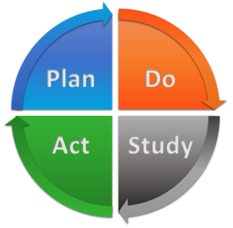
The four stages of the PDSA cycle are:
- PLAN – the engagement, experience and inclusion activity, including identifying measurable outcomes. The CCG carries out Equality and Engagement Impact Assessments to inform the design of engagement activities e.g. targeting certain interested or under-represented groups. This is done in order to maximise opportunities and minimise risks to the effectiveness of any engagement activities.
- DO – undertake the engagement, experience and inclusion activity – modify during the engagement period as required in response to feedback and opportunities identified
- STUDY – based on the measurable outcomes agreed before starting out, reflect on the impact of the engagement, experience and inclusion activity and identify what went well and what could be improved – see Engagement, Experience and Inclusion Evaluation Framework below
- ACT - Plan future activity, modify in response to Study outcomes
Engagement, Experience and Inclusion Evaluation Framework: The Science and Technologies Facilities Council has developed a useful engagement evaluation framework, https://stfc.ukri.org/files/corporate-publications/public-engagement-evaluation-framework/

We have adapted this to support the STUDY element in our Engagement, Experience and Inclusion PDSA Cycle

Dimension | Definition
Inputs | Engagement, experience and inclusion inputs include the time, skills and money that are invested into delivering engagement activities.
Outputs | Engagement, experience and inclusion outputs are the activities we undertake and the resources that we create.
Reach | Reach has two main elements:  - The number of people engaged, this includes attendance at events, completion of surveys, social media interaction etc  - The types or diversity of people engaged.
Outcomes | Outcomes are the way that audiences respond to the engagement, experience and inclusion activity – completed event evaluation forms, independent observation reports
Processes | Processes are the way we work to plan, develop and deliver our engagement, experience and inclusion activities. They include our approaches to quality assurance and following good practice.

Reviewing the effectiveness of this Strategy
Following the approach set out in ‘Our open culture’ Strategy we expect that:
- ‘quiet voices’ are heard;
- we are an open organisation, which is flexible in its approach to change and is willing to share power i.e. open to influences on decision making;
- we value and learn from the experiences of everyone involved in promoting, delivering and receiving health, wellbeing and care in Gloucestershire;
- the views of local people are sought in a variety of ways, tailored and adapted to the needs of individuals who experience care and to local communities;
- the needs and the views of the population of Gloucestershire inform the decisions of the CCG throughout the stages of the commissioning cycle using the ‘Engagement Cycle’;
- that where there are health inequalities in Gloucestershire we tailor our approach to experience and engagement to support their reduction;
- we have mutually beneficial trusting relationships with individuals, groups, ‘anyone and everyone’ and our strategic partners;
- ‘health literacy’, shared decision making and co-production are increased;
- our Member GP practices and their Patient Participation Groups are more involved;
- levels of understanding of the challenges facing the NHS locally amongst Gloucestershire’s residents are increased;
- the NHS’s reputation locally is maintained;
- the CCG meets its legal duty to involve the public in the commissioning process as set out in the NHS Act 2006, amended in the Health and Social Care Act 2012 and the NHS Constitution 2010;
- opportunities are available for all to be engaged, either directly or indirectly, if they choose to be, and these are promoted;
- we are delivering our statutory and good practice obligations under the Equalities Act 2010, endeavouring to work with a wide cross-section of the people who use or may use NHS funded services locally;
- we are evaluating the effectiveness of our engagement and learning from our experience and your feedback; and
- we are being ‘commissioners on the ground’.
Independent observation, oversight, assurance and audit
In addition to internal evaluation activities, we seek external feedback from others.
Observation: Healthwatch Gloucestershire, as well as being engagement delivery partners and co-producers, also observe the quality and effectiveness of engagement and consultation activities led by the CCG e.g. in 2017/18 Healthwatch produced a report based on Healthwatch volunteers observations during the engagement undertaken to identify a location for a new community hospital in the Forest of Dean.
Oversight: Associated with the same project (Forest of Dean Community Hospital), the CCG and provider partner commissioned independent facilitation of a Citizens Jury to hear evidence and provide recommendations to decision makers. The Citizens Jury process was overseen by an independent Oversight Panel made up of Healthwatch Gloucestershire, the Voluntary Sector Alliance and a local elected District Council representative.
Assurance: NHS England has developed a ‘Patient and Community Engagement Indicator’ as part of the annual CCG Improvement and Assessment Framework. The CCG has an opportunity to demonstrate compliance against a series of quality Domains to gain assurance:
1. Involve the Public in governance
2. Explain public involvement in commissioning plans
3. Demonstrate public involvement in Annual Reports
4. Promote and publicise public involvement
5. Assess, plan and take action to involve
6. Feedback and Evaluate
7. Implement assurance and improvement systems
8. Advance equality and reduce health inequality
9. Provide support for effective engagement
10. Hold providers to account

As mentioned above the CCG is a member of The Consultation Institute (tCI). tCI offers a range of Quality Assurance services to assist public bodies to navigate consultations. When the time is right to hold the consultation itself, tCI recommend using our compliance assessment methodology to ensure we fully meet best practice standards. Subject to those standards being met, tCI will then be able to certify that the consultation has been Independently Assessed and Quality Assured by the Consultation Institute. This process helps to improve the quality of consultation throughout the organisation, improving reputation and mitigating many other risks.
Audit: The CCG has an annual internal audit programme, which regularly reviews the organisation’s functions, for instance in 2019/20 the CCG Complaints function will be subject to an internal audit review.
Engagement, Experience and Equality Annual Report
Each year we produce an Engagement, Experience and Equality Annual Report, which includes case studies to show how our activities have an impact.
https://www.gloucestershireccg.nhs.uk/about-us/equality-diversity/reports/
https://www.gloucestershireccg.nhs.uk/about-us/equality-diversity/case-studies/

CCG Annual Report
The CCG produces an annual report, which includes information to comply with the legal duty to involve patients and the public in commissioning. The CCG follows the guide produced by NHS England to support the development of our annual report https://www.england.nhs.uk/participation/resources/ccg-reportingpublicpart/
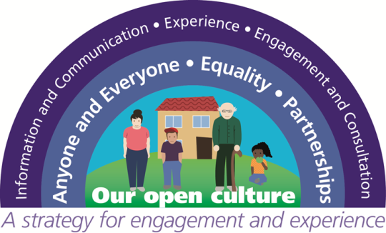

The Care Quality Commission’s (CQC) role is to check whether hospitals, care homes, GPs, dentists and services in your home are meeting national standards. The CQC does this by inspecting services and publishing its findings, helping people to make choices about the care they receive.

