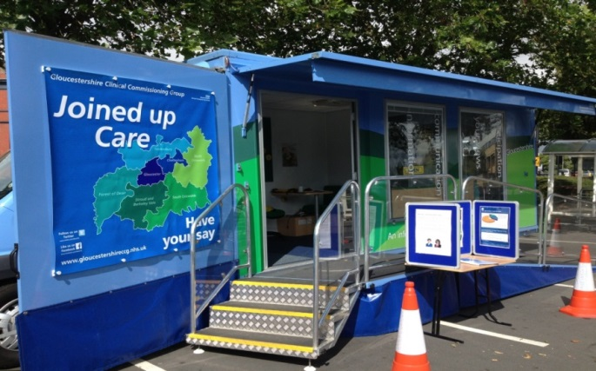

NHS GCCG Information Bus Schedule
The Information Bus provides the opportunity for people to come and talk to us about their queries or concerns on any health, social care or disability.

The schedule below lists dates the Information Bus will be out during July 2019. The focus of the Bus visit varies but we are always happy to receive your feedback on the NHS.

Date | Time | Venue | Topic
Monday 1st July | 10am – 3pm | The Cross, Gloucester City Centre | Blood Pressure testing
Tuesday 2nd July | 10am – 3pm | Kings Square, Gloucester | Blood Pressure testing
Wednesday 4th July | 10am – 3pm | Outside M&S, Cheltenham Town Centre | Remembering Srebrenica
Friday 5th July | 10am – 3pm | Cinderford Co-op | Fostering / Family Link
Saturday 6th July | 10am – 3pm | Hucclecote | Hucclecote Hullabaloo
Monday 8th July | 10am – 3pm | Morton in Marsh Town Centre | Family Link
Thursday 11th July | 10am – 3pm | Tewkesbury Hospital | Hydration Awareness
Friday 12th July | 10am – 3pm | Outside M&S, Cheltenham Town Centre | Family Link
Wednesday 12th June | 10am – 3pm | Cinderford Co-op | Carers Week, People Plus
Tuesday 16th July | 10am – 3pm | Stroud Hospital | Hydration Awareness
Wednesday 17th July | 10am – 3pm | Cirencester Hospital | Hydration Awareness
Monday 22nd July | 10am – 3pm | The Cross, Gloucester City Centre | Long Term Plan Engagement
Tuesday 23rd | 10am – 3pm | Cirencester Market Place | Long Term Plan Engagement
Thursday 25th July | 10am – 3pm | Parsonage Street, Dursley | Long Term Plan  Engagement
Monday 29th July | 10am – 3pm | Morrisons, Tewkesbury | Long Term Plan Engagement
Tuesday 30th July | 10am – 3pm | Budgens, Morton in Marsh | Long Term Plan Engagement
Wednesday 31st July | 10am – 3pm | Gloucestershire Royal Hospital | Hydration Awareness

