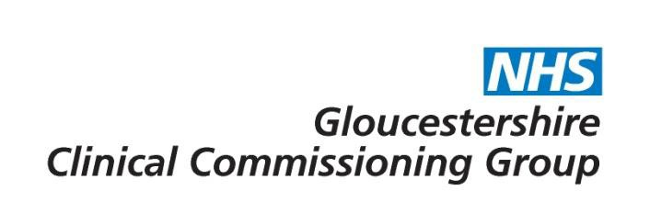

Risk Reducing Surgery – Mastectomy or Oophorectomy

Commissioning decision | The CCG will provide funding for risk reducing surgery for patients with a mutation, high risk patients or high risk families confirmed by our Genetics Service in Bristol who meet the criteria. The policy does not cover women who have a personal history of breast cancer.

Policy Statement:
Risk reducing mastectomy or oophorectomy is commissioned if ONE of the following indications applies:

- Women who have a mutation such as BRCA1, BRCA2 or TP53 (other genes may be relevant such as Lynch, RAD51C/D) confirmed by our Genetics Service in Bristol
- Women from high risk families with a family history confirmed where no mutation has been identified, and a first degree relative with a breast/ovarian cancer
- Women identified as high risk by the Clinical Genetics Service without a gene mutation
- Women who have had lymphoma and have undergone mantle radiotherapy (these patients will not have been reviewed by Clinical Genetics)
- Women at high risk of ovarian cancer

AND
- Undergone genetic and psychological counselling with risk assessed by the Clinical Genetics Service (with the exception of lymphoma patients who have had mantle radiotherapy and undergone psychological counselling)
- Chemoprevention has been discussed for post-menopausal women at high risk of developing breast or ovarian cancer
- Modifiable risk factors have been discussed and patients have been signposted to Healthy Lifestyles Gloucestershire if appropriate

Risk-reducing surgery will not usually be commissioned for:
- People who have a limited life expectancy from their cancer or conditions

Rationale:
Risk reducing surgery will be offered to patients who have a high risk of developing breast or ovarian cancer. As patients are prepared to accept different levels of risk they should have been referred and assessment made by the Clinical Genetics Team, including genetic counselling to enable communication of risk. Due to the psychological impact of this diagnosis psychological counselling may also be appropriate.

Plain English Summary:
What is risk reducing surgery?
Risk reducing surgery is an operation that removes healthy body tissue in order to significantly reduce the risk of cancer developing. It can be used to reduce the risk of developing both breast and ovarian cancer. Risk reducing breast surgery removes the breast tissue (called a mastectomy) and risk reducing ovarian surgery removes the ovaries and fallopian tubes (called an oophorectomy).
What does this policy mean for me?
Risk reducing surgery is only appropriate for a small number of women with a high risk of developing breast or ovarian cancer in their lifetime. The policy sets out the criteria that a patient should meet in order for risk reducing surgery to be funded by the NHS in Gloucestershire.

Evidence base:
Familial breast cancer: classification, care and managing breast cancer and related risks in people with a family history of breast cancer – https://www.nice.org.uk/guidance/cg164, The National Institute for Health and Care Excellence

Prophylactic surgery in hereditary breast/ovarian cancer syndrome - http://www.ncbi.nlm.nih.gov/pubmed/12886864, The National Center for Biotechnology Information

Link to application form – Not applicable
For further information please contact GLCCG.IFR@nhs.net

Date of publication | 1 August 2018
Policy review date | December 2020

Consultation
Consultee | Date
GHNHSFT | December 2017
GP Membership (via What’s New This Week) | July/August 2018
Has the consultation included patient representatives? | Yes (via ECCP membership)

Policy sign off
Reviewing Body | Date of review
Effective Clinical Commissioning Policy Group | 01/02/2018
Integrated Governance and Quality Committee | 21/06/2018

Version Control

Version No | Type of Change | Date | Description of Change
2 | Plain English summary & review date | 11.6.2020 | Plain English summary wording updated. Review date changed to December 2020.

