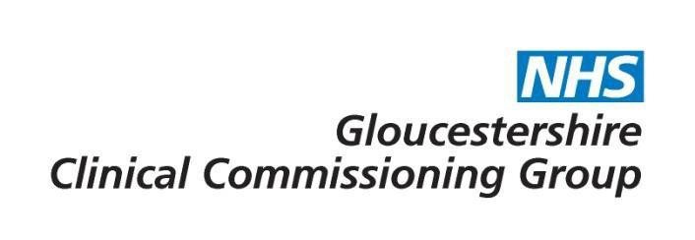

Excimer laser eye surgery

Commissioning decision | The CCG will provide funding for Excimer laser eye surgery for patients who meet the criteria defined within this policy.

Policy Statement:
Excimer laser treatments are only funded when all of the following criteria are met:
- Treatment is subject to evaluation as agreed in the commissioning risk management plan AND
- The patient would otherwise require surgical treatment of their corneal disorder i.e. manual debridement, corneal graft or arcuate keratotomy.
AND
- The patient requires one of the following procedures in (a) or (b) below, for the conditions specified:
  - Phototherapeutic keratectomy (PTK):

    - Superficial and stromal corneal dystrophies and degenerations (including band keratopathy, granular dystrophy, macular dystrophy, lattice dystrophy and Reis-Bückler's dystrophy); or
    - Epithelial membrane dystrophy; or
    - Irregular corneal surfaces secondary to degenerations including Salzmann's nodular degeneration, Spheroidal degeneration, or keratoconus nodules; or
    - Corneal scars and opacities (including post-traumatic, post-infectious, post- surgical, and secondary to pathology); or
Recurrent corneal erosions when more conservative measures (e.g., lubricants, bandage contact lenses, course of oral Doxycyline treatment, gentle debridement of severely aberrant epithelium) have failed to halt the erosions.

  - Photorefractive Keratectomy (PRK), laser assisted epithelial keratomileusis (LASEK) and laser assisted in situ keratomileusis (LASIK) procedures following corneal transplant surgery or cataract surgery when there is both:
    - Post-operative regular astigmatism greater or equal to 2.00 dioptres or irregular astigmatism or anisometropia (the difference in optical power between the two eyes) greater or equal to 2.00 dioptres;
AND
    - The patient must be intolerant of spectacles or contact lenses, as assessed by a Corneal Consultant Ophthalmologist (based upon review of symptoms and clinical examination including refraction by an optometrist and corneal topography after a period of spectacle or lens wear).

Rationale:
Current evidence suggests that photorefractive (laser) surgery for the correction of refractive errors is safe and efficacious in appropriately selected patients. However, refractive errors are usually corrected by wearing spectacles or contact lenses, and so laser surgery is not commissioned for conditions that can be treated in this way.

Plain English Summary:
In recent years laser surgery, or laser refractive surgery, has become more popular as a way to correct eyesight. The surgery usually involves reshaping the cornea – the transparent layer covering the front of the eye. This is done using a type of laser known as an excimer laser.

Laser refractive surgery is generally considered non-essential, so it's not usually available on the NHS. However, if your doctor believes that you meet the criteria set out in this policy the CCG will fund your treatment.

Evidence base:
NICE IPG 164 - Photorefractive (laser) surgery for the correction of refractive errors.

Similarity of neighbouring CCG policies – West Midlands

Link to application form – Not applicable
For further information please contact GLCCG.IFR@nhs.net

Date of publication | 1st October 2015
Policy review date | June 2024

Consultation
Consultee | Date
Clinical Programme Group | 30th June 2015
GHNHSFT (via CPG) | 30th June 2015
GP Membership (via CCG Live/What’s New This Week) | 10th July – 7th August 2015
Has the consultation included patient representatives? | Yes (via CPG and ECCP membership)

Policy sign off
Reviewing Body | Date of review
Effective Clinical Commissioning Policy Group | 3rd August (virtual)
Integrated Governance and Quality Committee | 20th August 2015

Version Control

Version No | Type of Change | Date | Description of Change
1 |  | 01.10.2015
2 | Review date change | 03.05.2018 | Policy review date changed to May 2019
3 | Review date change | 21.06.2018 | Response received from Prof Andy McNaught. Policy review date changed to March 2021
4 | Review date change | 10.06.2021 | Policy reviewed by G Mennie, Ophthalmic Lead – no changed required. Policy date changed to June 2024

