NAME OF POLICY: | Whistleblowing Policy (raising concerns at work)
JOB TITLE OF AUTHOR: | Associate Director of Corporate Governance
SPONSOR: | Accountable Officer
NAME OF GROUP:  (if applicable) | Quality and Governance Committee
EQUALITY AND DIVERSITY – Mandatory Requirement
An Equality & Diversity assessment has been completed  (Please contact the Equality & Diversity Lead) |  |  | Date Completed:  4th August 2015
CONSULTATION
NAME OF GROUP (S) (complete where relevant) |  |  | DATE CONSIDERED
Name of Local Committee or Specialist Group?

Name of Countywide Committee or Specialist Group? County Wide  Policy  YES / NO |  |  | *
Other relevant Forum/Individual? |  |  | *
APPROVED BY GOVERNING BODY / Q&GC
NAME i.e. Governing Body  Quality and Governance Committee |  |  | DATE APPROVED
 |  |  | August 2021
TO BE REVIEWED BY: (Author) |  |  | DATE TO BE REVIEWED:
Associate Director of Corporate Governance |  |  | August 2024
TO BE COMPLETED BY CO-ORDINATOR
DATE PUT ONTO POLICY REGISTER: |  | August 2015
POLICY NUMBER: |  | 1
DATE PLACED ON INTRANET: |  | V3 December 2017

Whistleblowing Policy
“Freedom to Speak Up”

Version | 4
Policy ID No | 1
Author | Associate Director of Corporate Governance
Sponsor | Accountable Officer
Approved By | Quality and Governance Committee
Approval Date | August 2021
Review Date | August 2024

This document may be made available to the public and persons outside of the CCG as part of the CCG’s compliance with the Freedom of Information Act 2000.

Contents
1. Introduction 4
2. Scope of the Policy 5
3. Aims and Objectives 5
4. Roles and Responsibilities 6
5. Raising Concerns Internally 6
6. Process for Internal Disclosure to your Line Manager 7
7. Process for Internal Disclosure to the Freedom to Speak Up Guardian 7
8. Process for Internal Disclosure to the Accountable Officer, Lay Member or Clinical Chair 8
9. Resolving Concerns 8
10. Referral to the Chair for matters relating to the Accountable Officer or Directors 9
11. If you are dissatisfied 9
12. External contacts 9
13. Making a ‘protected disclosure’ 10
14. Monitoring and Review 10
15. Useful Contacts 10
16. References and Further Information 10

Introduction

  - Whistleblowing is the disclosure of information which relates to suspected wrongdoing or dangers at work. Refer to Appendix 1 for examples. Whistleblowing can inform those who need to know about unsafe working practices, potential environmental problems, fraud, corruption, bribery, coverups, bullying and many other problems. Through whistleblowing, this information comes to light and can be addressed before any real damage is done.
  - All of us at some time may have concerns about what is happening at work. Usually these concerns are easily resolved. However, when a concern feels serious because it’s about possible danger to patients, the public or colleagues, professional misconduct or financial malpractice (including fraud, bribery or corruption), it can be difficult to know what to do. You may be worried about raising such issues, perhaps feeling it is none of your business or that it is only a suspicion. You may feel that raising the matter would be disloyal to colleagues, to managers or to the CCG. You may have already said something but found that you spoke to the wrong person or raised the issue in the wrong way and are not sure what, if anything to do next. If something is troubling you which you think we should know about or look into, please use this policy for guidance.
  - A whistleblowing concern should not be confused with a grievance, which is a personal complaint about an individual’s own employment situation. The CCGs’ Grievance Procedure should be referred to for further information on this.
  - NHS professionals have a duty to report concerns therefore if in doubt, please raise it. Employees making a disclosure in the interests of the public have legal rights to protection from victimisation under the Public Interest Disclosure Act 1998. The act protects NHS employees after they have made a qualifying disclosure (a disclosure of information about malpractice). However, to be awarded this protection you must:
        - make the disclosure in good faith (which means with honest intent and without malice);
        - reasonably believe that the information is substantially true;
        - reasonably believe you are making the disclosure to the right 'prescribed person'.

  - This policy takes into account guidance issued under the ‘Freedom to speak up: raising concerns (whistleblowing) policy for the NHS’ (2016). The need for an independent National Guardian for the NHS was highlighted in Sir Robert Francis’s Freedom to Speak Up review in February (2015) , which found that patients could be put at risk of harm because vital information about mistakes and concerns was not being raised by NHS staff routinely. The creation of the National Guardian was one of the key recommendations from the review. The Freedom to speak up review included a visual for raising concerns in the NHS illustrating a user led vision for how concerns handling should be handled. This diagram is available in Appendix A.
  - You may raise a concern about risk, malpractice or wrongdoing you think is harming the service we commission. A few examples of this may include (but are not restricted to):
        - Unsafe patient care
        - Unsafe working conditions
        - Inadequate induction or training for staff
        - Lack of, or poor response to a reported patient safety incident
        - A bullying culture
        - Suspicions of fraud, bribery and/or corruption (which may also be reported to the Local Counter Fraud Service or the NHS Counter Fraud Authority)

  - An example process for raising and escalating a concern is detailed in Appendix 2.

Scope of the Policy
  - This policy applies to all CCG staff, whether you are in a permanent or temporary post, on the bank, an agency/contract worker or a volunteer. It applies to all areas of the organisation without exception.

Aims and Objectives

  - Your Safety
    - The Governing Body is committed to this policy and takes malpractice or wrongdoing seriously. If you raise genuine concerns under this policy, you will not be at risk of losing your job or suffering any form of retribution as a result provided that you are acting in good faith. It does not matter if you are mistaken or if there is an innocent explanation for the concern, therefore please do not think we will ask you to prove it.
    - The policy encourages you to raise concerns with your manager or others where appropriate in the first instance and provides protection to staff for Whistleblowing on wrong-doing when their actions are not spurious or malicious in intent.
  - Your Confidence
    - We will not tolerate the harassment or victimisation of anyone who raises genuine concerns and doing so would be considered misconduct under the CCG’s Disciplinary Policy. However, we recognise that you may nevertheless be anxious. If so, you can ask to talk to someone in private. If you ask us not to disclose your identity, we will not do so without your agreement first. If the situation arises where we are not able to resolve the concern without revealing your identity (for instance because evidence is needed in court), we will discuss with you on how we can proceed.
  - Anonymous Reports
    - Remember that if you do not tell us who you are, it will be much more difficult for the concern to be investigated and for us to protect your position or give you feedback. All anonymous reports will be looked into but it may not be appropriate for the matter to be dealt with under this policy.
  - Representation
    - If you raise a concern you will have the right to seek and be represented by a trade union representative or work colleague at all stages.

Roles and Responsibilities
  - The Clinical Commissioning Group, (the CCG): Is committed to ensuring the highest possible standards of service and the highest possible ethical standards in delivering this service. It is the responsibility of all staff to ensure that if they become aware that the actions of other employees of the CCG or anyone working for, with or connected to it might compromise this objective, they will be expected to raise the matter.
  - The Governing Body: Will promote a culture of openness that welcomes the opportunity to address and resolve concerns. The Governing Body will respond positively to any escalated concerns, either taking or arranging appropriate action.
  - Managers: Must ensure that they are familiar with this policy and that their staff understand how to access and implement the policy. Managers should understand that the individual staff member may feel as though they are in a difficult position by raining their concerns.
  - Freedom to Speak Up Guardian: Will act as an independent and impartial source of advice to staff at any stage of raising a concern, with access to anyone in the organisation, or if necessary, outside the organisation.

Raising Concerns Internally

  - If you have a concern that you feel needs to be raised, then the following options are available to you:
    - Internal disclosure to your Line Manager.
    - Internal disclosure to the Freedom to Speak Up Guardian for the CCG. This is the Executive Nurse and Quality Lead or the Chief Finance Officer in their absence.
    - Internal disclosure to the Accountable Officer and Lay Members.
  - You can initially raise your concerns with any of the above persons. However, we would encourage you to initially raise them with those identified on point 1 and 2 above. If your concerns remain unresolved after utilising these options, we encourage you to raise them with either the Accountable Officer or Lay Member. If your concerns are of such gravity you may wish to raise them immediately with a Lay Member and this option is open to you.
  - All issues raised under this policy will be reported to the Clinical Chair of the CCG within 10 working days of receipt. Line managers and designated officers are responsible for ensuring this takes place.

Contact details for the Clinical Chair are:

Clinical Chair
Gloucestershire CCG
Sanger House
5220 Valiant Court
Gloucester Business Park Brockworth
Gloucester
GL3 4FE

We recommend that if you raise a concern via correspondence the envelope is clearly marked “confidential” and “to be opened by addressee only” to help us maintain your confidentiality as far as possible.

Process for Internal Disclosure to your Line Manager

  - All managers have an ongoing responsibility for the provision and operation of this policy within the workplace.
  - You can meet with your manager or another relevant senior manager to discuss your concerns, or alternatively you may prefer to put your concerns in writing. All attempts will be made to resolve the matter informally and your manager will take the necessary steps to do this and record them and send the details to the Clinical Chair of the CCG within 10 working days of the notification of the concern. You should make clear at the outset and both agree that the provisions of this policy are being used and followed.

Process for Internal Disclosure to the Freedom to Speak Up Guardian
  - The CCG has a designated Freedom to Speak Up Guardian who is an independent officer who can be contacted to discuss any concerns in confidence.
Contact details of the Freedom to Speak Up Guardians are:

Patient Experience & Safety Manager
Sanger House
5220 Valiant Court Gloucester Business Park Brockworth
Gloucester
GL3 4FE

and

Governance Manager
Sanger House
5220 Valiant Court Gloucester Business Park Brockworth
Gloucester
GL3 4FE

  - If you feel the issues raised have not been addressed by the Designated Officer you can escalate this to the Accountable Officer, a Lay Member or the Clinical Chair.

Process for Internal Disclosure to the Accountable Officer, Lay Member or Clinical Chair
  - If you wish to raise an issue directly with the Accountable Officer or Lay Member or escalate a previously reported unresolved concern the address is as follows:

Sanger House
5220 Valiant Court
Gloucester Business Park Brockworth
Gloucester
GL3 4FE

  - You are able to raise concerns with any Lay Member, the following Lay Members have been specifically identified to be nominated contacts:

Mr Alan Elkin, Lay Member – Patient and Public Involvement: alan.elkin@nhs.net

  - Communications to Lay Members should be made through the Accountable Officer’s Office at Sanger House.

Resolving Concerns

  - Upon receipt of concerns an initial meeting will be held where you can outline the issue; this meeting will be held in the strictest confidence. You will be offered an option to make a verbal or written statement; in either case, the manager/designated officer will write a brief summary of the meeting which will be mutually agreed between both of you.
  - An investigation may be commissioned and will be undertaken by an appropriately trained and experienced member of staff. This may be the person to whom you addressed your concerns.
  - Once the investigation has been concluded, you will receive a response within 10 working days of the final outcome for consideration of the concern. You will also be kept up to date of the progress of the investigation by the appointed Investigating Officer.

Referral to the Chair for matters relating to the Accountable Officer or Directors
  - If your concern relates to the Accountable Officer or a Director you should raise the concerns directly with the Clinical Chair, who will in turn commission an appropriate investigation.

If you are dissatisfied
  - While the CCG cannot guarantee that you will be satisfied with the response, it is the CCG’s aim to handle the matter fairly and properly. By using this policy, you will help us to achieve this. If you remain dissatisfied following the internal procedures, there may be circumstances where you wish to raise your concerns externally.

External contacts

  - Whilst we hope that this policy gives you the reassurance for you to raise any matters internally, we recognise that there may be circumstances where you wish to seek advice or report matters to bodies outside of the CCG.
  - You are encouraged to resolve all issues internally however should you feel it is necessary to go outside of the organisation to resolve your concerns you may be expected to provide a higher level of proof to substantiate your concerns.
  - You can also raise concerns with an outside body:
- NHS Improvement for concerns about:
    - NHS Procurement, choice and competition
    - The national tariff
- Care Quality Commission for quality and safety concerns
- NHS England for concerns about Primary Medical Services (general practice)
- Health Education England for education and training in the NHS
- NHS Counter Fraud Authority for concerns about fraud and corruption

  - These bodies have their own procedures relating to investigations which you can enquire about and follow.
  - Public Concern at Work will be able to advise you on such an option if you wish.

Making a ‘protected disclosure’
  - There are very specific criteria that need to be met for an individual to be covered by whistleblowing law when they raise a concern (to be able to claim the protection that accompanies it). There is also a defined list of ‘prescribed persons’ available from the Department of Business, Energy, & Industrial Strategy, who you can make a protected disclosure to.
  - To help you consider whether you meet these criteria, please see independent advice from the Whistleblowing Helpline (0800 724 725) for the NHS and social care, Public Concern at Work or a legal representative.

Monitoring and Review
  - The Governing Body will be responsible for auditing the effectiveness of this policy. The policy will be monitored and activity under this policy will be reported by the Clinical Chair at scheduled Governing Body meetings
  - This policy will be reviewed after 3 years or earlier on the request of either the CCG or staff side of the recognised consultative forum.

Useful Contacts

Human Resources Department (ConsultHR)
Tel: 0300 123 6220
Email: operations.consulthr@nhs.net
Write: ConsultHR, West Swindon Health Centre, Link Avenue, Swindon, SN5 7DL

Local Counter Fraud Service
Tel: 0300 422 2726 / 0300 422 2753
Email ghn-tr.fraudAccountMailbox@nhs.net

The NHS Counter Fraud Authority
Tel: 0800 028 4060
Website: https://cfa.nhs.uk/reportfraud

Protect: Free, confidential whistleblowing advice
Tel: 020 3117 2520

Speak Up: Free, independent, confidential advice on the speaking up process:
Website: https://speakup.direct/
Tel: 08000 724 725

References and Further Information

- Public Interest Disclosure Act (1998) available at: http://wbhelpline.org.uk/resources/public-interest-disclosure-act/
- NHS Improvement (2016); Freedom to speak up: raising concerns (whistleblowing) policy for the NHS; available at: https://improvement.nhs.uk/resources/freedom-to-speak-up-whistleblowing-policy-for-the-nhs/
- Sir Robert Francis (2015); Report on the Freedom to Speak Up review; available at https://www.gov.uk/government/publications/sir-robert-francis-freedom-to-speak-up-review.
- Whistleblowing: list of prescribed people and bodies, (2019), https://www.gov.uk/government/publications/blowing-the-whistle-list-of-prescribed-people-and-bodies--2/whistleblowing-list-of-prescribed-people-and-bodies
- Raising a Concern with the CQC; Care Quality Commission; available at: https://www.cqc.org.uk/about-us/our-purpose-role/who-we-are
- Department of Business, Energy, & Industrial Strategy (2020); Whistleblowing: list of prescribed people and bodies; available at: https://www.gov.uk/government/publications/blowing-the-whistle-list-of-prescribed-people-and-bodies--2/whistleblowing-list-of-prescribed-people-and-bodies

Appendix 1
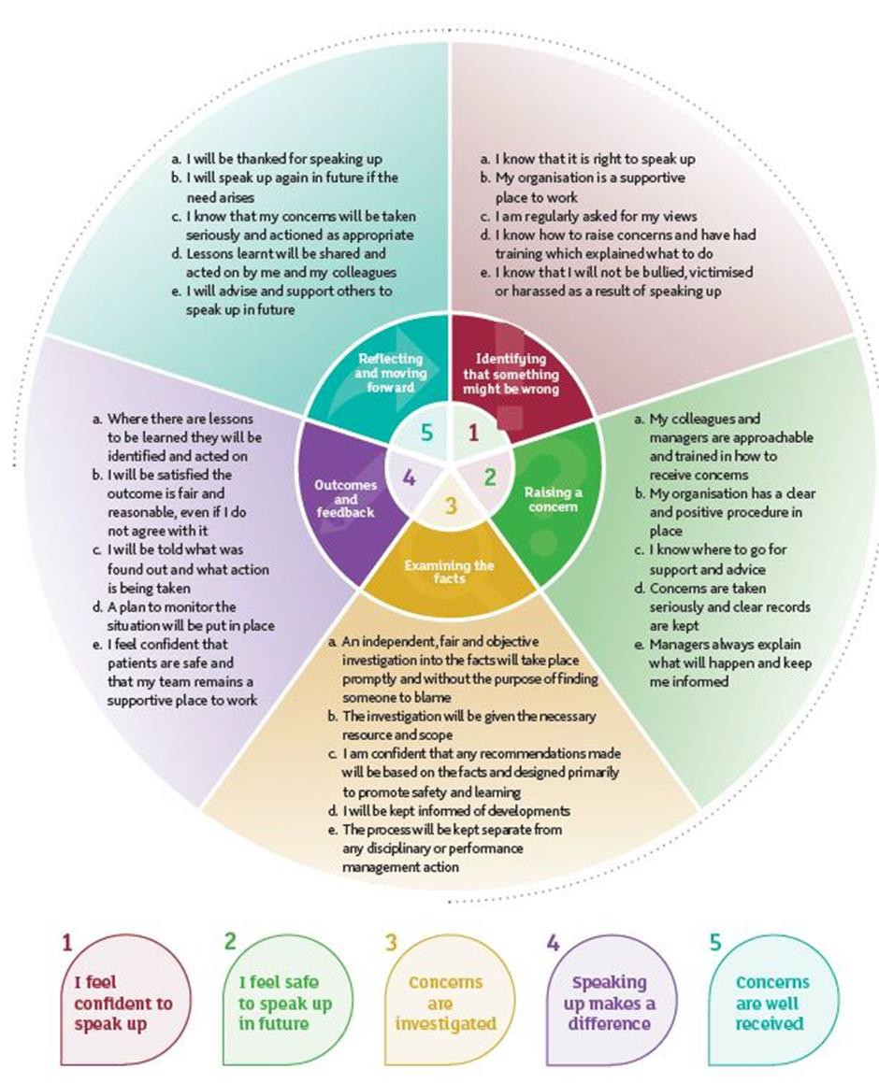
Source: Sir Robert Francis QC (2015) Freedom to Speak Up: an independent report into creating an open and honest reporting culture in the NHS.

Appendix 2
Example process for raising and escalating a concern

Step one

If you have a concern about a risk, malpractice or wrongdoing at work, we hope you will feel able to raise it first with your line manager. This may be done orally or in writing.

Step two

If you feel unable to raise the matter with the line manager, for whatever reason, please raise the matter with our local Freedom to Speak Up Guardian (details can be found at point 7):

This person has been given special responsibility and training in dealing with whistleblowing concerns. They will:

Treat your concerns confidentiality unless otherwise agreed
Ensure you receive timely support to progress your concern
Escalate to the board any indications that you are being subjected to detriment for raising your concern
Remind the organisation of the need to give you timely feedback on how your concern is being dealt with
Ensure you have access to personal support since raising concerns may be stressful

If you want to raise the matter in confidence, please say so at the outset so that appropriate arrangements can be made.

Step three

If these channels have been followed and you still have concerns, or if you feel that the matter is so serious that you cannot discuss it with any of the above, please contact those officers mentioned at point 4 of this policy.

Step four

You can raise concerns formally with external bodies

