POLICY AUTHORISATION FORM

1  NAME OF POLICY: | Learning Disabilities and Autism Review (LeDeR) Policy Framework and 3 year strategy
JOB TITLE OF AUTHOR: | Outcome Manager – Integrated Disabilities Commissioning
SPONSOR: | Dr Marion Andrews-Evans (Director of Nursing and Quality)  Kim Forey (Director of Integrated Commissioning)
NAME OF GROUP:  (if applicable) | Gloucestershire LeDeR Governance and Steering Group
2
EQUALITY AND DIVERSITY – Mandatory Requirement
An Equality & Diversity assessment has been completed  (Please contact the Equality & Diversity Lead) |  |  | Date Completed:  Jan 2022
CONSULTATION
NAME OF GROUP (S) (complete where relevant) |  |  | DATE CONSIDERED
Name of Local Committee or Specialist Group?  Gloucestershire LeDeR Governance and Steering Group |  |  | September 2021  January 2022
Name of Countywide Committee or Specialist Group?  Learning Disability and Autism Clinical Programme Group  County Wide Policy YES |  |  | September 2021  January 2022
Other relevant Forum/Individual?  CCG Core Management Group |  |  | TBC
3
APPROVED BY GOVERNING BODY / Q&GC
NAME  Quality and Governance Committee |  |  | DATE APPROVED
 |  |  | February 2022
TO BE REVIEWED BY: (Author) |  |  | DATE TO BE REVIEWED:
LeDeR Local Area Contact |  |  | February 2025
4
TO BE COMPLETED BY CO-ORDINATOR
DATE PUT ONTO POLICY REGISTER:

POLICY NUMBER: |  | 100
DATE PLACED ON INTRANET:

POLICY UPDATES/CHANGES
(AFTER GOVERNING BODY/Q&GC APPROVAL)
Date | Summary of Changes | Author/Editor | Approved by | Version
February 2022 | Updated to reflect national policy changes and local operational requirements. Included 3 year strategy | Cheryl Hampson |  | 2
The Policy Authorisation Form is part of the overall policy template and forms the front of the document and must be completed in all cases

Equality and Diversity - Part 2 of the form (Appendix 1)

The policy should be checked to see if it has any adverse effect on any personal group covered by Discrimination Legislation. In order to do this an ‘Impact Assessment’ must be completed. Further advice can be obtained from the Equality and Diversity Lead.

Approval & Review - Part 3 of the form

Once the Policy has been approved the name of the group / individual and date of approval should be included. The policy document should be sent to the Policy Co-ordinator to log on the Policy Register.

Review and amendments are the responsibility of the Author and Director of the Policy and a date for review must be set and included on the form. However, the Policy Co-ordinator will give a reminder to an author when a policy is overdue a review. The review date must be at least annually.

If, after a review, changes are made the document must be resubmitted, by the Author, for approval and therefore the ‘Policy for Policies’ must be followed again. Any changes should be included in the necessary ‘Policy updates/changes’ section at the beginning of the document.

CCG Policy Spreadsheet ‘ Information Register’- Part 5 of the form

The Policy Co-ordinator will input the approved policy onto the Policy Register and allocate a Policy Number which will be inserted onto the authorisation form and also communicated to the Author via email. The Policy Co-ordinator will also ensure that after a review a new version number is allocated and noted on the register.

LeDeR – Learning from Lives and Deaths of people with a Learning Disability and autism Policy Framework
and
3 year strategy
2022-2025

Version | 2
Policy ID No | 100
Author | Outcome Manager Learning Disabilities Health
Sponsor | Director
Approved By | Gloucestershire CCG Quality And Governance Committee
Approval Date | February 2022
Review Date | February 2025

This document may be made available to the public and persons outside of the CCG as part of the CCG’s compliance with the Freedom of Information Act 2000.

CONTENTS

Section | Section Heading | Page Number
1  2 | EXECUTIVE SUMMARY  INTRODUCTION, BACKGROUND AND RATIONALE | 5  7
3 | PURPOSE, VISION, AIM AND OBJECTIVES | 9
4 | GOVERNANCE, ROLES AND RESPONSIBILITIES | 11
5 | DEFINITION | 17
6 | POLICY DETAILS | 18
7 | CONSULTATION | 21
8 | TARGET AUDIENCE | 21
9 | COMMUNICATION | 22
10 | TRAINING | 22
11 | REFERENCES AND APPENDICES | 23
SUPPORTING DOCUMENTS

Appendix 1 | Equality Impact Assessment
Appendix 2 | Detailed LeDeR Process Pathway
Appendix 3 | Terms of reference for Gloucestershire LeDeR Governance and Steering Group
Appendix 4 | Terms of reference for Gloucestershire LeDeR Quality Assurance and Governance Panel
Appendix 5 | Terms of reference Gloucestershire Learning into Action Working Group
Appendix 6 | Gloucestershire Quality Assurance and Governance Panel Checklist
Appendix 7 | Guidance on the grading of care for local reviewers
Appendix 8 | Template for Learning into Action Tracker

Forward

The terms autism and autistic are used throughout this document since many individuals and their families prefer to be identified as autistic. However, there is no universally accepted terminology. Awareness of preferences is important when talking to individuals and their families and carers. It is also important to acknowledge that autistic individuals and their families may prefer words such as ‘condition’ instead of ‘disorder’, and ‘difference’ instead of ‘impairment’.

Nonetheless, for the purposes of LeDeR review processes, official clinical terminology will be used to describe accurately the diagnosis that was recorded in clinical notes.

EXECUTIVE SUMMARY
  - The new LeDeR National Policy published on 23rd March 2021 will give the local LeDeR programme opportunities to further strengthen the operational, governance and service improvements and extend this to autistic adults as well during the course of the coming three years.

  - Gloucestershire ICS “One Gloucestershire” must systematically act upon findings in LeDeR reviews and improve the care provided by all services (not just Learning Disability specific services) to stop people dying prematurely and provide better quality services.

  - NHS England and NHS Improvement will hold ICSs to account for the delivery of the actions identified in reviews as part of their assurance processes so that ICSs improve the ways that local health and care services meet the needs of people with a Learning Disability and autistic people. The LeDeR Programme is a Service Improvement Programme with aims;
      - improve care,
      - reduce health inequalities and
      - prevent premature mortality of people with a Learning Disability and autistic people

  - The national policy outlines a number of changes to the existing LeDeR processes and by 1st April 2022 all changes in the policy must be implemented by Integrated Care Systems.

  - Any person with a Learning Disability, aged 4+ who dies and every adult (aged 18 and over) with a diagnosis of Autism is eligible for a LeDeR review. NB the Child Death Review (CDR) process reviews the deaths of all children who are aged 4-17 years and the results are shared with the LeDeR programme.

  - New governance processes are required with ICSs now becoming responsible for the delivery of the LeDeR Programme, including undertaking reviews and the delivery of service improvements, Figure 1 provides an overview of the local process and Figure 2 Provides an overview of the local governance structure.

Figure 1 - The LeDeR Review process - an overview
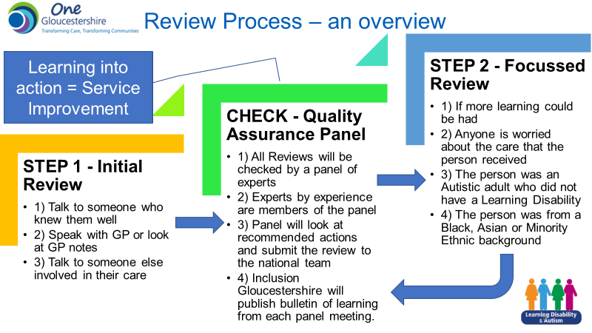

Figure 2 - Local LeDeR Governance Structure
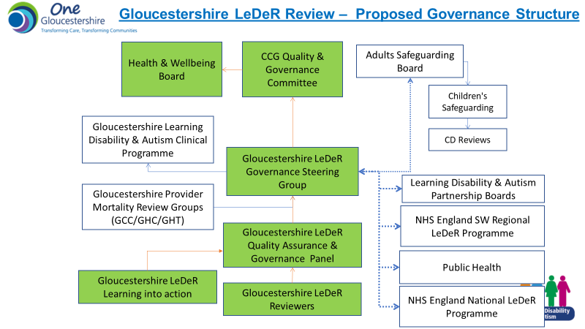

  - The Gloucestershire LeDeR Programme has an establish methodology for working in co-production with people with lived experience and this will continue to be a key aspect of the Quality Assurance and Governance Panels and the LeDeR Governance Steering Groups meetings going forward. A new group will be established to take forward formally the learning into action. There will be a commitment from the ICS to develop co-produced bulletins and learning case studies to share with health and social care professionals and subject specific learning webinars/conferneces will also be planned based on specific learning themes identified through the review process.

  - Reducing Health Inequalities is a key aspect of the local LeDeR Programme and based on learning themes to date Figure 3 demonstrates the core areas of work for service improvement over the coming three years.

Figure 3 - Learning into Action 3 Year Strategy
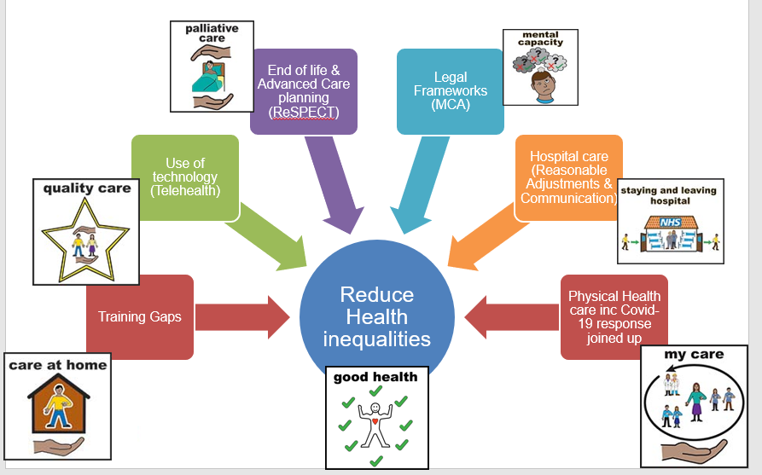

INTRODUCTION, BACKGROUND AND RATIONALE

The LeDeR programme was established in 2015 as a response to the recommendations from the Confidential Inquiry into premature deaths of people with learning disabilities (CIPOLD, 2013). CIPOLD reported that people with learning disabilities are three times more likely to die from causes of death that could have been avoided with good quality healthcare. Gloucestershire have been at the forefront nationally of rolling this programme out, being a pilot site in 2017.

  - The new LeDeR National Policy published on 23rd March 2021 will give the local LeDeR programme opportunities to further strengthen the operational, governance and service improvement programme and extend this to autistic people as well during the course of the coming three years.

  - What is the purpose of LeDeR?
LeDeR is a service improvement programme which aims to improve care, reduce health inequalities and prevent premature mortality of people with a Learning Disability and autistic people by reviewing information about the health and social care support people received. It does this by:
- Delivering local service improvement, learning from LeDeR reviews about good quality care and areas requiring improvement.
- Driving local service improvements based on themes emerging from LeDeR reviews at a regional and national level.
- Influencing national service improvements via actions that respond to themes commonly arising from analysis of LeDeR reviews.

  - A LeDeR review is not a mortality review. It does not restrict itself to the last episode of care before the person’s death. Instead, it looks at key episodes of health and social care the person received that may have been relevant to their overall health outcomes. LeDeR reviews take account of any mortality review that may have taken place following a person’s death. LeDeR reviews are not investigations or part of a complaints process, and any serious concerns about the quality of care provided should be raised with the provider of that service directly or with the Care Quality Commission (CQC) via their online system.
  - Key implications and changes within the national policy: -
    - The LeDeR reviews will now include people (aged 18+) with an autism diagnosis (by without a learning disability) from January 2022.
    - The name will change to Learning From Lives And Deaths – People With A Learning Disability and autistic people, however the Acronym will remain as LeDeR.
    - A new streamlined review process and IT system (which will need to be implemented by local systems in line with the changes to the web-based platform went live on 1 June 2021).
    - All reviewers must be employed on an NHS or Local Authority contract from 1st June 2021 and have access to appropriately encrypted ICT. Gloucestershire now has two band 7 senior reviewers and two band 6 reviewers employed on a bank contract who are independent. They have all been supplied with CCG IT equipment to ensure appropriate information governance standards are met. Clinical Supervision for these roles will be undertaken by the Quality Assurance Panel.
    - The governance for the programme will remain with the LeDeR Steering group (Figure 2). However, the review of individual cases will be delegated to the Quality Assurance panel and taking learnin into action will form part of a new group.
    - Changing how reviewers are trained by implementing a training and competency framework. This means they will be required to undertake regular CPD activity on top of their review work and the CCG will need to pay for this activity.
    - The Integrated Care System will take over responsibility from Clinical Commissioning Groups for making sure LeDeR Reviews are completed, and governance will need to reflect this. An update to this policy will be required when new ICS governance structures are known.
    - By 1 April 2022 all changes within this policy must be implemented by the Integrated Care System.

Each local area has a designated ‘Local Area Contact’. Within Gloucestershire the Local Area Contact is employed by Gloucestershire County Council as part of its Joint Commissioning function. The role of the Local Area Contact is detailed within section 4.

More information about the programme and the review process can be found at: https://leder.nhs.uk/about

PURPOSE, SCOPE, VISION, AIM AND OBJECTIVES

  - The purpose of this Framework is to detail how LeDeR programme is managed within Gloucestershire.

  - Scope
LeDeR stands for Learning From Lives And Deaths – People With A Learning Disability and autistic people
This is a national programme and everyone in England with a Learning Disability and Autistic Adults will have their death reviewed in the same way.

The reviews will look at everyone with a Learning Disability aged 4 years or older.

Those individuals with a learning disability under 4 years of age will be reviewed via Child death overview panel.

Every adult (aged 18+) with a confirmed diagnosis of Autism within clinical records will also be included within the LeDeR Programme from 2022.

In Gloucestershire reviewers will only be reviewing those who were registered with a Gloucestershire GP at the time of their death.

Every death has a first check. We call this an Initial Review.

Initial reviews will contain
- Demographic data
- Cause of death
- Summary discussion with family/ carer or someone who knew the person well
- Summary of discussion with the GP/ and or clinician involved in the care of the person who died
- Pen portrait
- Any long-term conditions linked to the cause of death.
- Whether or not the person had DNACPR in place, with paperwork correctly completed.

Using their professional judgement and the evidence available to them, the reviewer will determine where a focused review is required.

The person’s family has the right to request a focused review.

Focused reviews will also be completed for every person from a Black, Asian or Minority Ethnic background.

  - Aim of LeDeR
LeDeR is a service improvement programme which aims to improve care, reduce health inequalities and prevent premature mortality of people with a learning disability and autistic people by reviewing information about the health and social care support people received. It does this by:
- Delivering local service improvement, learning from LeDeR reviews about good quality care and areas requiring improvement.
- Driving local service improvements based on themes emerging from LeDeR reviews at a regional and national level.
- Influencing national service improvements via actions that respond to themes commonly arising from analysis of LeDeR reviews.

  - The national LeDeR programme was established to support local areas to review deaths of people with learning disabilities, and to use the lessons learned to make improvements to service provision. The LeDeR programme is not an investigation. If, during or after a review of a death, the Local Area Contact working with the LeDeR Quality Assurance and Governance Panel has concerns which have not or cannot be addressed within the scope of the LeDeR review process, the Local Area Contact will recommend to the appropriate organisations/bodies the need for a fuller investigation (e.g. Adult Safeguarding Review).

  - The core principles and values of the LeDeR programme are:
- LeDeR is a service improvement programme aimed at improving local services for people with a learning disability and autistic people, and reducing premature mortality.
- We value the on-going contribution of people with a learning disability and autistic people and their families to all aspects of our work, and see this as central to the development and delivery of everything we do.
- LeDeR reviews will be conducted by dedicated reviewers working in multi-disciplinary teams with appropriate supervision and administrative support.
- Reviews will be completed in as timely a way as possible so that where good practice is identified, or issues identified these can be shared and addressed as soon as possible.
- We take a holistic perspective, looking at a person’s life as well as their death.
- The key principles of communication, cooperation and independence will be upheld when working alongside other investigation or review processes.
- The programme overall strives to ensure that reviews lead to reflective learning which will result in improved health and social care service delivery.
- LeDeR reviews are not investigations.

  - The LeDeR programme works closely with other existing mortality review processes. More details regarding these interfaces can be found in the National Handbook (page 16)

  - A wealth of information regarding the LeDeR programme can be found on the LeDeR programme website: https://leder.nhs.uk/about

  - This Framework does not seek to duplicate this information, but to:
- detail the governance and operational arrangements specific to Gloucestershire
- provide ‘signposting’ to existing LeDeR information.

GOVERNANCE, ROLES AND RESPONSIBILITIES

  - NHS England and NHS Improvement
    - National LeDeR team The national LeDeR team is employed by NHS England and NHS Improvement. The team helps to support CCGs (and in future ICSs) to complete LeDeR reviews and use the information to change and improve the way they provide services in their local area. They also help local systems to learn from one another so that learning and good practice can be spread across the country. They are responsible for making sure that there is an academic partner to support the programme and a web platform is commissioned to help reviewers complete reviews. (Further detail can be found in the National LeDeR Policy Page 34)

    - Regional coordinators There are 7 NHS England and NHS Improvement regional Learning Disability and autism programme teams across the country. A regional coordinator from each region sits in these teams and provides oversight for LeDeR. Regional coordinators provide operational support for local area contacts (LACs) and reviewer teams, and act as a point of escalation where issues cannot be resolved locally. Further detail can be found in the National LeDeR Policy Page 32)
    - Diagram 1 - National programme Structure
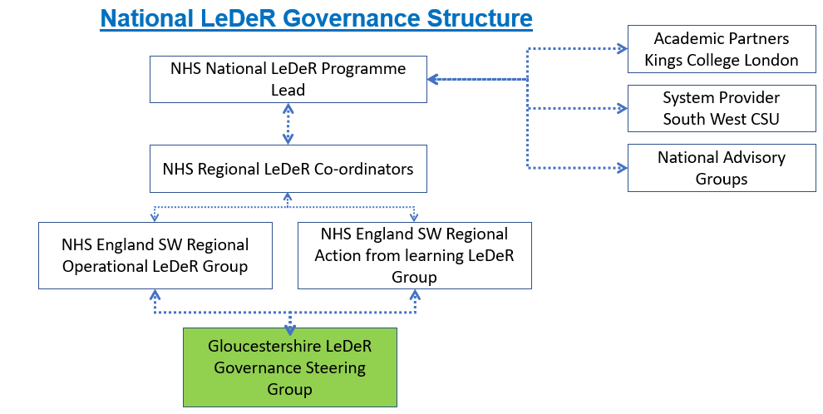

  - CCG Responsible Directors
Joint Director responsibility for the programme is held by Director of Nursing and Quality and Director of Integrated Commissioning hold Director-level responsibility for the LeDeR programme within Gloucestershire. The Directors assign the day-to-day operational management of the programme to the Local Area Contact.

The Directors have delegated the role of Chair of the Gloucestershire LeDeR Governance Steering group to the Clinical Commissioning Group Deputy Director of Nursing.

  - Local Area Contact
The Local Area Contact (LAC) is the link between local system and the regional and national LeDeR programme. There is an expectation that the LAC will be a member of the the South West regional operational Group and the South West Action from Learning Group. Further detail on the role of the LAC can be found in the National Policy page 24. In summary the LAC role is to work in partnership with the LeDeR programme team and is responsible for:
  - receiving notifications of deaths;
  - allocating cases to local reviewers;
  - providing advice and support for local reviewers as necessary;
  - monitoring the progress and completion of reviews to ensure that they are of a consistent standard and completed in a timely and comprehensive way;
  - organising and chairing the LeDeR Quality Assurance and Governance Panel; preparing papers and keeping a record of decisions and recommendations in agreement with the panel members..
  - Signing off completed reviews on the national database
  - Attending the quarterly LeDeR Governance and Steering Group; preparing papers and keeping a record of actions
  - anonymising and collating learning points and recommendations through an action tracker and Learning into Action Subgroup.

  - Within Gloucestershire, the role of the Local Area Contact is held by the Outcome Manager: Learning Disabilities Health (Integrated Disabilities Commissioning).

  - Local Reviewers
Local Reviewers are responsible for undertaking robust and high quality reviews of the deaths of people with learning disabilities and autistic people (expected from Winter 2021) and are integral to the success of the Gloucestershire LeDeR programme. It is the responsibility of the reviewer to declare a conflict of interest in regard to cases they are reviewing to the LeDeR team. Where reasonably practicable the LAC will not allocate a review to a local reviewer if they have been involved in that persons care. Further detail on the role of the reviewer can be found in the National Policy page 28.

An outline of what local reviewers are specifically looking into is outlined in Table 1 - what are Reviewers looking for?

Table 1 - what are Reviewers looking for?
The person and /or their environment | People who live in unsuitable placements for their needs including the availability of appropriate communications facilities/channels to ensure the person has access to information/support appropriate for their foreseeable needs.
 | Inadequate housing that places the person at risk of falls, accidental injury or isolation in their home.
 | Key information provided by family members or other carers being ignored or concerns not taken seriously or low expectations of family members.
 | Families not wanting or feeling able to challenge medical professionals’ authority and opinion.
 | Any good practice that can be shared/disseminated wider
The person’s care and its provision: | The lack of provision of reasonable adjustments for a person to access services.
 | Lack of routine monitoring of a person’s health and individual specific risk factors.
 | Lack of understanding of the health needs of people from minority ethnic groups.
 | Inadequate care.
 | Any good practice e.g. examples of reasonable adjustments that can be shared/disseminated wider
The way services are organised and accessed:  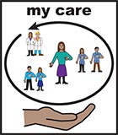 | No designated care coordinator to take responsibility for sharing information across multi-agency teams, particularly important at times of change and transition.
 | Lack of understanding and/or recording of the Mental Capacity Act when making essential decisions about health care provision.
 | Inadequate provision of trained workers in supported living units.
 | Inadequate coverage of specialist advice and services, such as Speech and Language Therapy (SLT) or hospital Learning Disability liaison nurses.
 | Any good practice that can be shared/disseminated wider

  - Gloucestershire LeDeR Governance and Steering Group The full terms of reference can be found in Appendix 3

    - Purpose / role of the group
 | To guide the implementation of the programme of initial reviews and focussed reviews and wherever appropriate to work in partnership and collaboration with other agencies or bodies who may be involved in parallel work e.g. Safeguarding, coroners, Hospital learning from deaths etc
 | To support and ensure the quality assurance of the review of all deaths of people with learning disabilities and autistic people in Gloucestershire.
 | Membership will be asked to participate in Quality Assurance & Governance panels.
 | To receive regular updates from the Local Area Contact about the progress and findings of reviews.
 | To approve and publish an annual report of reviews in Gloucestershire and actions taken.
 | To help interpret and analyse the data submitted from local reviews, including areas of good practice in preventing premature mortality, reducing health inequalities, and areas where improvements in practice could be made.
 | To monitor the action plans that are developed by the LeDeR Learning into Action Group, and take, guide or escalate appropriate action as a result of such information.
 | To ensure agreed protocols are in place for information sharing, accessing case records and keeping content confidential and secure.
To undertake a quality assurance role in respect of:
- the role of the reviewer/s and LAC
- the quality of reviews
- Learning into action
- Annual Reports
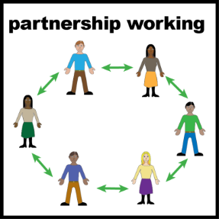 | Membership of the group will also consist of Learning from Deaths leads (or representatives) from each of the provider Trusts (GHC Mortality Group, GHT SJR Group) and will formally report into the Quality Surveillance Group any themes in relation to the health care of those with a Learning Disability or Autistic People.

    - Diagram 2- Gloucestershire LeDeR Governance Structure

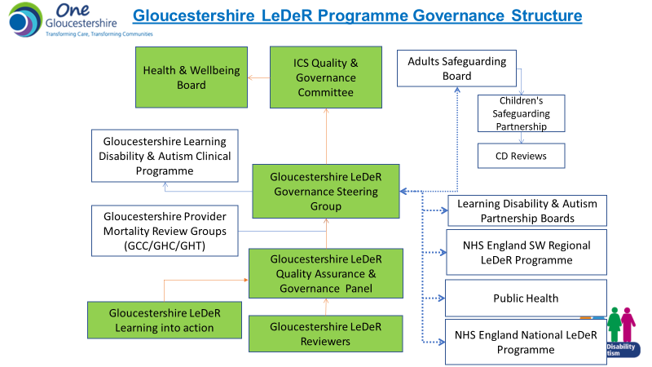

  - LeDeR Quality Assurance Panel The full terms of reference can be found in Appendix 4

    - Purpose / role of the group

Is a group of Experts-by-Experience that look at how good each review is. They give ideas of what can be done better.

Experts-by-experience are people that are disabled, carers or people who work in health and social care.

To look at:
  - What the reviewer does.
  - How good the review is and making sure something is done to make things better.
  - How we help reviewers do their job well.
  - Think about what changes need to happen. We call this learning from action.
To work out what the information from the reviews mean.

This could be something good, helping to stop someone dying too early.

It could be something that could be made better.

Cases will be given to Safeguarding if the group feels it is needed.
A mark between 1 – 6 is given to how good the care is.

6 being the best and 1 the worst.
When a review has been looked at, the person who leads on LeDeR in Gloucestershire (this person is called the Local Area Contact or LAC), does the following:
- Fills in the Gloucestershire LeDeR checklist
- Tells the reviewer that…
- the review has been closed.
Or…
2. Asks the reviewer to make changes or get more information.
- Asks the reviewer to tell everyone who they spoke with about the review.
- Share learning with the LeDeR Learning into Action Group.

    - Reviewers will be asked to grade the care the person received at the end of a focused review (cases which only receive an initial review will not be graded). Care is graded on two elements of the health and social care the person received:
1. Quality of care the person received
2. Availability and effectiveness of services the person Care is graded on a scale of 1-6 where 1 represents poor care and 6 represents excellent care.

The scales on which care is graded can be found in Table 2. The system may suggest a grade for a review based on the answers a reviewer has given to previous questions (for example, where the reviewer has indicated that there were gaps in service provision or NICE guidance was not followed the system will suggest that the review is graded as a 3). The reviewer can change the suggested grade and add an explanation as to why they have changed it. When a review is graded 1 or 2, it is important for the reviewer to think about potential safeguarding and serious incidents and speak with the local area contact.

Table 2 - National LeDeR Scoring System
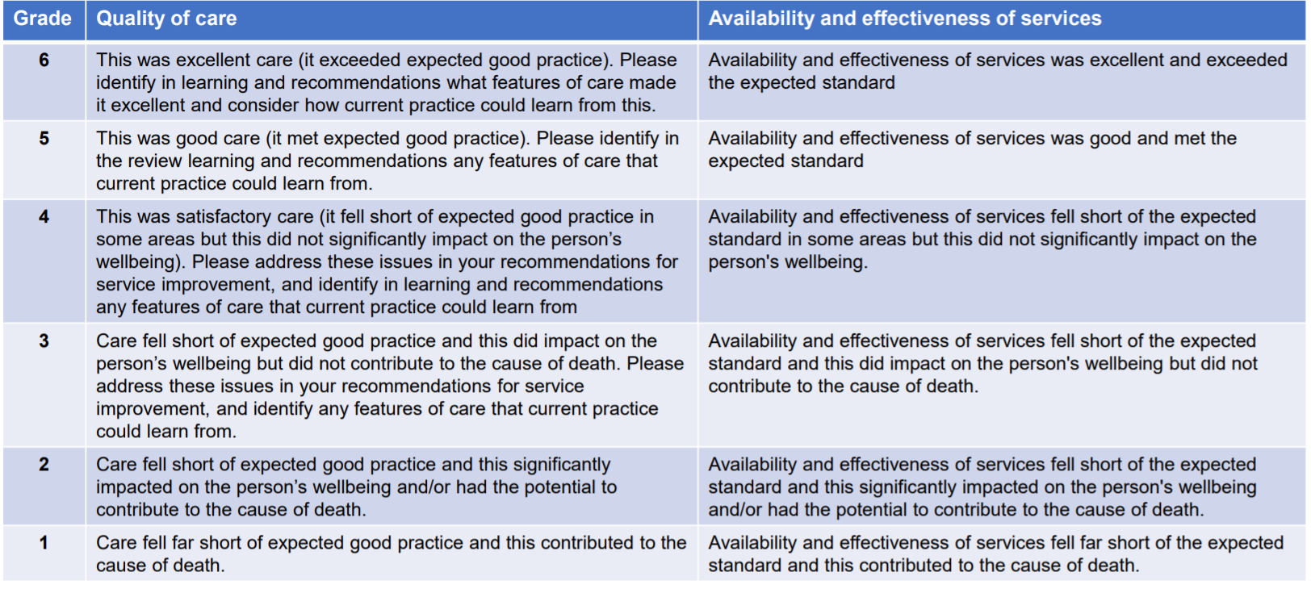

DEFINITION

  - This policy and supporting procedural document is a ‘framework’ as it is a broad overview which supports a particular approach to a specific objective.

  - The LeDeR programme uses the following definition of a Learning Disability:

Individuals with a Learning Disability (internationally referred to as individuals with an intellectual disability) are those who have:
    - a significantly reduced ability to understand new or complex information, to learn new skills (impaired intelligence) with:
    - a significantly reduced ability to cope independently (impaired adaptive and/or social functioning) and:
    - which is apparent before adulthood is reached and has a lasting effect on development.

Learning Disability is different from a specific learning difficulty (such as dyslexia), or autism or a mental health condition. Some people have all of these and also have a Learning Disability. A person does not necessarily need to have been on a locally held Learning Disability register (also sometimes called a GP quality outcomes framework [QoF] register) to be eligible for a LeDeR review.

  - For an autistic person to be eligible for a LeDeR review, they must have had a confirmed diagnosis of autism recorded in their clinical records prior to their death.
    - For an autistic individual to be eligible for a LeDeR review, they must have had a confirmed diagnosis of autism recorded (any of the terms as outlined in DSM or ICD) in their clinical records prior to their death.
    - LeDeR does not include those who self-identify as autistic but have not sought or not received a clinical diagnosis from a qualified health professional.
    - LeDeR does not include individuals who have been referred for a clinical assessment of autism, but who have died prior to the assessment having been carried out or completed. This is because the autism diagnosis will not have been confirmed. Whilst the needs and difficulties leading them to a referral are not to be dismissed, these individuals nonetheless currently do not fall within the scope of the review.

POLICY DETAILS

The process from notification to submitting to the national programme is outlined in Diagram 3. A full process pathway is available in Appendix 2

Diagram 3 - The LeDeR process

  - There is a wealth of information regarding the LeDeR programme on the LeDeR programme website. Some of the key information is summarised below:

    - Notifying LeDeR of a death Anyone can notify LeDeR of a death, including people with learning disabilities themselves, family members, friends and paid staff. Notifications can be made online via this link https://leder.nhs.uk/report or by calling 01278 727411.

    - Information for families and carers Key to the review process is the involvement of family members and/or carers to find out more about the life and the circumstances leading up to the death of their relative or friend. The information available to family and carers can be viewed via this link; https://leder.nhs.uk/about/working-with-families

    - Information for local reviewers about how to undertake an initial and focussed review can be found here: https://leder.nhs.uk/images/learning-docs/Training_handbook.pdf

    - Links with other mortality review processes
The LeDeR review is a service improvement programme and not a statutory process and its purpose is not to hold any individual or organisation to account. Other processes exist for that, including safeguarding, criminal proceedings, disciplinary procedures, employment law and systems of service and professional regulation. It is vital, if individuals and organisations are to be able to learn lessons from the past, that reviews are trusted and safe experiences that encourage honesty, transparency and sharing of information to obtain maximum benefit from them.

In order to do this in a timely manner, to avoid duplication and to ensure there is no additional distress to the relatives of the individual, reviewers need to be clear where and how the LeDeR process links with other reviews or investigation processes.

Other investigations or reviews may include, for example:
• Serious Case Reviews (SCRs);
• Safeguarding Adult Reviews (SARs);
• Safeguarding Adults Enquiries (Section 42 Care Act);
• Domestic Homicide Reviews (DHRs);
• Mental Health Homicide Reviews (MHRs);
• Serious Incident Reviews;
• Coroners’ investigations;
• Child Death Reviews (CDOP).
• An organisation’s internal Root Cause Analysis investigations

Information for reviewers on working with other investigation and review processes is available within the Reviewer Training Handbook (page 16): https://leder.nhs.uk/images/learning-docs/Training_handbook.pdf

This LeDeR paper outlines the remit of other review or investigation processes and provides guidance to the local LeDeR programme as to the process to follow. In all cases, the key principles of communication, cooperation and independence should be adhered to.

  - Reporting
    - Reporting to NHS England The Local Area Contact is required to submit a quarterly report to NHS England and NHS Improvement detailing the progress against Key Performance Indicators.
    - Reporting within Gloucestershire The Local Area Contact will produce a quarterly report for the Local LeDeR Governance and Steering Group which will be escalated to the Quality and Governance Committee, detailing the progress of the programme and key learning. The Quality and Governance Committee reports to Governing Body.

Members of the steering group are able to use this report for their own assurance and for the organisations they represent.

The Steering group will prepare an annual report for Health and Wellbeing Board on an annual basis which will provide the key learning outcomes from the past 12 months and learning into action plan for the coming 12 months.

    - The NHS Operational Planning and Contracting Guidance requires a local annual report to be submitted to the appropriate board/committee for all statutory partners, demonstrating actions taken and outcomes from LeDeR reviews. Gloucestershire will produce this report will be produced by July of each year for approval by the Steering group and Quality & Governance committee. The report will aim to be published on the CCG Publications pages of the public facing website no later than September of each year. These reports can be accessed via this link: https://www.inclusiongloucestershire.co.uk/engagement/leder/

  - Future plans Since 2018/19, the focus for the Local Area Contact was to imbed the agreed local LeDeR governance structure and processes for managing the LeDeR workload and to manage the backlog of reviews as well as actively recruiting new reviewers.

    - The summary of development focus for the programme until 2024 is shown in Figure 4. Further details can be found in Table 4 and Table 5. This is a 3 year plan which represents a “road map” for where we want to focus our efforts. This plan does not provide the details of every “turn” in the road, or given a detailed instruction on how we will get there. This is because the health and care landscape across Gloucestershire is changing and developing all of the time, all partner organisations are different and will have their own particular challenges and ways of working. This plan is therefore not overly prescriptive, but as a partnership this provides a vision of where we want to go together. The programme will explore creative and innovative ways to deliver on this priorities, and supporting providers to deliver change.
Figure 4 - Three Year LeDeR strategy themes

Table 3 - Learning into action enablers
Locally accessible information available on the programme | - A dedicated LeDeR page is to be maintained. A link to this Framework, annual reports and Learning into Action and easy read information about LeDeR, will be available on this web page.
Learning into Action | - Establishment of a group with clinical input.  - Production of monthly Learning into Action Bulletins for wider stakeholder group  - Production of quarterly targeted Health and Social care “feedback on a page” documents to aid professional specific learning.  - Themed webinars to share learning
Advocacy, user/carer involvement and Co-production | - Established strong links with a local User Led organisation to ensure co-production is at the heart of the local programme, and experts by experience contribute to the action from learning.  - Further develop the local processes in relation to stronger user/carer involvement in the programme for underrepresented minority groups e.g. ethnicity or LGBQT+.
Benchmarking and sharing of good practice | - South West LeDeR Operational Group  - South West Health Inequalities Group  - NHS Futures Website
Established links with Quality, Safeguarding, nursing and system clinical leadership across ICB | - Programme reports to Quality and Governance Committee  - Regular updates to Quality Surveillance Group  - Regular updates to Adults Safeguarding Board  - Established links with NHS Providers within the programme

Table 4 - 3-Year LeDeR Governance Plan

Statement​ | Deliverables​ | Method of Measurement​ | Frequency of collection​ | Date of Delivery ​
A three-year LeDeR strategy demonstrating how the CCG/ICB will act strategically to tackle those areas identified in aggregated and systematic analysis of LeDeR reviews and national findings including how the ICB will reduce the health inequalities faced by people from Black, Asian and Minority Ethnic communities who live locally who have a learning disability​ | Three-year strategy shared with NHS England and NHS Improvement’s Regional Team and updated annually in June each year. Strategy contains section on issues faced by people with learning disability from Black, Asian and Minority Ethnic backgrounds who have a learning disability. ​ | Documents approved within ICB governance and available as stated and shared with NHS England and NHS Improvement regional teams​ | 3 yearly | To be presented to CCG Quality & Governance Committee February 2022
Clear and effective governance in place which includes LeDeR governance within mainstream CCG/ICB quality surveillance and governance arrangements. | LeDeR actions reported on as part of routine quality assurance of the CCG/ICB and to the NHS England and NHS Improvement regional team. ​ | Minutes of quarterly meeting of ICB LeDeR governance & Steering group meeting. ​  Quarterly Highlight report | Quarterly | Achieved
Clear strategy for meaningful involvement of people with lived experience in LeDeR governance​ | Evidence of meaningful engagement of people with lived experience in local governance group and Quality Assurance Panel by November 2020 which engages autistic people who have a learning disability proportionately to the number of notifications received locally for each group​ | Quality Assurance Panel Checklists.  Learning into action newsletters  Annual Report | Quarterly | Achieved
The CCG/ICB will demonstrate how they are narrowing the gap in health inequalities and premature mortality for those who have a learning disability and autistic adults in Gloucestershire. | Locally determined targets agreed with NHS England and NHS Improvement regional teams to include measures around:  - A reduction in the repetition of recurrent themes found in LeDeR reviews in Gloucestershire.  - Reduced levels of concern and areas for improvement – utilsiing the grading of care for reviews as an indiciator.  - Reduced frequency of deaths that were potentially avoidable or amenable to good quality healthcare​ | Agreed with NHS England and NHS Improvement regional teams. Through LeDeR reporting and analysis of reports ​  Annual reports  Learning into Action Tracker | Annually​ | Achieved
CCG/ICB should have a clear plan in place and agreed by March 2022, for the new quality assurance structures and processes which will be implemented for LeDeR and fully operational from 1 April 2022. ​  ​ | ​Development of Gloucestershire LeDeR Quality Assurance Framework | Gloucestershire LeDeR Framework  Gloucestershire Quality Assurance Checklists  Learning into Action tracker  Learning into Action Newsletter | Framework reviewed yearly | Achieved

Table 5 - 3 year “Learning into Action” strategy action plan
LeDeR Thematic Area | LDA Programme Area | Year 1 | Year 2 | Year 3
Training Gaps | Improving Quality of Services | - Complete Training gaps analysis with providers  - Fundamentals of Care (FoC) LD Pilot  - AHSN RESTORE2 Mini train the training sessions  - We will develop and embed increased knowledge and understanding of best practice in primary care networks | - Evaluate FoC LD Pilot and business case for continued funding  - RESTORE2 Mini local training resources developed  - Implement Oliver McGowan Mandatory Training  - LD AHC Training offer reviewed and gaps identified with solutions to address  - Implement LeDeR Action learning sets with specific learning for different professional groups initial stakeholders inc GPs, Hospital staff, Social Care, Care Providers  - Work with Primary Care Training Hub to standardise the offer for primary care staff.  - Continue to promote system learning to ensure all learning from death and examples of best practice are shared across the health, social care and third sector services, rather than sitting in silos | - Implement recommendations from FoC Evaluation  - Address any training gaps identified through the LeDeR Reviews over the last 1-2 years.
Use of technology | Improving Quality of Services | - Evaluate Telehealth/Bayswater pilot with AHSN  - Implement regular electronic LeDeR Newsletters | - Further Development and refinement of a local Information dashboard utilising Power BI to inform local health inequalities. | - Reasonable adjustments digital flag in summary care records rolled out for people with LD and Autistic Adults.  - Scope with other regions any new innovative technology.
End of life and Advance Care Planning (ReSPECT) | Reducing Health Inequalities | - Work with End of Life Clinical programme and RESUS Council to develop easy read resources | - A range of co-produced film RESPECT2 accessible films will be developed and shared.  - Continued engagement with the ICS End of Life Clinical Programme to ensure reasonable adjustments and personalised end of life care for people with a learning disability and autistic adults. | - Continued engagement with the ICS End of Life Clinical Programme to ensure reasonable adjustments and personalised end of life care for people with a learning disability and autistic adults.
Legal Frameworks | Improving Quality of Services | - To increase knowledge, appropriate use and improved recording of Mental Capacity Act (MCA) and Best Interest (BI) decisions within primary care and acute care.  - Guidance written to ensure consistent approach to BI meetings in Acute Care. | - To continue to support and promote the appropriate use and recording of MCA/BI/Use of advocates.  - Consider impact of implementing LPS.  - Implement Hospital BU Meeting guidance and leaflets. | - To continue to support and promote the appropriate use and recording of MCA/BI/Use of advocates.
Hospital Care (reasonable adjustments and communications) | Reducing Health Inequalities | - Amend the Health (hospital) passport to be editable and easy read in co-production.  - Focus on Oral Health care and dysphasia within hospital settings  - Develop easy one page checklist for supporting people with LD and Autism during covid-19 times. | - Continue to promote the use of the passport with hospital colleagues  - Focus on Oral Health care and dysphasia within hospital settings.  - Continue to work with colleague in Mental Health Inpatient settings to ensure all reasonable adjustments are put in place to ensure equitable health outcomes | - Continued engagement with the LDA Clinical Programme to ensure reasonable adjustments and personalised care for people with a learning disability and autistic adults when going into hospital are and address any gaps identified through reviews.
Physical Health Care | Improving Quality of Services & Reducing Health Inequalities | - Continue to meet LD AHC 75% target and make better use of the health check action plan  - Exemplar project LD AHC commenced  - Raise awareness of national campaigns such as Mouthcare Matters, dysphagia and Dying for a Poo.  - Development of a CCG/ICB Clinical Champion for LDA.  - Establish links with Social prescribers | - We will work to continue to meet the 75% target, and improve the quality and effectiveness of annual health checks, and access to screening services.  - LD AHC children and young people deep dive of barriers and co-produce solutions to overcome barriers.  - Continue to support reasonable adjustments for people to access flu and covid-19 vaccinations.  - Continue to engage and influence national campaigns around physical healthcare for people with a learning disability or Autistic adults.  - We will work to improve the regognition and management of pain – by recognising soft signs of deterioration, to understand when indiviudals are distressed, in pain or poorly and how they communicate in order to take prompt clinical action.  - Embed CCG/ICB Clinical Champion in learning into action work.  - Partnership with social prescibers established and support provided to improve their competency to support the LDA programme and learning into action.  - Improve the understanding and awareness of additional health needs in our community care providers | - Continue to promote RESTORE2 and RESTORE2 mini across Gloucestershire  - Continue to embed the role of Social prescribers to support people with a learning disability and autistic adults.

CONSULTATION

This Framework has been subject to consultation and has been reviewed (and commented upon where necessary) by:
- Members of the Gloucestershire LeDeR Quality Assurance Panel
- Members of the Gloucestershire LeDeR Governance Steering Group
- Members of the Gloucestershire Learning Disabilities and Autism Clinical Programme Board
- All Gloucestershire LeDeR Local Reviewers;
- Named GP Clinical Lead for Learning Disabilities Gloucestershire CCG
- Designated Nurse Consultant for Safeguarding Gloucestershire CCG;
- Integrated Learning Disability commissioners, NHS Gloucestershire CCG
- Gloucestershire CCG Core Group
- Inclusion Gloucestershire (user led organisation for people with disabilities)
- ICB Governance and Quality Committee

TARGET AUDIENCE

  - This framework is for:
    - Members of the Gloucestershire LeDeR Quality Assurance Panel
    - Gloucestershire LeDeR Governance Steering Group
    - Gloucestershire LeDeR Quality Assurance and Governance Panel
    - Gloucestershire Learning Disabilities and Autism Clinical Programme Board
    - Gloucestershire Learning Disabilities Partnership Board
    - ICS Quality and Governance Committee
    - Experts-by-Experience (people with a Learning Disability, family or carers)
    - User led organisations supporting people with learning disabilities
    - To provide assurance to the ICS board
    - To provide assurance to NHS England and NHS Improvement

COMMUNICATION

Internal CCG Intranet | CCG/ICB Internet Website | Communications Bulletin | External Stakeholders

TRAINING

  - The Local Area Contact and Secondary Local Area Contact and Reviewers have received training from NHS England and NHS Improvement on the requirements and responsibilities of their role.

  - To undertake LeDeR reviews and become a ‘Local Reviewer’, specific online training, accessed via this link: https://leder.nhs.uk/review/review-resources/e-learning (with supported local face-to-face “buddy” training as required) must be completed. Once this training has been completed, the individual will be given access to the LeDeR programme database through which reviews are managed.

  - No other LeDeR-specific training requirements have been identified at this time, however work is on-going within the national programme to develop CPD training modules for reviewers.

  - Reviewers are offered peer support supervision utilising the Quality Assurance Panel. They each receive management supervision from the Local Area Contact.

REFERENCES

LeDeR National Policy | https://www.england.nhs.uk/wp-content/uploads/2021/03/B0428-LeDeR-policy-2021.pdf
LeDeR programme website | https://leder.nhs.uk/about
National LeDeR Reviewer Handbook | https://leder.nhs.uk/images/learning-docs/Training_handbook.pdf
National LeDeR Training | https://leder.nhs.uk/review/review-resources/e-learning

APPENDIX 1

Appendix 1: Equality and Engagement Impact Assessment

Please refer to the Guidance for Completion of the Equality and Engagement Impact Assessment. If you require any assistance in completing this form please contact the Patient Engagement and Experience team.

Title of service, policy or programme: | Learning Disabilities and Autism Review (LeDeR) Policy Framework and 3 year strategy
Name and job title involved in the completion of this assessment: | Outcome Manager Integrated Disabilities Commissioning  Head of Integrated Commissioning Learning Disabilities and Physical Disabilities  Deputy Director of Nursing and Quality
Date of this assessment:  (It is good practice to undertake an assessment at each stage of the project) | January 2022
Stage of service, policy or programme change  (earlier versions of this impact assessment should be included in your submission) | Development ☐ | Implementation ☐ | Evaluation/review

1. Outline
Give a brief summary of your policy, service or programme. Include reference to the following:  Is this a new or existing policy, service or programme?  If it is not new, detail any proposals for change. | The policy sets out how, as a commissioning organisation, Gloucestershire Clinical Commissioning Group (and One Gloucestershire ICS) will fulfil its statutory duties and responsibilities for the delivery over the next three years of the service improvement programme LeDeR. The Policy operates in the context of all commissioned services for the population of Gloucestershire both within its own organisation and across the local health and social care economy via its integrated commissioning arrangements.  The NHS Long Term Plan aims to improve the health of people with Learning Disability by making sure they receive timely and appropriate health checks, it also wants to improve the level of awareness and understanding across the NHS of how best to support people with Learning Disabilities to ensure equitable outcomes as patients, and reduce health inequalities faced by this disadvantaged group. During the course of 2022 the programme will also be extended to health inequalities faced by autistic adults as well.  The national LeDeR policy was reviewed and published in March 2021, following the end of the University of Bristol contract. This amended policy it sets out the NHS core aims and values of the LeDeR programme and the expectations placed on different parts of the health and social care system in delivering the programme from June 2021. The change in the national policy has necessitated a local change to reflect the operational amendments to local delivery and governance, and this updated local policy therefore replaces policy 100 v1 which was published in 2019.
What aims/outcomes do you want to achieve? | NHS England and NHS Improvement will hold ICSs to account for the delivery of the actions identified in LeDeR reviews as part of their assurance processes so that ICSs improve the ways that local health and care services meet the needs of people with a Learning Disability and autistic people.  The LeDeR Programme is a Service Improvement Programme with aims;  - improve care,  - reduce health inequalities and  - prevent premature mortality of people with a Learning Disability and autistic people
Give details of any evidence, data or research used to support your work. Consider the following:  Health Needs Assessment  JSNA/Inform data  National/regional data  Patient experience data | Public Health England have produced a series of guidance sharing information, ideas and good practice in making reasonable adjustments for people with learning disabilities in specific health service areas.  - Public Health England report that:  - people with learning disabilities have higher rates of hospital episodes than other people and longer stays,  - they occupy disproportionately more bed days than average for their numbers,  - these are focussed in some specific clinical specialties (medicine, paediatrics, dentistry),  - a higher than average proportion of admissions for people with learning disabilities start as unplanned emergencies,  - a higher than average proportion are emergency admissions for conditions which should be avoidable with good personal and primary care.  - National LeDeR Annual reports  A total of 9,110 deaths of people with learning disabilities (622 deaths of children; 8,488 deaths of adults) occurring between 1st Jan 2018 and 31st December 2020 were notified to the LeDeR programme.  Between 2018–2020 the number of deaths fluctuated between 200-300 each month with a larger number of deaths reported during winter months. There was a significant increase in the number of deaths at the peak of the COVID-19 pandemic from March – May 2020.  Overall, males accounted for 57% of deaths. Among adults, there was little variation in this across the three years (2018, 2019, 2020). For children, the proportion of males ranged from 54% in 2018 to 61% in 2020.  A large majority of adults with learning disabilities were of white British ethnicity (91% of those who died in 2018; 90% in 2019; 89% in 2020) but this was the case for a smaller proportion of children (59% of those who died in 2018; 59% in 2019; 54% in 2020). The number of deaths of people from different minority ethnic groups is too small for analysis by individual ethnicities and data is therefore less robust. Fewer than 5% of adults who died were of Asian/Asian British ethnicity (3% of those who died in 2018; 3% in 2019; 4% in 2020), but this was the case for a quarter of children (26% of those who died in 2018; 22% in 2019; 25% in 2020).  A much smaller proportion of adults with learning disabilities had profound and multiple learning disabilities (9% of those who died in 2018; 8% in 2019; 7% in 2020) than children with learning disabilities (47% of those who died from 2018-2020 combined), although there is a substantial amount of missing data for children in this respect. The median age at death has increased by one year for deaths occurring between 2018 and 2020. In 2019, the majority (85%) of people in the UK population died aged 65 and over. The corresponding proportion of people with learning disabilities from 2018-2019 was 38%. The lowest median age at death of adults, at 33 years, was for males from minority ethnic groups and with severe, profound and multiple learning disabilities. Their median age at death had increased from 30 years in 2018 to 32 years in 2019 and 42 years in 2020.  - Local Information  Based on the ‘Gloucestershire learning disabilities and autism joint strategic needs assessment’ there are estimated to be in the region of 11 thousand adults in Gloucestershire with a Learning Disability, 2,412 of which will have a moderate or severe Learning Disability and 2816 will be aged 65 years or over.  3353 people were identified as having a Learning Disability on their primary care record in 2018 (0.6% of the general population). In 2020, this had increased to 4167 (of which 3803 are over 14 and eligible for an annual health check).  Approximately 4,918 adults in Gloucestershire are predicted to have autism in Gloucestershire. This is expected to rise in 2035 to 5,560 (13% increase). A quarter of this population are predicted to be aged 65 years or older. 1850 are known to primary care.  The LeDeR programme was established in 2015 as a response to the recommendations from the Confidential Inquiry into premature deaths of people with learning disabilities (CIPOLD, 2013). CIPOLD reported that people with learning disabilities are three times more likely to die from causes of death that could have been avoided with good quality healthcare. Gloucestershire have been at the forefront nationally of rolling this programme out, being a pilot site in 2017. All of the previous local annual reports can be found on Inclusion Gloucestershire (The local Co-production Partner for LeDeR programme) website.

2. Engagement
What relevant patient experience data/feedback is already available?  Include information from any relevant national/regional patient groups, eg. Healthwatch, national surveys | Within the governance arrangements for the local programme there are Experts-by-Experience, carers and a user led organisation (Inclusion Gloucestershire). They have been actively involved in developing the local processes and framework policy since the amended National Policy was published in march 2021.  The format for the reviews triangulates feedback on a persons life and death from family, carers and clinicians. These sources of information is then collated by the LeDeR Reviewers and included in the national review documentation which is considered by the local Quality Assurance and Governance Panel. Additional local themes are analysed by the panel and learning into action is taken forward by the learning into action group.  Learning from reviews is shared by a variety of media including 1) Website 2) Bi monthly Newsletter 3) Social Media 4) Annual Reports 5) Other learning resources which is shared by Inclusion Gloucestershire. The learning is presented to the wider Clinical programme, Partnership Boards and Health Action Groups as well as being collated annually in a annual report that is signed off by the Quality and Governance Committee. In future this annual report will also be presented to the Health and Wellbeing Board.
How have patients, carers and families, staff been involved in shaping your proposals.  If your policy/programme is currently being developed, please explain any further plans for engagement and/or consultation.  (*Plans for additional engagement should also be included in the Section 5: Action Plan below) | The Local programme is co-produced with all stakeholders including (but not limited to);  - Experts-by-Experience with learning disabilities and autism  - User led voluntary organisation which seeks out views of the wider patient population  - Carers  - Clinicians  - Quality colleagues  - Safeguarding Board members  - Learning Disability partnership board.
If your plans/policies are implemented please explain:
Any impact on the way in which services are delivered?  E.g. Change in location, frequency of appointments. | At the time of writing this EIA, there is no anticipated adverse impact in the change of how LeDeR is delivered by introducing this new policy. However, this will be reviewed yearly to address any emerging new impacts once the full policy has been implemented locally.
Any impact on the range of health services available? | This policy is about reviewing deaths of people with a Learning Disability and autistic adults and the health inequalities faced by them across the One Gloucestershire system. Clearly any service improvement to enable this group of vulnerable individuals to access health and social care services will ultimately reap benefits for the wider system in terms of accessibility, reasonable adjustments and consistent use of legislation such as Mental Capacity. This EIA will be reviewed on a yearly basis in order to review the interdependent links to wider health and social care services delivery.
Have you considered whether any change could be considered significant variation? If yes, formal public consultation will be required (See Guidance or ask your Engagement Team for advice). | As above. Not considered significant variation. Consultation and public engagement on the national policy has been undertaken by NHS England and NHS Improvement before publication.

3. Equality considerations
This is the core of the Equality Impact Analysis; what information do you have considering any potential or existing impact on protected groups, as defined by the Equality Act 2010. Consideration should also be given regarding wider inequalities that people may experience because of social, domestic, environmental and economic circumstances, eg. Unpaid carers, rural isolation, areas of deprivation. If your proposals contain more than one solution for service delivery, you should consider the potential impact for each of the solution in this section.
(Please complete  each area) | What key impact have you identified at this stage? |  |  | Explain any positive or negative impact below. What action, if any, has been taken to address these issues? | Further action required?  (*Include details in Section 5: Action Plan below)
 | Positive  Impact | Neutral  impact | Negative  Impact
Age | ☐ |  | ☐ | The policy applies to all people over the age of 4 with a learning disability (separate process exists for reviewing child deaths) and for all autistic adults over 18. This criteria has been set by the national programme and we are unable to change.
Disability |  | ☐ | ☐ | The overall aim of the Learning Disabilities Mortality Review (LeDeR) programme is to drive improvement in the quality of health and social care service delivery and to help reduce premature mortality and health inequalities.
Gender reassignment | ☐ |  | ☐ | The policy applies to all people and therefore is consistent in its approach regardless of gender.
Marriage and civil partnership | ☐ |  | ☐ | This policy is consistent in its approach regardless of marriage or civil partnership status.
Pregnancy and maternity | ☐ |  | ☐ | This policy is consistent in its approach regardless of pregnancy and maternity.
Race | ☐ |  | ☐ | The policy applies to all people and therefore is consistent in its approach regardless of race.
Religion or belief | ☐ |  | ☐ | This policy is consistent in its approach regardless of religion and belief.
Sex | ☐ |  | ☐ | This policy is consistent in its approach regardless of gender
Sexual orientation | ☐ |  | ☐ | This policy is consistent in its approach regardless of sexual preference
Other considerations | ☐ | ☐ | ☐ | As above

4. Monitoring and review
If you are at the implementation or evaluation stage of your policy development/service or programme change:
Has an earlier Impact Assessment been undertaken? | Yes | No ☐ | N/A ☐
If yes, please include details of any action plan below:
What issues/actions have previously been identified? | No negative impact of the policy. Positive impact for those groups/individuals with learning disabilities and autistic adults.
Are any further actions required? | No

5. Action Plan
Issues/impact identified in Section 2, 3 or 4 above | Explain any further actions required | How will you measure and report impact/progress | Timescale for completion
When will the proposal be next reviewed? | This policy will next be reviewed annually from the date of approval or February 2025.  This policy includes an action plan for delivery which will be regularly reviewed by the Local LeDeR Governance and Steering Group.

5. Completion: | Name and Job title | Date
Completed by: | Cheryl Hampson  Outcome Manager – Integrated Disabilities Commissioning | January 2022
Equality Lead:
Project Sponsor: | Kim Forey – Director of Integrated Commissioning  Dr Marion Andrews-Evans – Director of Nursing and Quality
Policy/programme signed off by:  (E.g. Governance and Quality, Governing Body, etc) | Quality and Governance Committee

Appendix 2

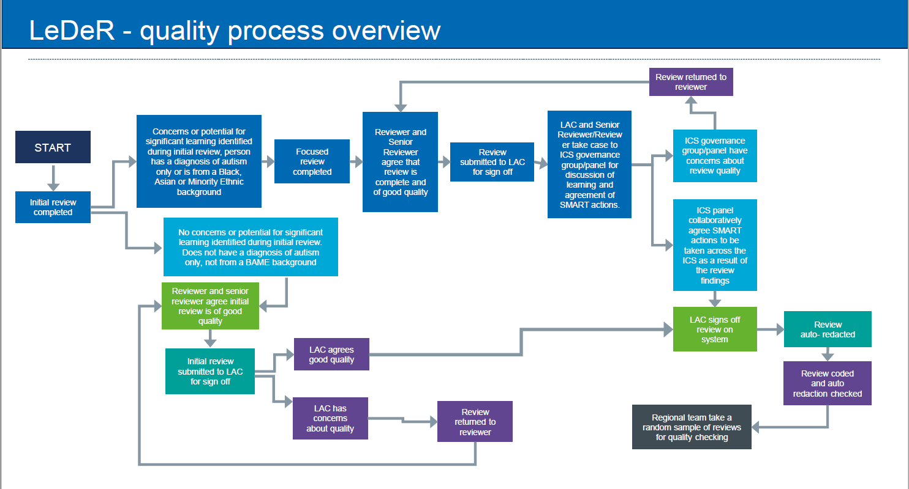
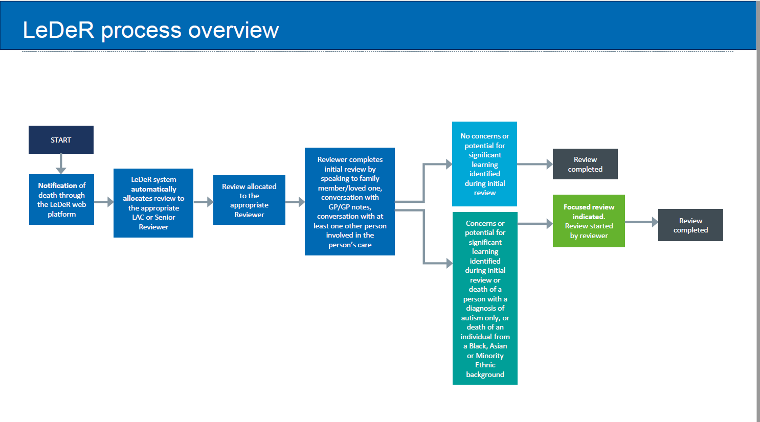
LeDeR Quality process

Appendix 3

Terms of reference for Gloucestershire LeDeR Governance and Steering Group

Appendix 4

Terms of reference for Gloucestershire LeDeR Quality Assurance and Governance Panel

Appendix 5

Terms of reference Gloucestershire Learning into action group

Appendix 6

Gloucestershire Quality Assurance Panel Checklist

Appendix 7

Guidance on the grading of care for local reviewers

Please note that this is different to how LeDeR previously graded care.

Reviewers will be asked to grade the care the person received at the end of a focused review (cases which only receive an initial review will not be graded formally, but the local Quality Assurance Panel will capture indicative grading).

Care is graded on two elements of the health and social care the person received: 1. Quality of care the person received 2. Availability and effectiveness of services the person Care is graded on a scale of 1-6 where 1 represents poor care and 6 represents excellent care.

The system may suggest a grade for a review based on the answers a reviewer has given to previous questions (for example, where the reviewer has indicated that there were gaps in service provision or NICE guidance was not followed the system will suggest that the review is graded as a 3).

The reviewer can change the suggested grade and add an explanation as to why they have changed it. When a review is graded 1 or 2, it is important for the reviewer to think about potential safeguarding and serious incidents and speak with the local area contact.

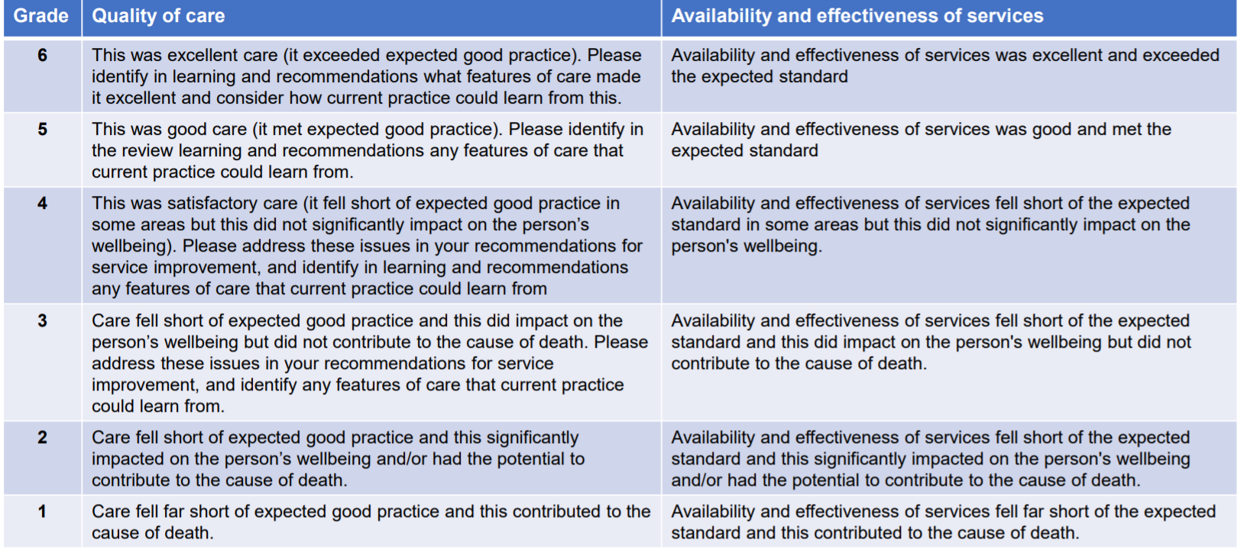

Appendix 8
Template for Learning into Action Tracker

https://www.england.nhs.uk/publication/learning-from-lives-and-deaths-people-with-a-learning-disability-and-autistic-people-leder-policy-2021/
Definition of Health Inequalities is available on the NHS England website https://www.england.nhs.uk/ltphimenu/definitions-for-health-inequalities/
Noting that depending on learning from new reviews additional themes may be added to this model
https://www.england.nhs.uk/publication/learning-from-lives-and-deaths-people-with-a-learning-disability-and-autistic-people-leder-policy-2021/
We know that there is significant under reporting to LeDeR from Black, Asian and Minority Ethnic communities and that premature mortality in Black, Asian and Minority Ethnic communities is significantly increased from the national data gathered to date. Therefore it is important that we review each of these deaths to understand better the health inequalities faced by each of these different groups and to help tackle inequalities identified.
https://leder.nhs.uk/images/learning-docs/Training_handbook.pdf
Please note that this is different to how LeDeR previously graded care.
Autism is described in the diagnostic manuals used for clinical and research purposes. These manuals are the: Diagnostic and Statistical Manual of Mental Disorders (DSM) https://www.psychiatry.org/psychiatrists/practice/dsm and International Classification of Mental and Behavioural Disorders (ICD) https://www.who.int/standards/classifications/classification-of-diseases
A diagnosis of Autistic Spectrum Disorder or past diagnostic term, for example, autistic disorder should be recorded in clinical notes and NHS systems, such as RIO, System One or EMIS.
https://www.england.nhs.uk/publication/learning-from-lives-and-deaths-people-with-a-learning-disability-and-autistic-people-leder-policy-2021/
https://www.longtermplan.nhs.uk/areas-of-work/learning-disability-autism/
https://www.gov.uk/government/collections/reasonable-adjustments-for-people-with-a-learning-disability
https://fingertips.phe.org.uk/profile/learning-disabilities
When reading the findings of the 2020 LeDeR national annual report it should be kept in mind that the LeDeR programme is not mandatory so does not have complete coverage of all deaths of people with learning disabilities, that some data is missing, particularly data relating to children, and that numbers in some subcategories are small so must be interpreted with caution. Findings must be considered indicative rather than conclusive.
https://inform.gloucestershire.gov.uk/media/2112214/your-voice-matters-report-final.pdf
https://www.inclusiongloucestershire.co.uk/engagement/leder/
Positive Impact: will actively promote the values of the CCG and ensure equity of access to services; Neutral Impact: where there are no notable consequences for any group; Negative Impact: negative or adverse impact for any group. If such an impact is identified, you should ensure, that as far as possible, it is eliminated, minimised or counter balanced by other measures.

